

**Using Data Mining Techniques in R studios and SAS to Explore Datasets**

**Name:** Ben Miller (@00498625)

**Submitted to:** University of Salford, Manchester

**Module:** Applied Statistics and Data Mining

**Qualification:** Master’s in data science

**2021/22**

**Section 1: Data Mining by Classification**

**Introduction:**

Classification is a type of supervised learning in which data is mapped into pre-set groups or classes using training data. For example, classification can be used to determine whether a person's application for a bank loan is risky. The goal of this section is to use R studios and SAS to do classification on a suitable data set. In this part, decision trees, a classification approach, are used to estimate whether an individual's annual pay is over $50k based on certain Census data variables. This dataset was chosen because it is relatively clean and aids in the creation of a snapshot and insight of the financial position in American society. Given the correct data, this method might be used to visualise who is living below the poverty line based on characteristics.

**Aims and Objectives:**

Conduct a Brief Literature Review on Decision tree classification and explore what research has already been done. Furthermore, what additionally decision trees classification is being used for.

* Conduct a Brief Literature Review on Decision tree classification and explore what research has already been done. Furthermore, what additionally decision trees classification is being used for.
* Next is to import the data set into R studios and perform data pre-processing. This includes cleaning the ensuring the data is ready to perform classification on. This includes removing any missing values and ensuring all variables are in the correct format. Furthermore, Data exploration, Explore and understand the dataset in R studios and get a visualization on what going on.
* Lastly to perform the classification in R studio. The classification used in this task will be the decision tree. A decision tree and node analysis will be performed. Additionally, the accuracy of the model will be assessed.
* Lastly, the same analysis done in R will be completed in SAS enterprise miner. The same data already pre processed will be used to output a decision analysis on the data. The accuracy and how valuable each variable will be assessed.

**Literature Review:**

In an article created by Yan-Yan Song and Ying Lu introduces decisions trees. Decision trees were first introduced in the 1960s and still are one of the most effective data mining methods. Decision trees are robust even in the presence of missing values in the dataset. When using decision tress, not only continuous data can be used but discrete. Decision trees are used in modern medical research to classify any symptoms for example. Decision trees are easy to understand, robust against any anomalous results, not effected heavily by skew data but however with small data sets, decision tress tend to underfit, or overfit meaning resultant models can’t be used as a reliable prediction of additional data (Song & Lu, 2015).

Decision trees analysis was used on a tree different remote sensing data to investigate land mapping problem. The paper explores three decision tree classification algorithms, univariate decision tree, a multivariate decision tree and a hybrid decision tree. All three tree structures were compared to traditional both maximum likelihood and linear discriminant function classifiers and were found to produces better accuracies for the land mapping problem. The hybrid decision tree performing the best (Friedl & Brodley, 1997).

Paper that explores a new cost-sensitive classification that evolves a population of biases for a decision tree induction algorithm. This new algorithm can be used for such problem as when a doctor wants to balance the cost of medical tests for a patient and the expected benefits. This new ICET (Inexpensive Classification with Expensive Tests) algorithm is tested against 4 other algorithms on a real-world medical data. The algorithm is found to be more robust and performs significantly better than the competitors (Turney, 1995).

**Database Preparation and Exploration:**

The dataset contains US Census data from 1994. The dataset contains 32561 rows and 15 columns. Each row being one US adult with the following 15 attributes,

• Age. Age of the individual in the Census. This data is continuous, numeric and an integer and also greater than 0.

• Work class. Represent the employment status of the individuals in the Census. This variable involves 8 employment statuses, Private, self-emp-not-inc, self-emp-inc, federal-gov, local-gov, state-gov, without-pay and never-worked. This variable is character data and contains strings.

• Fnlwgt: Fnlwgt means final weight. The final weight value estimates the number of the target populations this specific adult represents. This variable is continuous and numeric.

• Education: Represent the education level of the individual in the Census. This variable contains 16 levels of education, Bachelors, Some-college, 11th, HS-grad, Prof-school, Assoc-acdm, Assoc-voc, 9th, 7th-8th, 12th, Masters, 1st-4th, 10th, Doctorate, 5th-6th, Preschool. This variable is character data and contains strings.

• Education number. This variable is Continuous data. Like Education, it includes 16 levels of education. This attribute is not needed and is redundant in the presence of the Education variable. This column can be removed from the data.

• Marital status. Represent the martial status of the adults. This variable includes 7 different statuses, Married-civ-spouse, Divorced, Never-married, Separated, Widowed, Married-spouse-absent, Married-AF-spouse. This variable is character data and contains strings.

• Occupation. General occupation of the individuals in the Census. Tech-support, Craft-repair, Other-service, Sales, Exec-managerial, Prof-specialty, Handlers-cleaners, Machine-op-inspct, Adm-clerical, Farming-fishing, Transport-moving, Priv-house-serv, Protective-serv, Armed-Forces. This variable is character data and contains strings.

• Relationship. An individual’s Relationship status to another individual/individuals. This attribute is not needed and is redundant in the presence of the martial status. This column can be removed from the data. Wife, Own-child, Husband, Not-in-family, Other-relative, Unmarried. This variable is character data and contains strings.

• Race. The Race of the individual in the Census. White, Asian-Pac-Islander, Amer-Indian-Eskimo, Other, Black. This variable is character data and contains strings.

• Sex. The gender of the individual in the Census. Male and Female. This variable is character data and contains strings.

• Capital-Gain. The profit an individual has earned on the sale of an asset which has increased in value over the holding period. Continuous numeric data. All values are zero or higher.

• Capital-Loss. The loss an individual has earned on the sale of an asset which has increased in value over the holding period. Continuous numeric data. All values are zero or higher.

• Hours per week. The number of hours an individual works in a week. Continuous numeric data. All values are zero or higher.

• Native-Country. The country the individual originated from. United-States, Cambodia, England, Puerto-Rico, Canada, Germany, Outlying-US(Guam-USVI-etc), India, Japan, Greece, South, China, Cuba, Iran, Honduras, Philippines, Italy, Poland, Jamaica, Vietnam, Mexico, Portugal, Ireland, France, Dominican-Republic, Laos, Ecuador, Taiwan, Haiti, Columbia, Hungary, Guatemala, Nicaragua, Scotland, Thailand, Yugoslavia, El-Salvador, Trinidad & Tobago, Peru, Hong, Holland-Netherlands. This variable is character data and contains strings.

• Salary. Either the individual makes more or less than $50k a year. Either <$50k or >$50k.

The data was imported using a read. delim function that reads the data file and divides it into columns depending on particular criteria such as commas or forward slashes. Commas were used to separate the data. Because the imported data lacked column names, column names were added to each of the 15 attributes listed above. Next, the irrelevant columns were removed, such as the education and relationship columns, which are identical to the Education No and Marital Status columns. In addition, the data set’s missing values were removed; However, any cells with missing values in this particular dataset had a character string of “?”. Therefore, using a grepl function all rows containing “?” were removed. The original dataset containing 32561 rows and 15 columns was reduced to 30162 rows and 13 columns. Furthermore, another unneeded variable in Fnlwgt is removed as it about the population and not the individual.

After the pre-processing of the US Census data, there are 30162 rows and 13 columns.

First exploring the age of the individuals in the US census data, we can use summary function to observe a quick glance of the attribute. The summary data provides some interesting observations. The youngest person in the dataset is 17 and the oldest is 90 years old. The average age is 38.44 and median is 37. Furthermore that 50% of all the individuals are between the ages of 28 to 47 years old.

|  |  |  |  |  |  |
| --- | --- | --- | --- | --- | --- |
| **Min Value** | **Max Value** | **Mean** | **Median** | **1st Quartile** | **3rd Quartile** |
| 17 | 90 | 38.44 | 37 | 28 | 47 |

**Table 1:** Summary data of the age of the individuals in the US census data.

Using the hist function, a histogram can be used to explore the data. Taking a histogram of the age of the individuals in the US census data, normality in the age data can be investigated.  A frequency distribution of a set of data shows how frequently each different value happens. The most common graph for displaying frequency distributions is the histogram (ASQ, 2021).

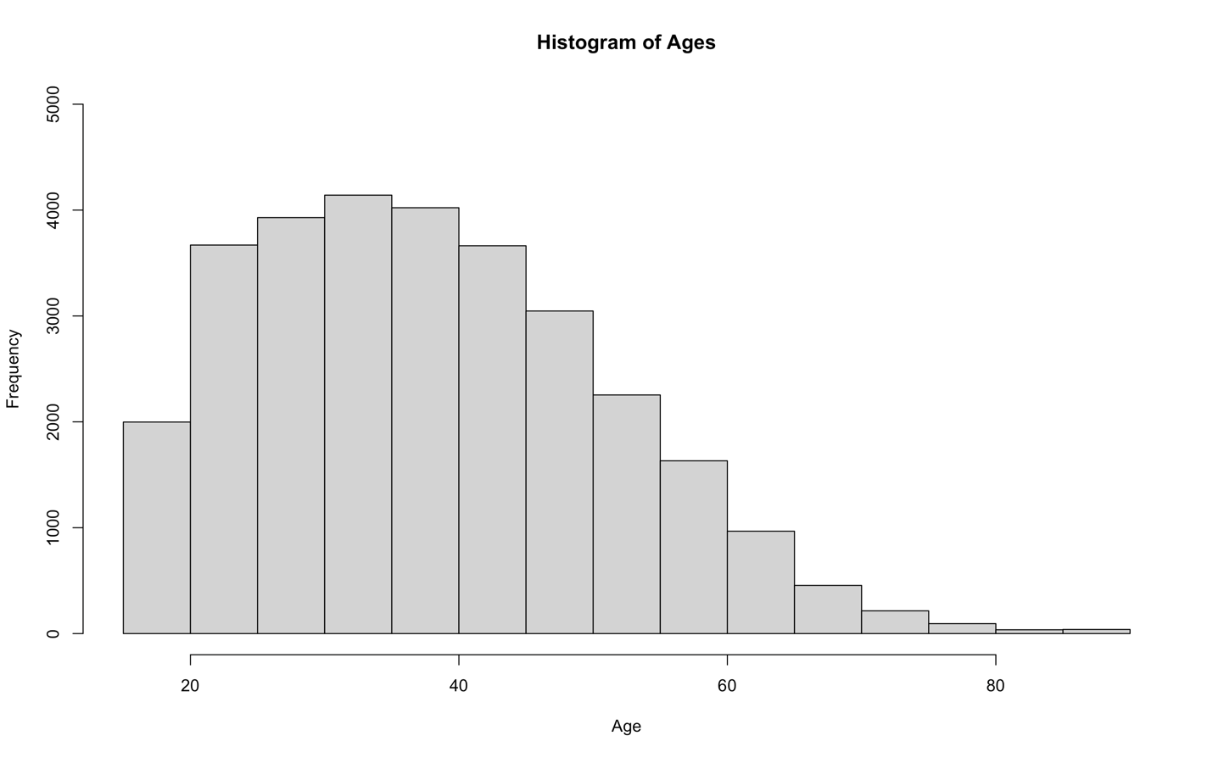

**Figure 1:** Histogram with age of the individuals verse the number of individuals at that age. This histogram produces a normal distribution with right skew.

Figure 1 explore the age of all the individuals in the dataset. There are more individuals near the age 40 bracket than anywhere else, and the least number of individuals aged 80 and onwards. This data produces a histogram with right hand skew. Most of the people are aged between 20 and 50 years old. Furthermore, the age data of the individuals can be split into two groups, people who earn over $50k annually and people who don’t. This segregation gives an insight in how age differs when with income.

|  |  |  |  |  |  |
| --- | --- | --- | --- | --- | --- |
| **Min Value** | **Max Value** | **Mean** | **Median** | **1st Quartile** | **3rd Quartile** |
| 17 | 90 | 36.61 | 34 | 26 | 45 |

**Table 2:** Summary data of the age of the individuals in the US census data of earners who make less than $50k a year.

|  |  |  |  |  |  |
| --- | --- | --- | --- | --- | --- |
| **Min Value** | **Max Value** | **Mean** | **Median** | **1st Quartile** | **3rd Quartile** |
| 19 | 90 | 43.96 | 43 | 36 | 51 |

**Table 3:** Summary data of the age of the individuals in the US census data of earners who make more than $50k a year.

There isn’t much difference between the min and max values when comparing the earners however for people earning more than $50k a year, the youngest individual is older than the youngest individual not earning over $50k a year. In addition, the mean, median and quartile are all higher in people earning over $50k. This suggests older an individual is the more likely they are to earn over the $50k a year threshold. A big difference between the two-summary data is the lower quartile. This suggests fewer younger individuals earn over the threshold. Looking at the segregated histograms, it becomes clearer.

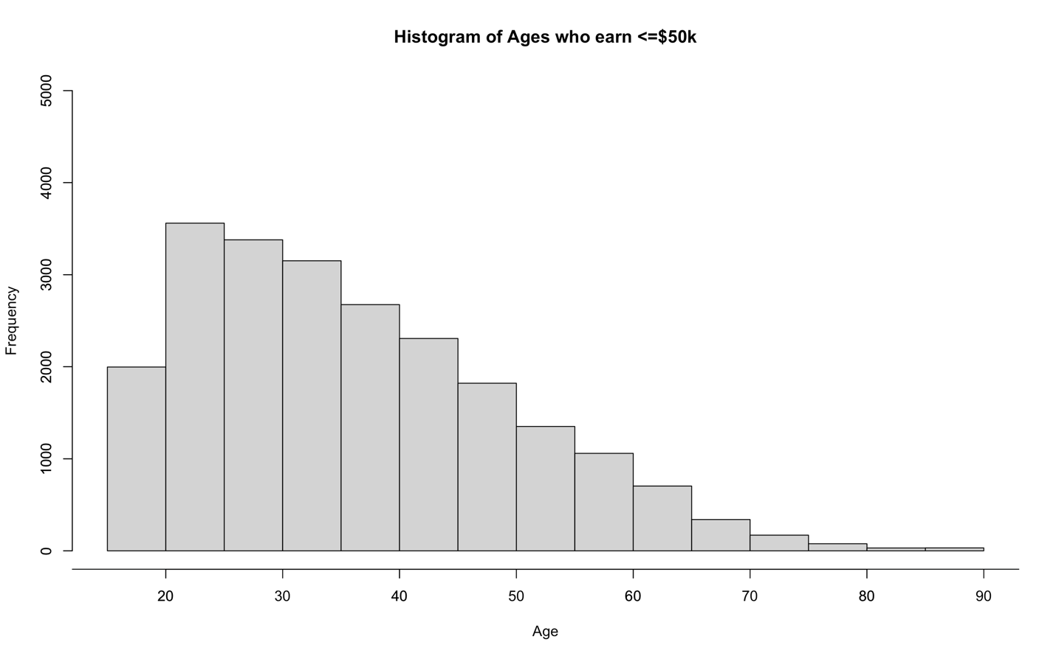

**Figure 2:** Histogram of age vs frequency of individuals in US census data that earn under $50k a year.

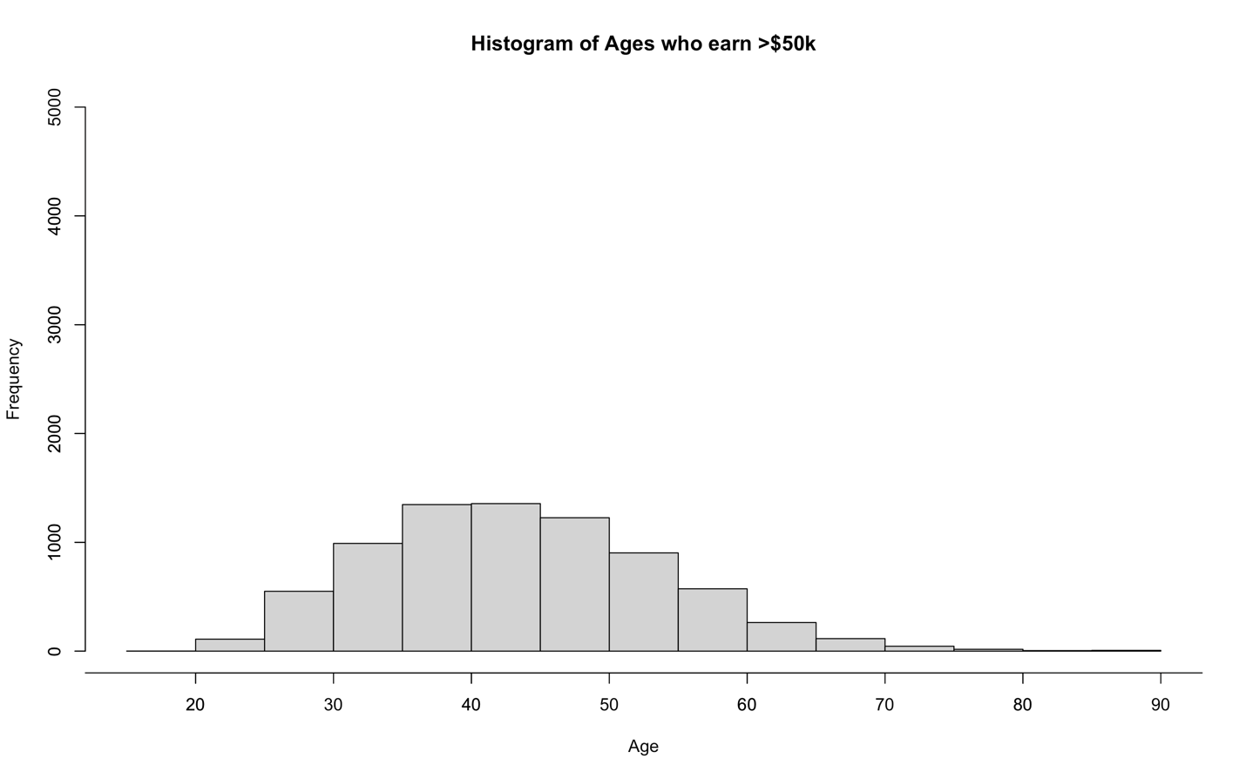

**Figure 3:** Histogram of age vs frequency of individuals in US census data that earn over $50k a year.

Figure 2 and Figure 3 represent individuals that earn under and over $50k respectively. It is clear shown in figure 3 when compared to figure 2 that there are less higher earners. Most of the high earners are in the bracket of ages 35 to 50 which is true to the summary data seen in table 3. Figure 3 shows it is normally distributed due to the bell like curvature however, figure 2 has massive right-hand skew.

Lastly to explore the age data of the Census dataset, is to conduct a chi square test to measure the significance of the attribute. This can be achieved using the chi square function in R studios, which outputs the x squared value, degrees of freedom and p value. Measuring if the two classes, Age and Salary are independent with a 5% significance level,

|  |  |  |
| --- | --- | --- |
| **X2 Value** | **Degrees of Freedom** | **p-value** |
| 3186.3 | 1 | 2.2e-16 |

**Table 4:** Table of the chi square data outputted from the chi square function.

Due to the p-value be less than the significance level of 5%, we fail to accept the null hypothesis that the two variables are independent. Exploring the salary variable next. Using a summary command like before, the number of individuals earning over and under the $50k can be seen.

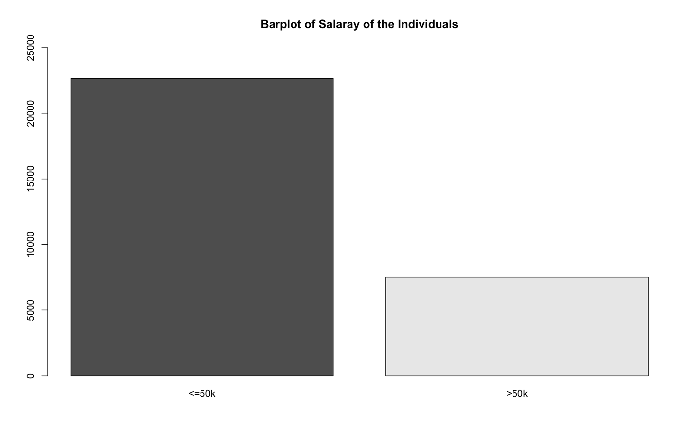

**Figure 4:** Barplot of the salaries of the individuals included in the census data. The left barplot includes people that earn less than or equal to $50k a year and the right includes people that earn more than $50k a year. Frequency is on the y axis.

The above graph, figure 4, show the amount of people under and over the $50k threshold. There is 22654 people earning less than or equal to $50k a year and 7508 people earning more than $50k. There is almost 3 times as many people earning less than or equal $50k than more. 75.1% of people earn less than or equal $50k a year and 24.9% earn more than $50k.

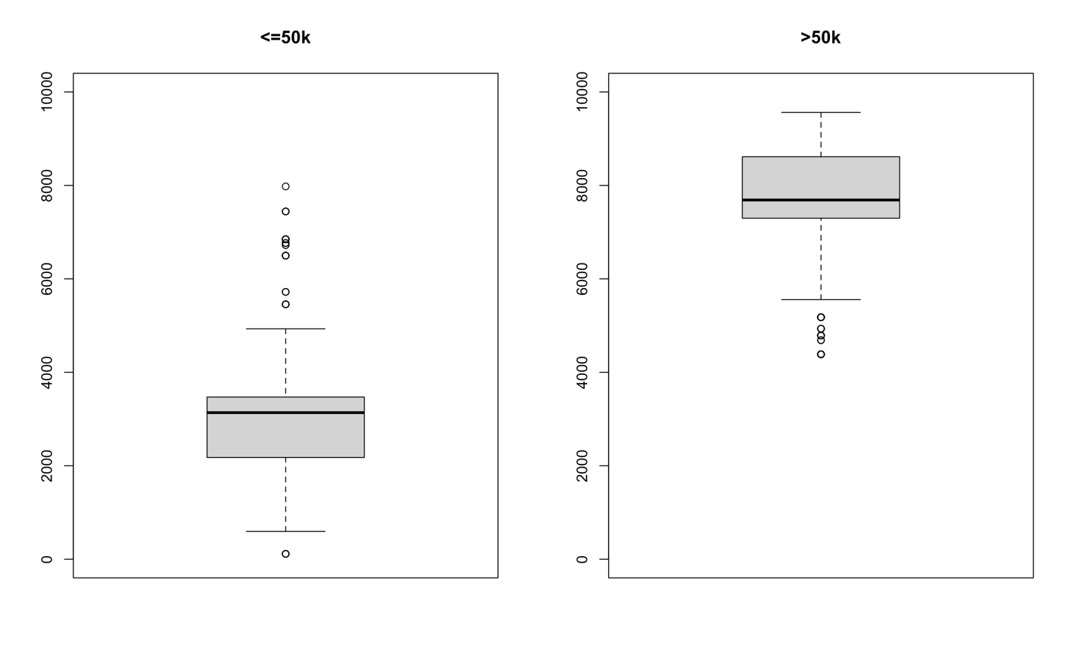

**Figure 5:** Two boxplots of the capital gain of the individuals in the US census data separated between if they make more or less than 50K a year with the removal of zero values. The Y axis is the amount of capital gained.

Figure 5 presents nonzero capital gain boxplots. With figure 5, the amount of capital gain between people making over $50k a year and people can be compared. On average, people making more have a higher capital gain than people not making over $50k a year. The mean in around 8000 for people making over $50k and around 3000 for people not making more than $50k. Furthermore, almost everyone making more than $50k except a few outliers make better investments than people below the threshold. People making more than $50k a year seem to be smarter with their money.

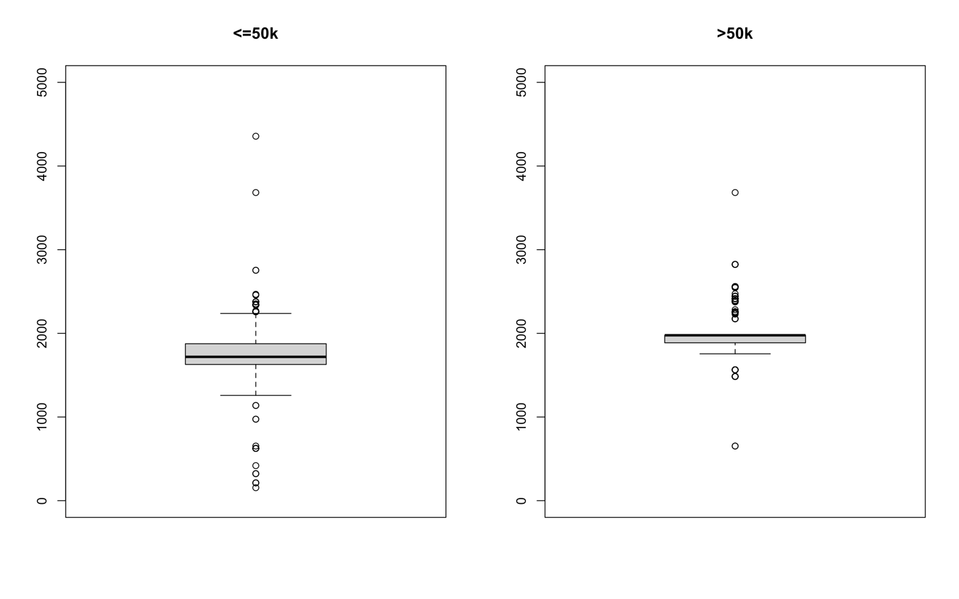

**Figure 6:** Two boxplots of the capital loss of the individuals in the US census data separated between if they make more or less than 50K a year with the removal of zero values. The Y axis is the amount of capital loss.

The amount of capital loss for both sets of data are similar. Both individuals that make over $50k a year and individuals that don’t have on average 2000 capital loss. However, people making more than $50k see less variation compared to people that don’t.

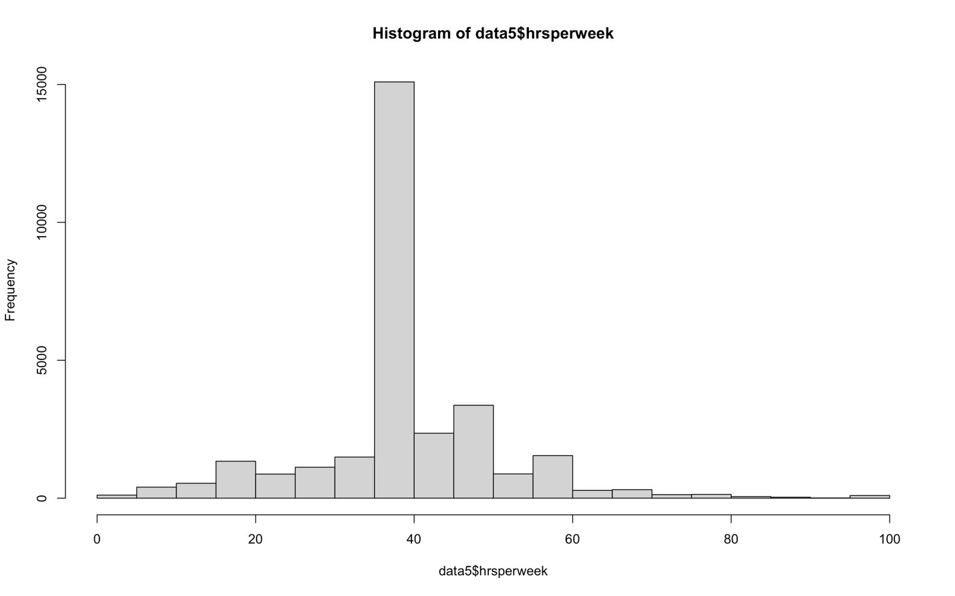

**Figure 7:** Histogram plot of the hours per week variable for the individuals in the Census data. Hours per week on the x axis and frequency on the y axis.

Figure 7 looks at the hours per week people work. Looking at the histogram, most people work between 35 to 40 hours whilst only a small frequency of people works over 60 and almost zero hours. Additionally, the summary data for the hour perk week variable can be investigated.

|  |  |  |  |  |  |
| --- | --- | --- | --- | --- | --- |
| **Min Value** | **Max Value** | **Mean** | **Median** | **1st Quartile** | **3rd Quartile** |
| 1 | 99 | 40.93 | 40 | 40 | 45 |

**Table 5:** Summary data for the hours per week worked by Individuals in the US census data.

The summary data confirm that most of the people work between the hours of 40 and 45 and the mean hours per week worked is 40.93. Using a chi square test and significance level of 5%, the significance of hours worked per week on salary can be investigated. Are the variables independent or not?

|  |  |  |
| --- | --- | --- |
| **X2 Value** | **Degrees of Freedom** | **p-value** |
| 1415.3 | 1 | 2.2e-16 |

Due to the p-value be less than the significance level of 5%, we fail to accept the null hypothesis that the two variables are independent. Another variable is the gender of the individuals in the Census. This variable produces some interesting results when inputted into a barplot with conjugate to income.

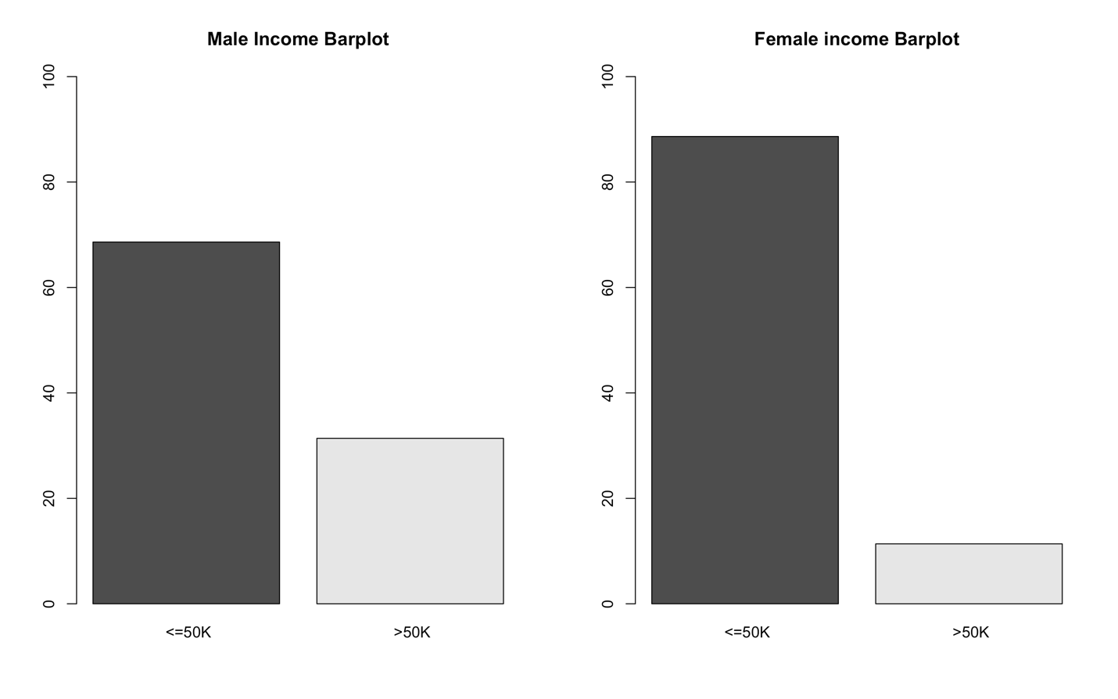

**Figure 8:** Two barplot for male and female. Each barplot figure represents the percentage of individuals with an income over $50k a year and under. The left is the Male plot and right is the females. Each plot has percentage on the y axis and income on the x axis.

Figure 8 is very interesting as it is clear straight away that more Males earn over $50k than Females for their respective populations. Three times of individuals in the Male population have an income greater than $50k a year compared to female. This is a significant indication that gender has a good relation to income.

**Implementation in R studios and Results:**

**Packages:**

The packages used are:

* Party – This package was used to train dataset and model using a decision tree
* Dplyr – This package is used for data manipulation. Used to drop rows and columns

**Decision Tree Model:**

Firstly, any character data in the dataset was removed from the decision tree model as the party package doesn’t recognise them. The tree function only can be used on numeric, integer and string data. Furthermore, the salary column which includes if the individuals have and in come greater or less than $50k a year was converted to a factor. This change is need as categorical data is needed to class the variable for prediction.

data5$salaryF <- as. factor(data5$salary)

Next, we set a seed. This seed creates the same sample every time to get consistent results. The seed that was chosen is 2599. Then the sample function is used to output a random set of values from “data5” which is the cleaned US Census dataset. Two samples are created with a respective 80% and 20% split from the whole dataset. 80% of the data is used to train and 20% to test upon to measure the accuracy of the model. Using this, two new datasets are created called train and validate.

set. seed (2599)

pd <- sample (2, nrow(data5), replace = TRUE, prob=c (0.8,0.2))

train <- data5[pd==1,]

validate <- data5[pd==2,]

tree <- ctree (salaryF ~ age + educationNo + capitalgain + capitalloss + hrsperweek, data = train)

Now, we use the ctree using the variable from the training dataset to predict the Salary. All variables found in the cleaned data are used. The response is the salary variable, and the inputs are age, educationNo, capitalgain, capitalloss and hrsperweek. The number of observations in the training set is 22181. The resulting tree has 117 terminal nodes. This is a large decision tree. In addition, the accuracy of the decision tree is 82.95% therefore there is 17.05% error in the prediction. Meaning 17.05% of the time, the model predicts the incorrect salary of the individual in the Census compared to the validation dataset. This is a large an unreliable error.

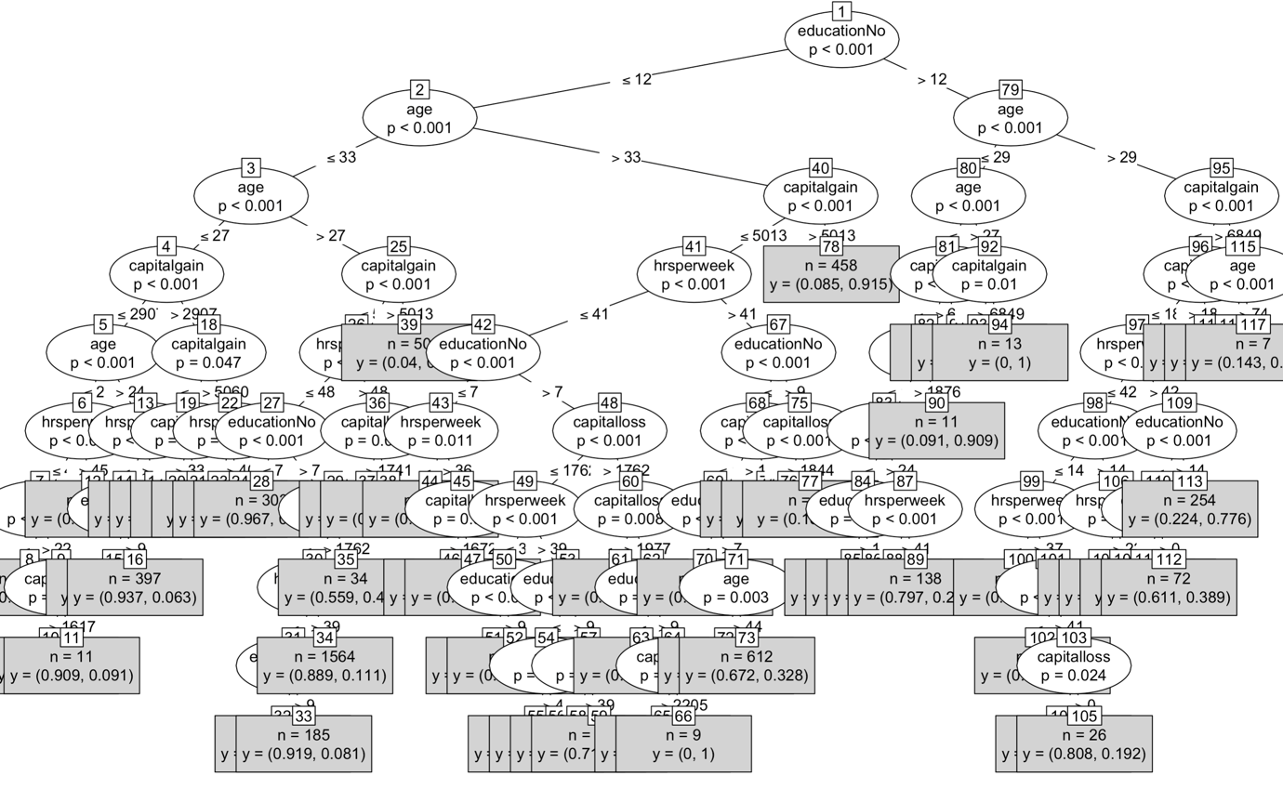

Changing the data split between the training and validation set produces interesting result. Therefore, splitting to data set into 20% train and 80% validation, the opposite seen above, produces a decision tress with much less nodes and similar misclassification rates. The decision tree produced, uses 35 nodes which is almost a third less than the previous to produces a similar error of 17.64%. The misclassification is still not great however it is done much quicker and less split to produce almost similar results. The misclassification rate isn’t much effected by changing of the split of data, only the nodes. Adding more variable to the model would improve the misclassification rate however, the only variable not used are character data which are not useable in this particular R studios model. Only using one variable for example age compared to multiple variable seen above produces a misclassification percentage of 25.10% which is far worse.

**Implantation in SAS and Results:**

To perform the decision tree mining in SAS, the SAS enterprise miner software is used. This software allows to perform many data science mining techniques and use models very easily and quickly. As the software is opened, new project is selected where the initial blank workstation will pop up. The left two windows show the diagrams created, data sources, packages and also the properties. These properties can be adjusted. Furthermore, the main screen is the diagrams where techniques and tools can be dragged and dropped to create operations to perform our desired data mining. Firstly, a diagram is created by right clicking on the diagram tab and selecting create diagram. This diagram is then named, and a blank diagram will appear. Next the data is imported. This is done by going to sample in the tool bar and dragging and dropping the file import tab into the blank diagram. The data is then selected by going to import file under the train section in the properties window. The data file was created previous in R Studios by saving the clean prepared data using the write.csv function that saves a data frame as a csv. This csv is the file imported. Next, the variables are edited by right clicking the file import node and selecting edit variables. The variables are changed like below to the correct roles.

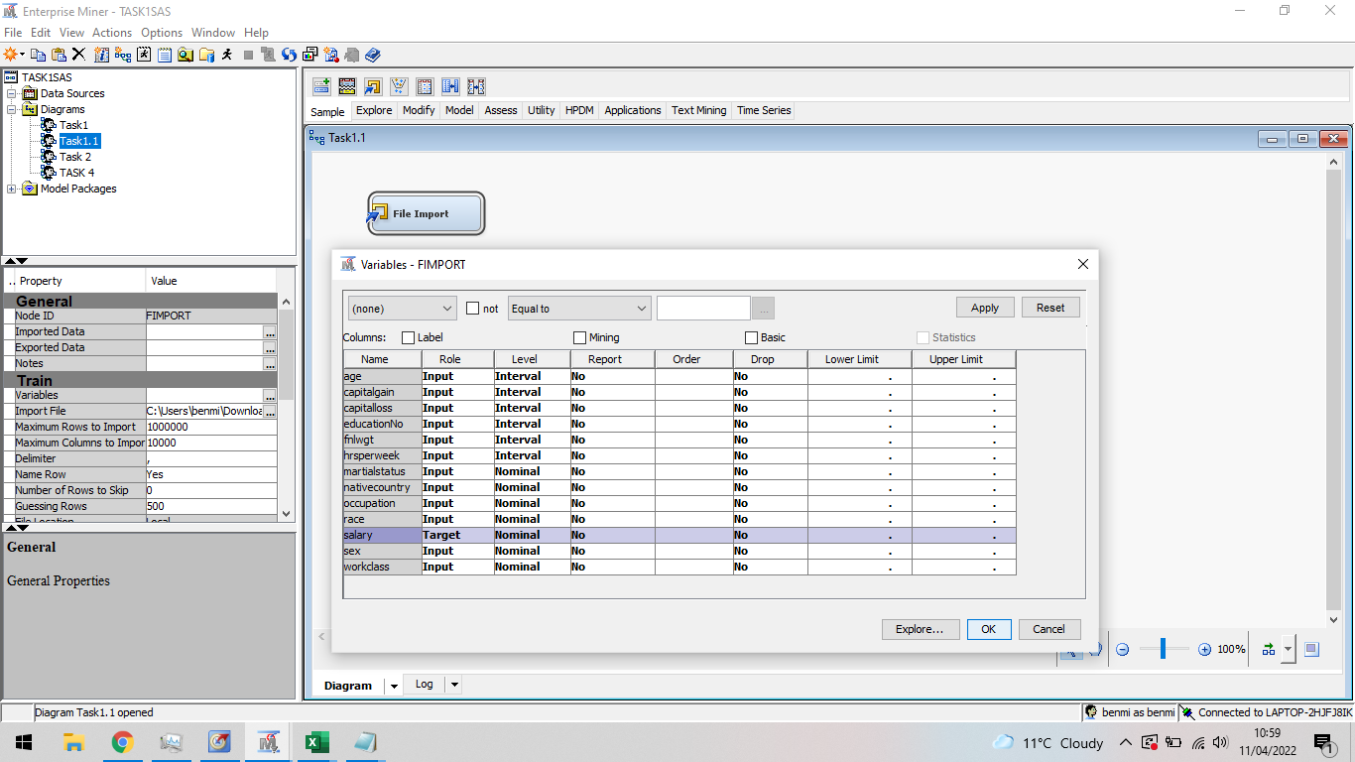

The Salary variable is changed to Target. This is the variable that the decision tree model will try to decide between for each person. After the file is imported and variables are edited, the node is run by selecting the stick man on the top tool bar. There is 30162 rows and 13 columns which is the same as the R studios implantation. After this, the data is partitioned into a training set and a validation set. This partition is done by dragging and dropping the data partition node from the sample tool bar into the window and connecting it the data. The percentage of split between the training set and validation set is 75/15 respectively with a the remaining 10% as a test data set. This node is run giving a partition of 22620 observation in the training set, 4524 in the validation set and 3018 observations in the test set.

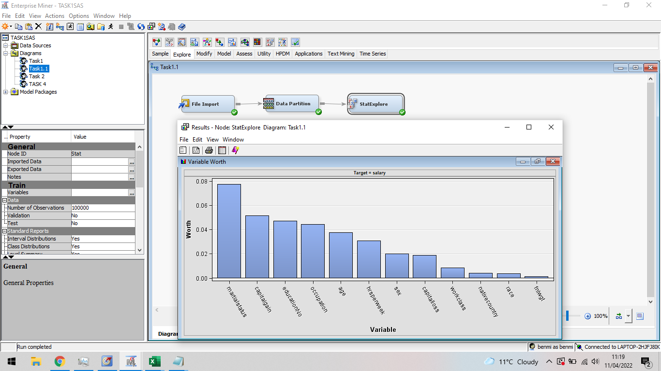

The results window gives information on the variables with the most worth that leads to the individual salary. From the bar plot, Martial Status, Capital Gain and education are all big contributor to the individual salary and on the other hand race, native country and fnlwgt are not big contributors. After this exploration, the decision tree for the classification can be created. This decision tree is created by dragging the decision tree node to the diagram and connecting it the exploration node or the data partition node. In the property window under node, the leaf size is increased to 8, the number of rules to 4 and under the splitting rule, the maximum depth is 10 and the maximum categorical size to 5. The following decision tree formed contains a total of 121 nodes with a misclassification rate of 14.61% based of the test dataset and an average squared error of 10.60%.

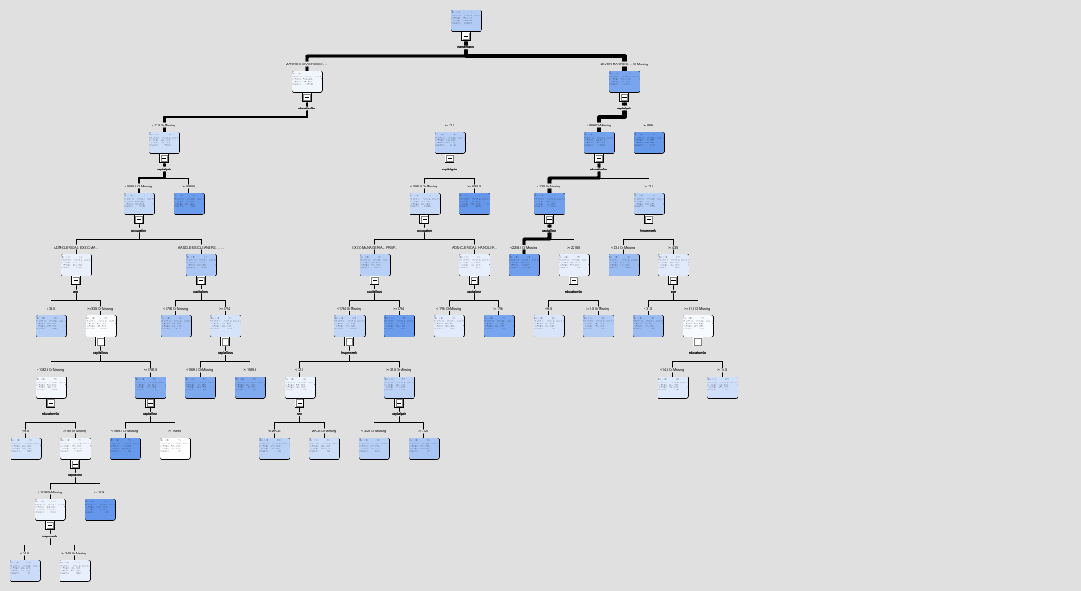

Additionally, to the decision tree model, SAS enterprise miner also allows the use of another decision tree method called HP Tree. The HP Tree model or High-Powered tree model are useful for large datasets. To complete this implantation of this HP tree model, a control point is added. For this task it is not needed but is good practice. Control point nodes reduces the amount of connection in the diagram. Therefore, under the utility tool bar, the control point node can be dragged and dropped into the diagram. This node is connected to the Data Partition node. Then the two tree models are connected after. The HP tree model can be found under the HP section in the tool bar. The following figure shows how the diagram should look.

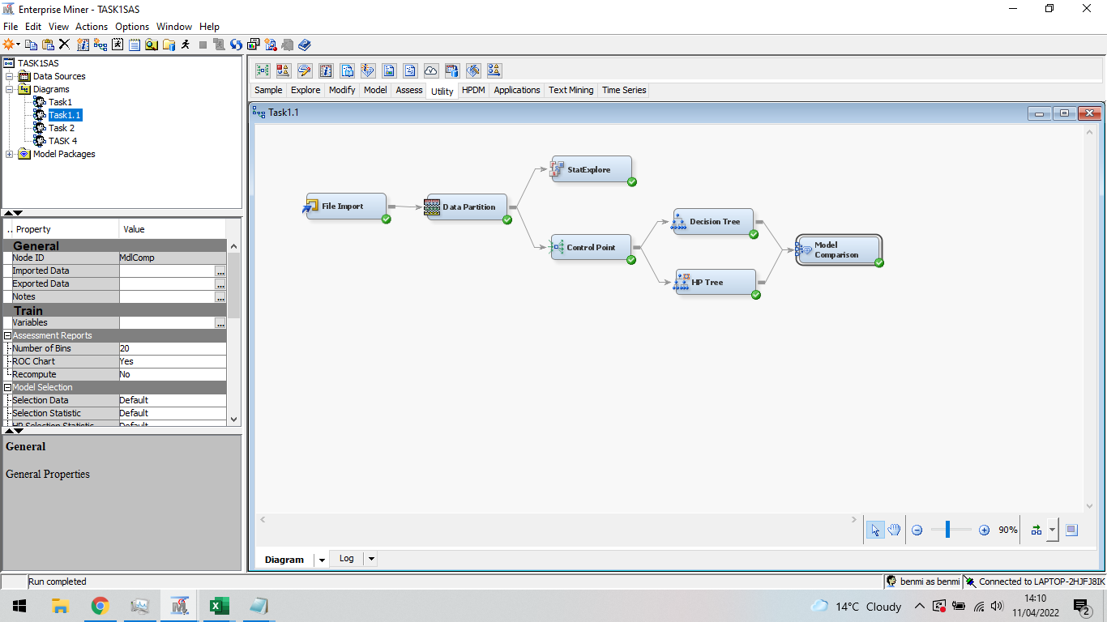

Using the same properties as the original decision tree model, a comparison of the two can be performed. The following decision tree formed contains a total of 98 nodes with a misclassification rate of 14.25% based of the test dataset and an average squared error of 10.17%. The HP tree produces better results in less nodes.

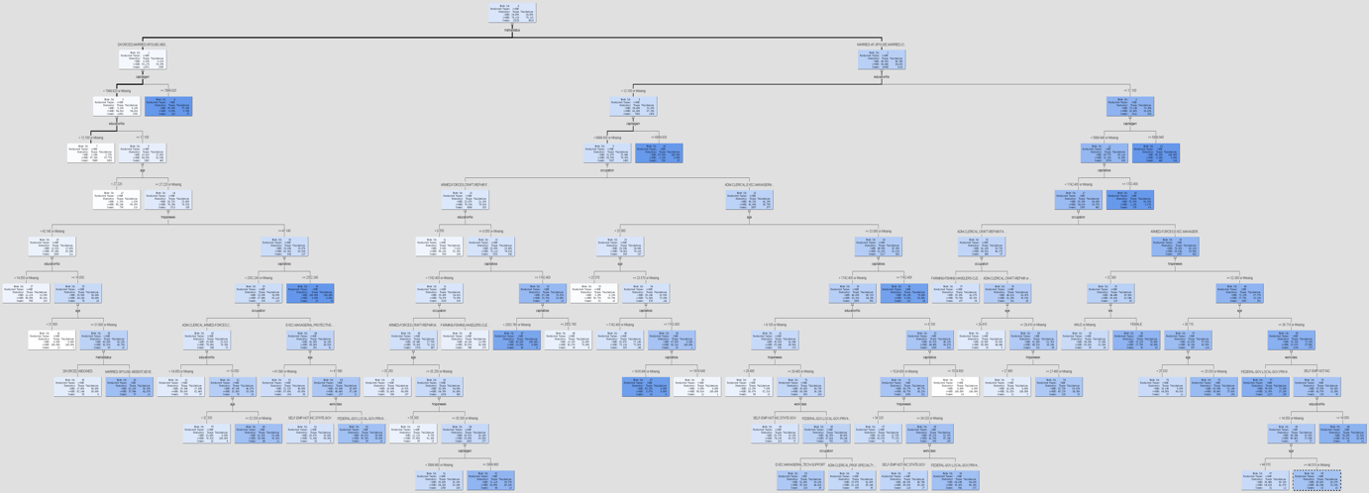

This comparison of the two models can be seen clearly using the model comparison node under the assess section in the tool bar. The node is dragged onto the diagram and the two models connected to it. The following comparison is created.

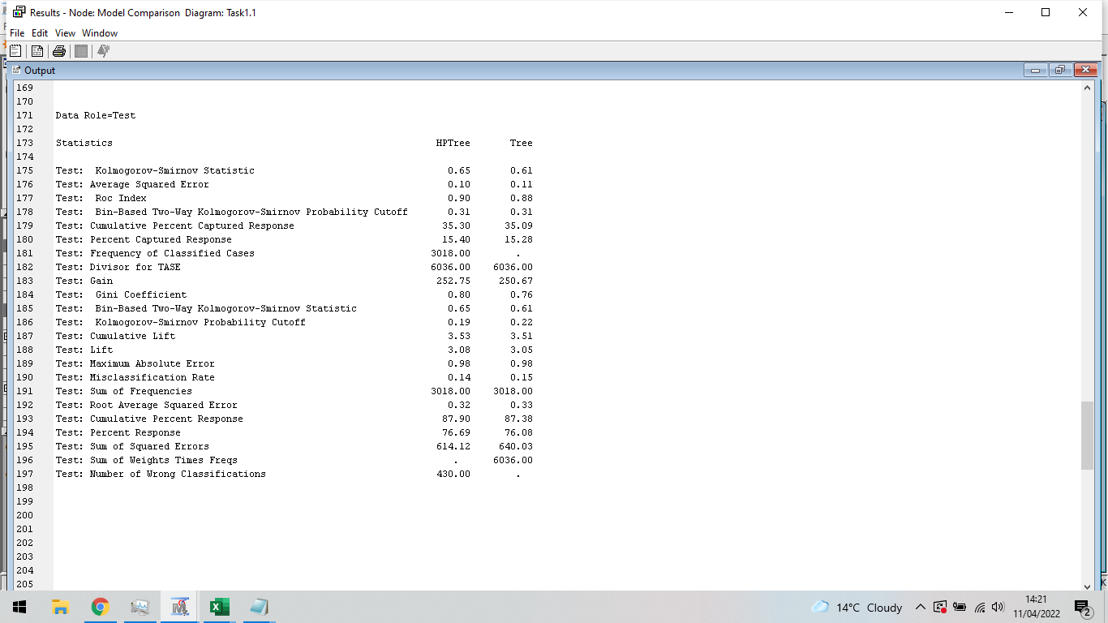

Both models produce very similar result. The HP tree preforms only slightly better and has slightly better accuracy. Furthermore, the two models’ classification rates can be compared.

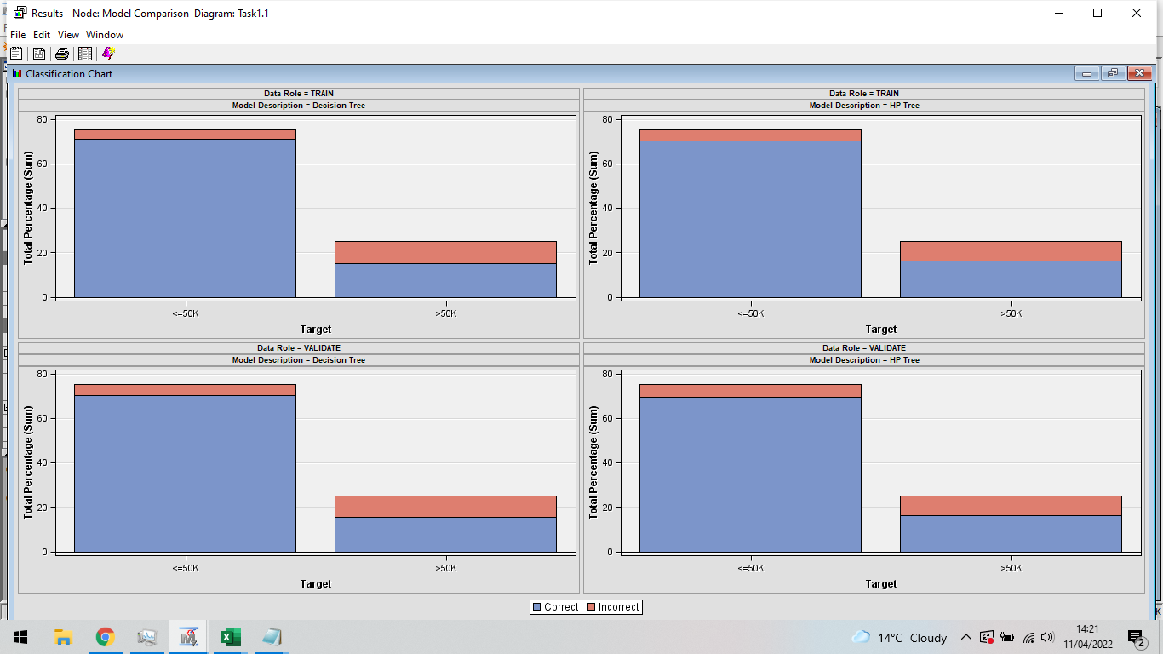

The two models have near identical classification bar plots. Most of the misclassification can be seen when the model estimates if the salary is greater than $50k a year. This suggests the model struggles to class an individual more if they earn more than $50k than if they if they earned under $50k a year. In addition, this could be due the smaller sample size of individuals in the training set earning over $50k to learn from.

**Conclusion:**

To conclude, during this task, classification analysis was performed in SAS enterprise miner and in R studios. The classification method used was decision trees. Classification is a type of supervised learning in which data is mapped into pre-set groups or classes using training data. For this task, census data on individuals living in the US was used to determine which individuals were earning over $50k or under $50k annually. Through data exploration of the original data set, there is 22654 people earning less than or equal to $50k a year and 7508 people earning more than $50k. There is almost 3 times as many people earning less than or equal $50k than more. Furthermore, the variables, Martial Status, Capital Gain and education, were all big contributors to determining whether an induvial earns more than $50k or less than $50k. Using decision tree classification to determine an induvial salary to be either over or under $50k in SAS and in R and it was found to have a misclassification error of 14.61 and 17.05 percent respectively for the two implementations. This misclassification rate is quite high however is improved to 14.25% using the high-powered decision tree method is SAS enterprise miner. The 3 method produced decision trees with 121 117 and 98 nodes respectively and therefore the HP decision tree model produced better results in much less tree splits. In R studios implementation, it was explored what effect the percentage split in the dataset for train and validation had on the error percentage. It was found it had no major effect however reduced the tree node significantly. Furthermore, using less variable in the decision tree model was explore and it was found that using less variable produced worser results. More variable, the better.

**Section 2 - Data Mining by Association:**

**Introduction:**

Association rule mining is an unsupervised learning technique. When an algorithm attempts to learn without the assistance of a training set, this is known as unsupervised learning. The association rule is a descriptive method, not a predictive one, and it's widely employed in large datasets to find interesting and previously unknown correlations. Relationships are frequently portrayed as rules. For this task Apriori method is used, this method is the most popular method used for association mining. In this task, the Apriori association rules will be used to look at the relationship on a market basket dataset. The objectives for this task are,

* Perform a short and concise literature review to find other application and studies there are around association rule mining.
* Perform data preparation and exploration steps. This includes exploring the variables included in the data and to find what they are and their significance. Furthermore, analysing the dataset to see what data need correcting. In this dataset, it is expected that there will be the removal and correction to ensure the data Is ready to be converted into the transaction format.
* Perform R studios implementation of the cleaned data from the data preparation step and use Apriori rule mining to find the interesting relationship between items in the market basket data set. This includes creation of the links graph and the rules table.
* On the same the same data set, implement association rules using SAS enterprise miner. Like in R studios, creation and discussion of the link graphs and rule table.

**Literature Review:**

Data mining methodologies can be used to investigate and get an insight in the educational system. A lack of knowledge in the aera could result in the inadequate education for students. The Apriori association algorithm was used to obtain minimal rules and it was found to be good at predicting the students under three specific categories. The obtained rules were based off a minimal confidence and support and help disguise between the good, average and poor performing students. The resulting performance report help the student results and paired them with industrial placement (Angeline, 2013).

A tradition Apriori association algorithm is used to analyse a set of transactions. As the problem is solved, multiple issued are pointed out but fixed with the introduction of an improved algorithm that incorporated time series. It is found that the improved time series Apriori association algorithm is better than the traditional method in storage space and found to be relatively stable in comparison. It is also found that the improved method has a higher search efficiency (Wang & Zheng , 2020).

In this paper, data is extracted by using a predictive and distributed Apriori association algorithm using grid technologies. It’s found that the predictive and distributed data mining systems speed up the execution of the data mining process. The grid technologies optimize resources, improve efficiencies, decreases data processing time and distributing workloads. This means massive operations can be achieved at a much quicker time. In this paper, Weka toolkit is used (Sumithra & Paul, 2010).

In the paper, the Apriori association method is used. This association algorithm is efficient and provides effective results. In the paper, the concepts of the Apriori association method are explored and how it is implemented. The paper describes the association method as a popular way of data mining using association rules to find patterns in the data. The method has many applications such as the business field with finding patterns in purchase data. The paper explores comparison between the Apriori and the regular association rule method and finds that the improved Apriori improves the efficiently of the algorithm and reduces storage space (Mandave , 2013).

**Data Preparation and Exploration:**

The dataset used for this task is data containing the transactional history of a United Kingdom based online retail store between the dates of 01/12/2010 to 09/12/2011. The data set contains 541909 rows and 8 columns. Each row contains one of the items sold and the information regarding the purchase. There are 8 variables in the dataset, one for each column,

Invoice No. The Invoice number given to the transaction. There could be multiple items that have the same number as they will be part of the same transaction. This variable is nominal. If the number starts with a C, then it is a cancelled purchase.

Stock Code. The individual stock code to each item. This variable is Nominal.

Description. The item description. This variable is Nominal.

Quantity: The number of the individual item bought in the one transaction. This variable is numeric.

Invoice Date: The date and time of the transaction. This variable is numeric.

Unit Price: The price of the item. This variable is numeric.

Customer ID: The ID number uniquely given to each customer. This variable is Nominal.

Country: The country the customer lives. This variable is nominal.

First, all rows containing missing values were removed. This was completed using the na. omit function in R Studios. This removal removed a total of zero rows meaning there were zero missing data. However, this can be confirmed using the skim function from the skimr package which reveals no missing values in either of the 8 variables. Next, the Invoice Date’s format was changed removing the time and just keeping the transaction date. This was done for data exploration later. After this, all cancelled transactions were removed. This removal was achieved using the grepl function in RStudios. All rows containing “C” in the invoice number column were removed. This removed a total of 9288 cancelled transaction bringing the new total number of rows to 532621 rows. Next, the quantity column is check for any quantity less than zero, this could be from damaged good or returns. This was completed by removing any row with a negative value and this was done using the grepl function used before. This removed a total of 1336 rows. Any rows with zero description were also removed as they will have no use in the creation of the association rules later and anything with a unit price of zero since it included mostly transactions for damaged goods or such things like crushed items. Furthermore, from the stock code column, such transaction like postage, carriage fees, manual, samples and Amazon fee were removed. These removals were completed using the following code which is a tiny bit different to the grepl function since we are looking for exact matches and not patterns, RetailData <- RetailData [! (RetailData$UnitPrice== "0"),]. Lastly this gives a total of 527792 rows.

**Implementation in R studios and Results:**

**Packages:**

The packages used are:

* Arules – This package offers a framework for representing, manipulating, and evaluating transaction data and trends through the use of frequent item sets and association rules.
* plyr – This package is used for data manipulation. Used to drop rows and columns
* tidyverse – This package is a collection of multiple packages used for Data structure and design.
* arulesViz – This R package adds multiple visualisation approaches for association rules and itemset to the package arules.
* ggplot2 – R package for data visualisation. It has the potential to significantly improve the quality and appearance of your graphics.
* skimr – Using the R package skimr, you can easily show summary statistics.

**Apriori Association Mining:**

First, we select the columns needed in the invoice number and the description and combine them into a new data frame using the ddply function. This function groups all rows with the same invoice number into one. This creates the data needed to create the basket data for the association rule mining. The description column is filled with all items bought by that respective invoice number. The code,

itemlist <- ddply(RetailData,c("InvoiceNo","InvoiceDate"), function(df1)paste(df1$Description, collapse = ","))

Next, we create a new csv file and the basket formatted data. This is done simply by saving the dataframe created before as a csv and then reading it again in the basket format using the read.transactions function. The code,

write.csv(itemlist,"Retail", quote = FALSE, row.names = TRUE)

tr <- read.transactions('Retail', format = 'basket', sep=',')

Now we have the data in the required format for the association rule mining, we can start making the rules. Rules are the relationship between two items. The rules are created using the apriori function from the arules package. The code,

rules <- apriori(tr, parameter =list(minlen=3, maxlen=6, conf = 0.90, sup = 0.005))

The rules created are created with a minimum of 3 items and maximum of 6 items with a confidence of 90% and support of 0.5%. The support seems low however for the size of the data, it is appropriate. The Support means the amount of the population that has that exact itemset or rule. Support is when both the antecedent and consequent item occur in the total population. Confidence means how often an item is the consequent after the antecedent occurs for example how often milk is bought after bread. 205 different rules are produces as a result for these given parameters. Sorting these rules from the highest support to the least as we are only interested in rules with high support. The rules can be inspected and summarized using a method of making the rules into a data frame and to summarise using the summary function. This is done using the following code,

rules <- sort(rules, by='confidence', decreasing = TRUE)

as(rules[1:205], "data.frame")

DATAFRAME(rules[1:205])

DATAFRAME(rules[1:205], separate = TRUE, setStart = "", setEnd = "")

Summary(rules)

After creating the rules into a new dataframe, they can be inspected. The LHS, RHS, support, confidence, coverage, lift and finally the amount of times the rule occurred can be seen.

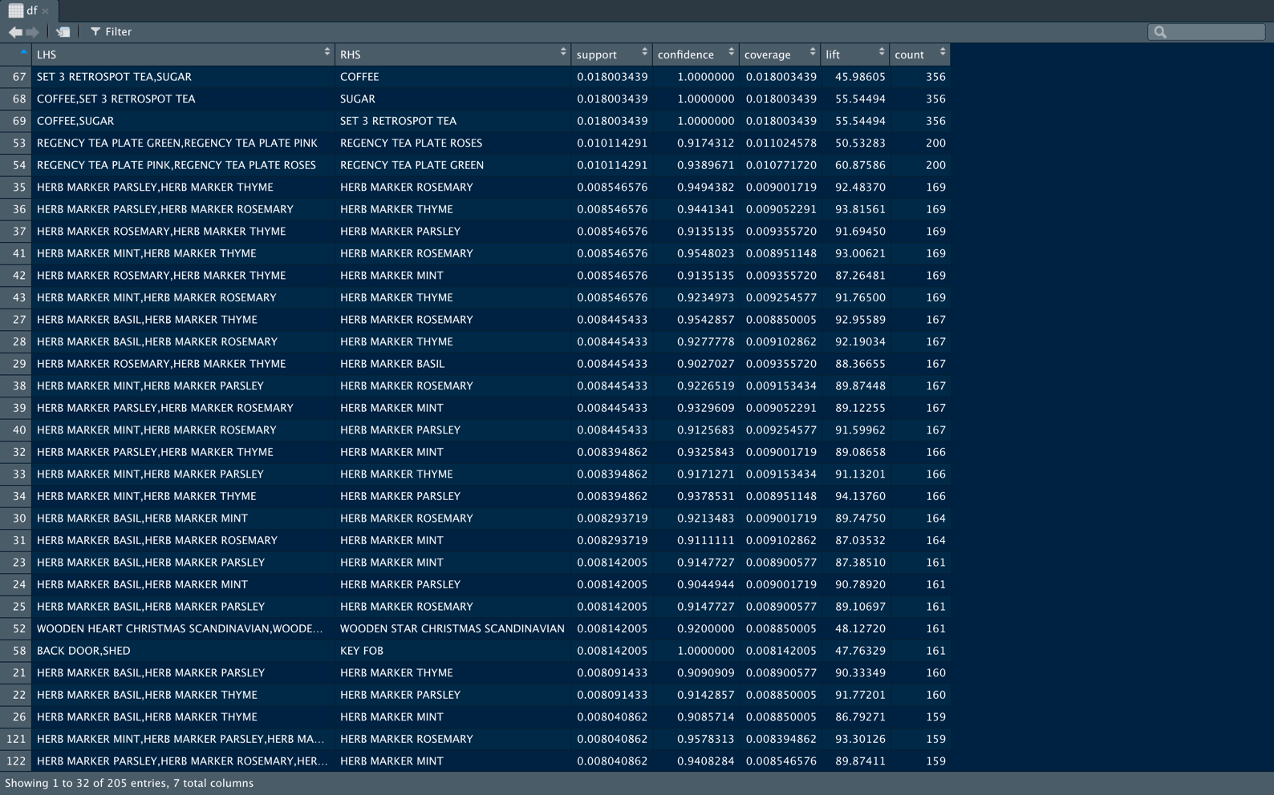

We can see the rule with the highest support is “SET 3 RETROSPOT TEA, SUGAR” going to “COFFEE”. This rule then appears the most in the database because of the most support. Furthermore, this rule has a confidence of 100% meaning every time the LHS was bought, the RHS was also bought. This suggest that coffee, sugar and retrospot tea should all be place together. The lift of this rule is 45.99 indicates a large positive correlation between the LHS items and the RHS items and indicates that the items are most likely to be bought together. Furthermore, looking at rule 41, “HERB MARKER MINT, HERB MARKER THYME” goes to “HERB MARKER ROSEMARY” has an even higher lift of 93.00 suggesting an even higher positive correlation and the LHS items and the RHS items are most likely going to be bought together. These rules would be expected in the real world, usually people buy sugar with their coffee and also when people buy herb markers, they tend to buy multiple since they are most likely growing multiple herbs not just one in a garden. In addition to just inspecting the rules, we can use the summary function mentioned before to get a solid overview of the rules.

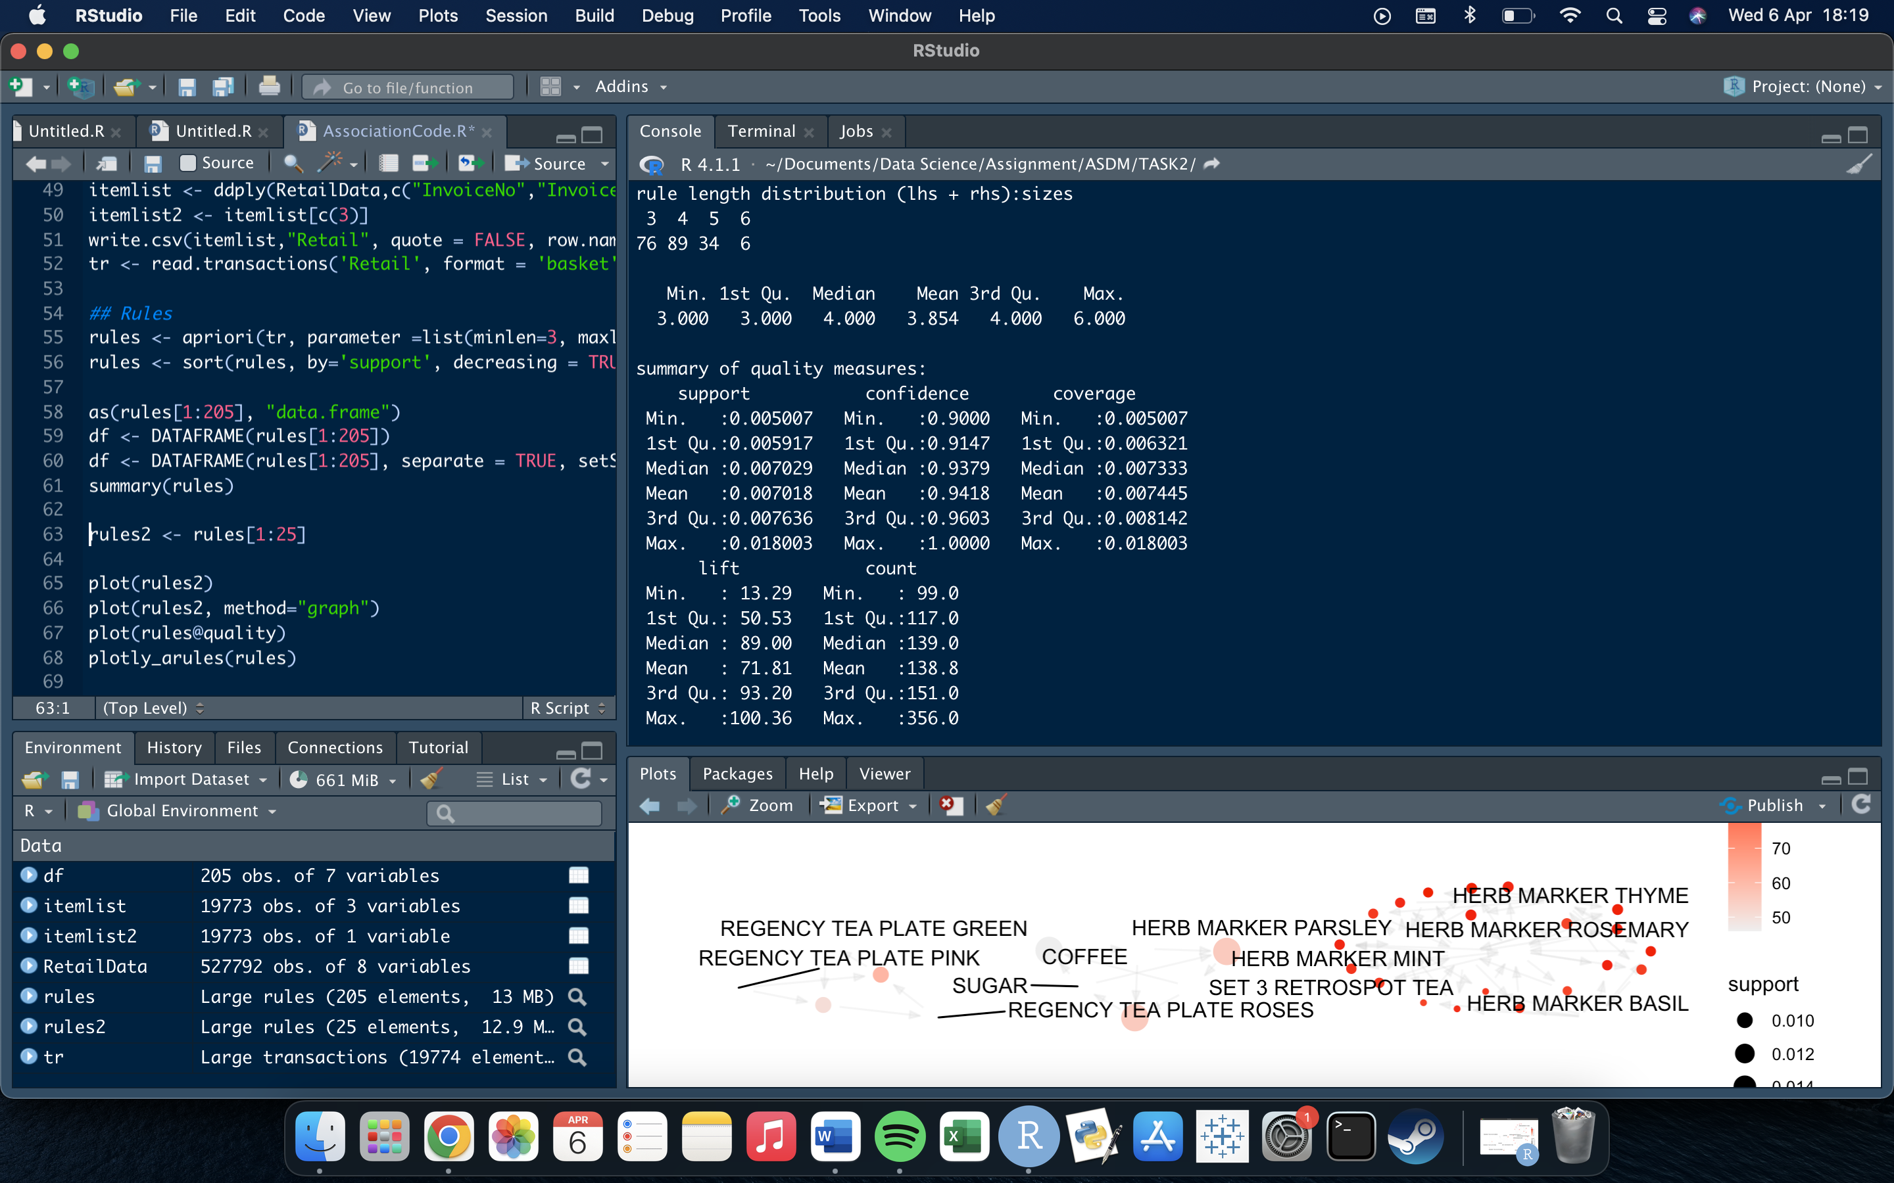

The summary gives us information on the rule length distribution and a breakdown of the variables describing the rules. The rules have mean length of 3.854 meaning most of the rules created have a length of 4. Only 6 rules have a length of 6. These rules are,

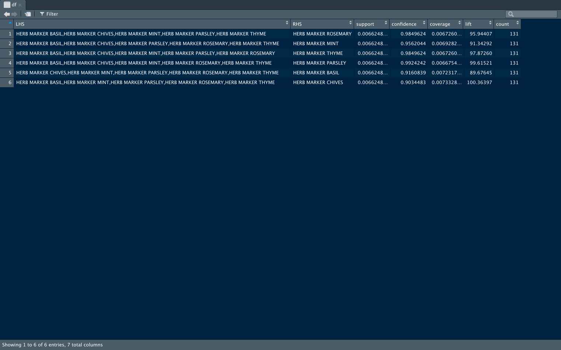

These rules all consist of very similar items, herb markers. Furthermore, to the length, like seen in in the summary figure, a breakdown of the variables. The mean confidence, support and lift is 0.9418, 0.007018 and 71.81 respectively. Meaning, on average, the percentage a rule’s LHS and RHS is bought together is 94.18%. On average these rules appear 0.7018% of the dataset and the rules have a very strong positive correlation. Additionally, to just inspecting the rules, a graphical visualization of the rules can be generated. The code,

rules2 <- rules[1:25]

plot(rules2)

plot(rules2, method="graph")

plot(rules2@quality)

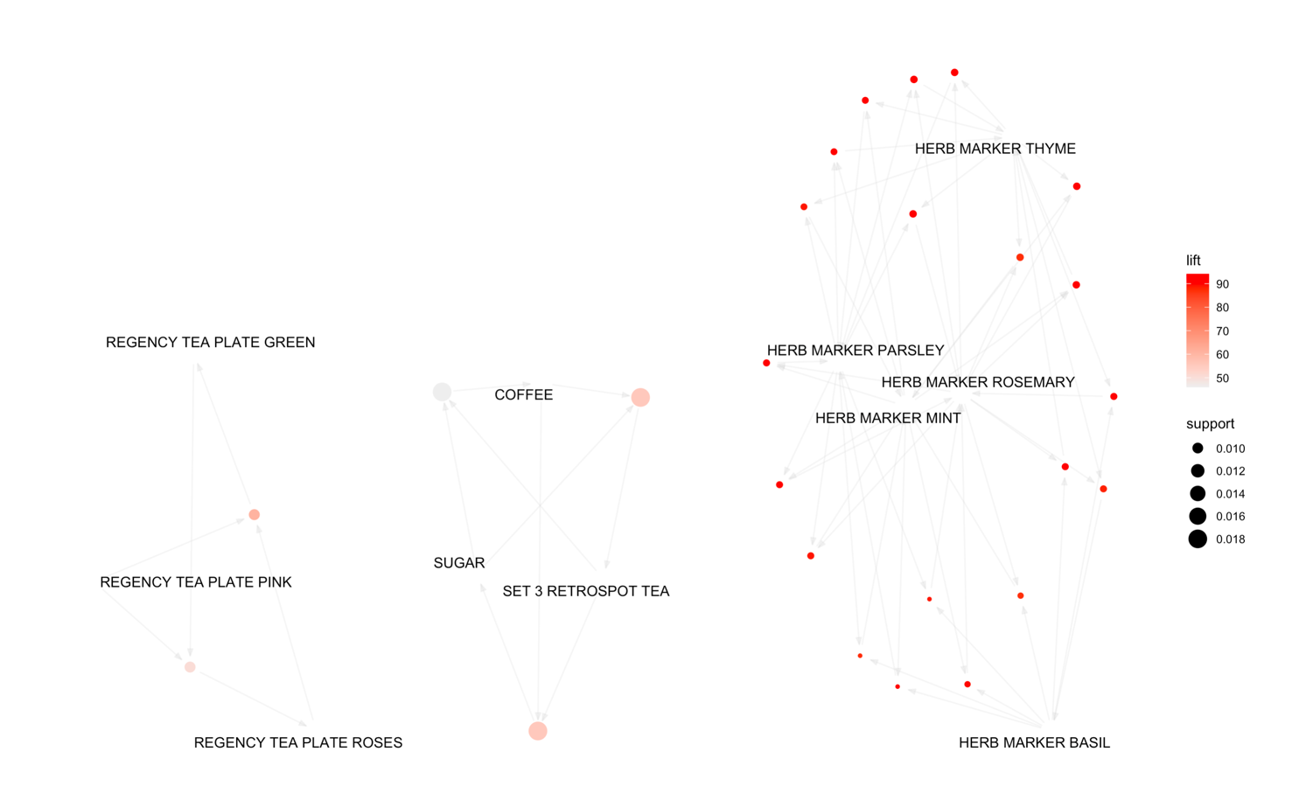

This representation focuses on how the rules are composed of individual items and shows which rules share items. The herb markers all share rules and so does the coffee, sugar and tea. This graph also shows the amount of lift and support. The bigger the circle, the higher the support. Herb markers have large lift and are bought together.

**Implantation In SAS and Results:**

To perform the association mining in SAS, the SAS enterprise miner software is used. As the software is opened, new project is selected where the initial blank workstation will pop up. Firstly, a diagram is created by right clicking on the diagram tab and selecting create diagram. This diagram is then named, and a blank diagram will appear. Next the data is imported. This is done by going to sample in the tool bar and dragging and dropping the file import tab into the blank diagram. The data is then selected by going to import file under the train section in the properties window. The data file was created previous in R Studios by saving the clean prepared data using the write.csv function that saves a data frame as a csv. This csv is the file imported. Furthermore, in the property window under the score tab, the role of the imported data is changed to transaction. Next, the variables are edited by right clicking the file import node and selecting edit variables. The variables are changed like below to the correct roles.

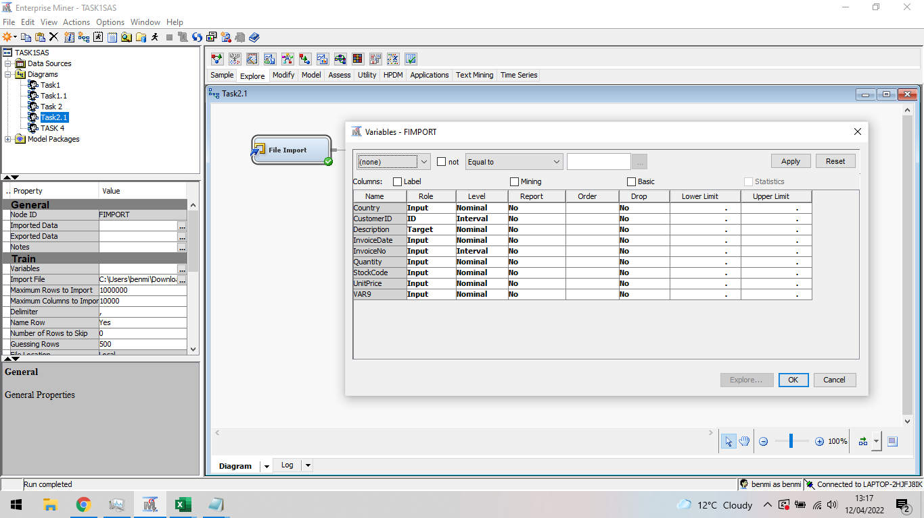

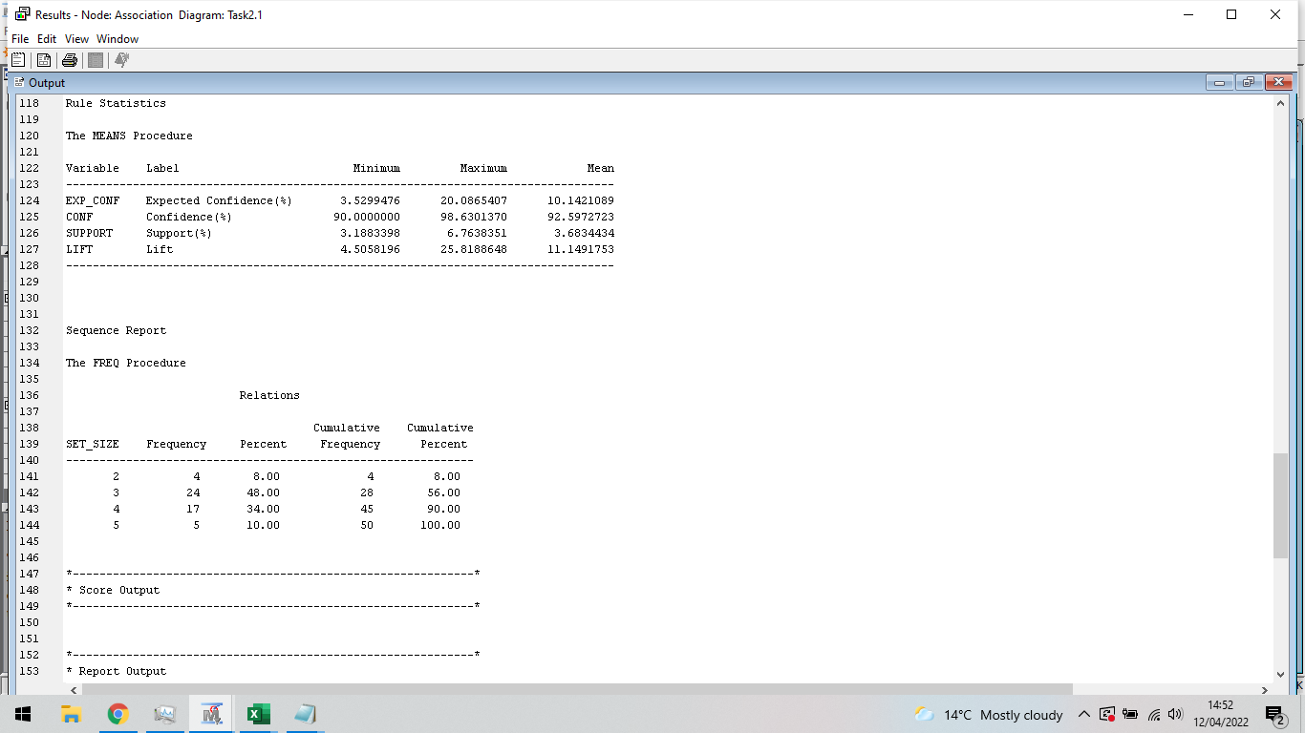

As it can be seen in the figure, a breakdown of the rules can be seen including the means. There are 4 rules that are length 2, 24 rules that are length 3, 17 rules that are length 4 and finally 5 that are length 5. The mean support for these rules is 3.68 and the mean confidence is 92.60. Therefore, the mean frequency of the rules in the dataset are 3.68% and on average, the percentage a rule’s LHS and RHS is bought together is 92.60%. In addition, the Rule link graph can be observed.

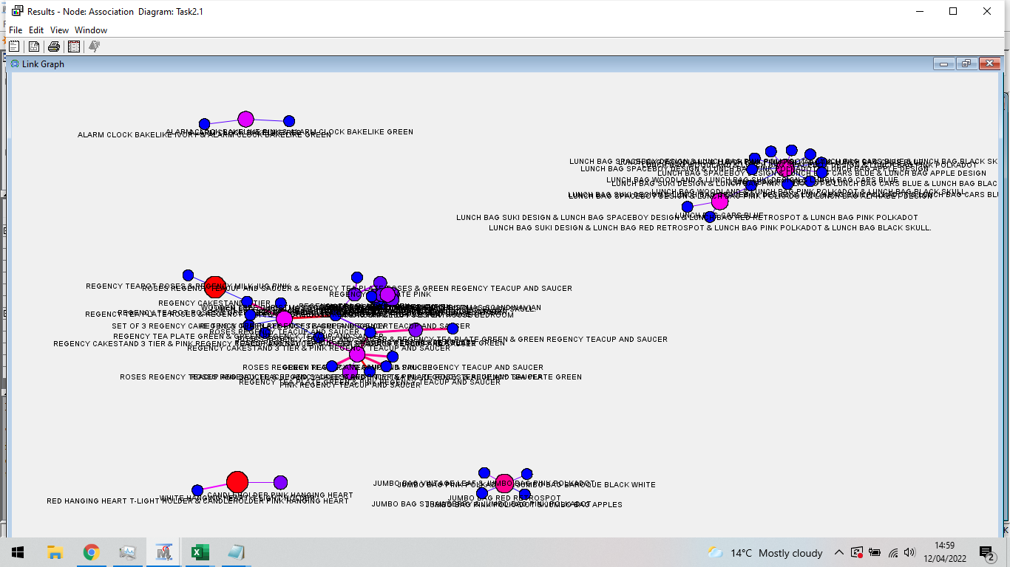

This representation focuses on how the rules are composed of individual items and shows which rules share items. This link graph is extremely cluttered due to the large number of items sharing the same rules. Zooming into one cluster of links,

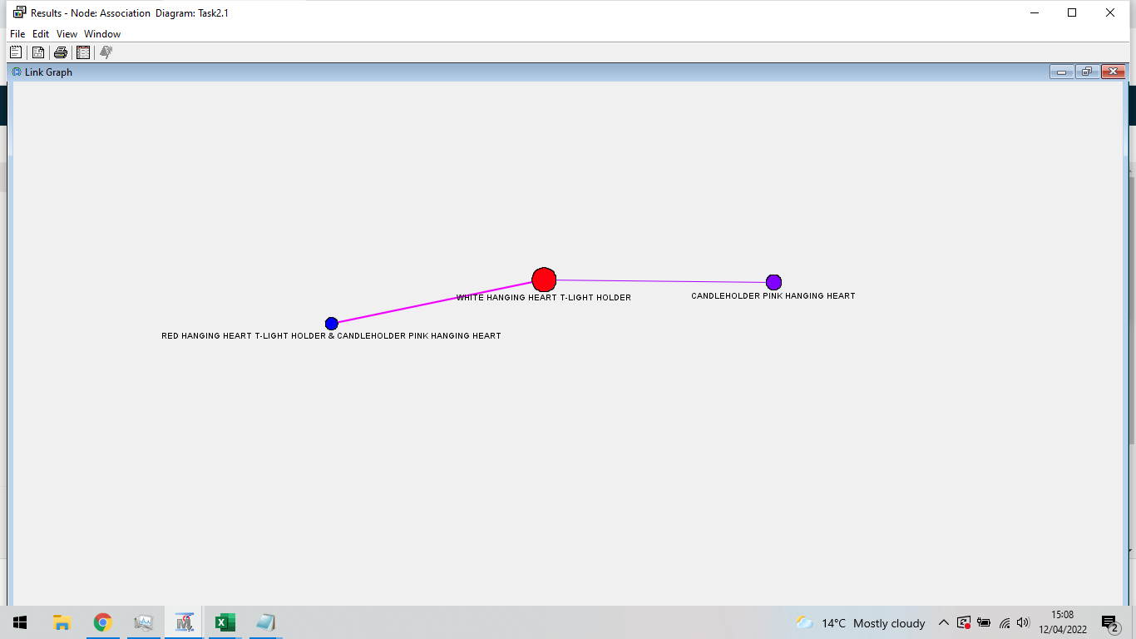

One big support item is the white hanging heart, the big red dot, this is most likely down to it high frequency inn the data. As it can be seen, all the items in the figure that share the rules all have similar descriptions. All the items are hanging hearts. This looks promising for the association since these items would most likely been bought together an associated together. Additionally, looking at the rules table which include the 50 observable rules, the highest supporting rule is the “PINK REGENCY TEACUP AND SAUCER” > “GREEN REGENCY TEACUP AND SAUCER”.

**Conclusion:**

To conclude in this task, association rule mining and in particular the apripori association method was used to find relationship in a market basket dataset. Association rule mining is an unsupervised learning technique. When an algorithm attempts to learn without the assistance of a training set, this is known as unsupervised learning. The association rule is a descriptive method, not a predictive one, and it's widely employed in large datasets to find interesting and previously unknown correlations. Relationships are frequently portrayed as rules. In the R studios implantation, a total of 205 rules with a mean length of 3.85 was produced. The mean confidence, support and lift is 0.9418, 0.007018 and 71.81 respectively. Meaning, on average, the percentage a rule’s LHS and RHS is bought together is 94.18%. On average these rules appear 0.7018% of the dataset and the rules have a very strong positive correlation. In addition, a link graph was produced to visualise the rules and relationships. This representation focuses on how the rules are composed of individual items and shows which rules share items. The herb markers all share rules and so does the coffee, sugar and tea. Furthermore, the association was performed in SAS. In SAS produced a lot more rules compare to R studios and produced a link graph extremely more cluttered with more relationships between the items. Out of the 50 observed rules, there are 4 rules that are length 2, 24 rules that are length 3, 17 rules that are length 4 and finally 5 that are length 5. The mean support for these rules is 3.68 and the mean confidence is 92.60. Therefore, the mean frequency of the rules in the dataset are 3.68% and on average, the percentage a rule’s LHS and RHS is bought together is 92.60%. This difference was most likely the difference in initial parameter due to implantation parameter not being able to perfectly match. In SAS, Additionally, looking at the rules table which include the 50 observable rules, the highest supporting rule is the “PINK REGENCY TEACUP AND SAUCER” > “GREEN REGENCY TEACUP AND SAUCER”.

**Section 3: Data Mining by Clustering**

**Introduction:**

Clustering is an unsupervised technique, which means the classifier does not need any training data to understand how to group. It is the process of dividing a collection of data into a set of useful subclasses. A common trait is shared by all the data in the subclass. It aids in the user's understanding of a data set's natural grouping or structure. Clustering, on the other hand, can be considered as subjective. Clustering can be used as a stand-alone tool to get insight into data distribution or as a pre-processing step before other algorithms are applied. Clustering has uses in libraries, where books are grouped together, and city planning, where buildings are grouped together. The K-Mean clustering algorithm will be employed in this work. The data set used in on different wines created from 3 cultivars. The objectives for this task include,

* Import the data in R studios and prepare the data. This include checking for any missing values and ensuring the data is in the correct format. This objective will be completed in R studios using packages like skimr. Furthermore, the data will be normalised or scaled for the use of the k means clustering later.
* Next the clustering analysis on the wine data is going to be completed in R studios to hopefully find which wine are created in the different cultivars. The clustering used in this task will be K-means cluttering. This objective will include graphs such as a cluster hagiarchy graph and a cluster plot. During this objective the best number of clusters will be investigated however this should be 3 for the 3 cultivars.
* The clustering next will be completed on SAS Using the same pre processed data. The data will be imported, and the same clustering anaylsis will be performed.

**Literature Review:**

K means is the best algorithm for separating large sets of data into homogenous groups. It is well suited. However, this paper explores k-means which is an extension on k-means allowing it to explore dataset with categorical data. The means of the clusters are replaced by modes. The k modes were tested on a widely known disease data set and performed well. The algorithm was found to be scalable in the number of clusters but also the number of records (Huang).

a paper explores the k mean clustering algorithm. Cluster analysis categorises items based on data that describes the objects or their relationships. The idea is for objects in one group to be comparable to one another while being unique from those in other groups. The bigger the difference, the better. It was found that the k means has two limitations. Firstly, being computationally expensive because each iteration requires multiple distance calculations of each data point from all centroids, and secondly, the final cluster results are significantly dependent on what starting centroids are chosen (Aggarwal , 2012).

paper where standardisation is introduced to the k means algorithm. In the paper 3 standardisation algorithms were explored, z score, min max and decimal scaling methods. It was found that the z score performed better compared to the other two methods. The z score method was more effective and more efficient (Standardization and Its Effects on K-Means Clustering Algorithm, 2013).

Another paper explores an improved k-means clustering algorithm. A drawback with the k-means method is the accuracy therefore Improvements to the k-mean clustering technique were suggested. These improvements included the ability to automatically define the number of clusters and assign the needed amount to unclustered locations. The suggested change will increase accuracy and shorten clustering time for objects assigned to the cluster (Bansal & Sharma , 2017).

**Data Preparation:**

The dataset contains results from a chemical examination of wines grown in the same region of Italy but from three distinct varieties. 13 components detected in each of the three varieties of wines was established by the analysis. The dataset contains 178 rows and 13 columns. The data is imported into R studios using the read.csv function. Once the data is imported, a skim on the data can be performed using the skimr package which gives the number of missing values in the data. This function returns zero missing data therefore no rows will need removed. The 13 attributes include,

* Alcohol
* Malic acid
* Ash
* Alkalinity of ash
* Magnesium
* Total phenols
* Flavonoids
* Nonflavonoid phenols
* Proanthocyanins
* Colour intensity
* Hue
* OD280/OD315 of diluted wines
* Proline

These 13 attributes of the wine all consist of continuous data and all different compounds found in the wines under analysis. Finally for the preparation of the data, the component valued are scaled for the K-means clustering later. This scaling is performed using the scale function found originally in R Studios. All the data is centred to same point.

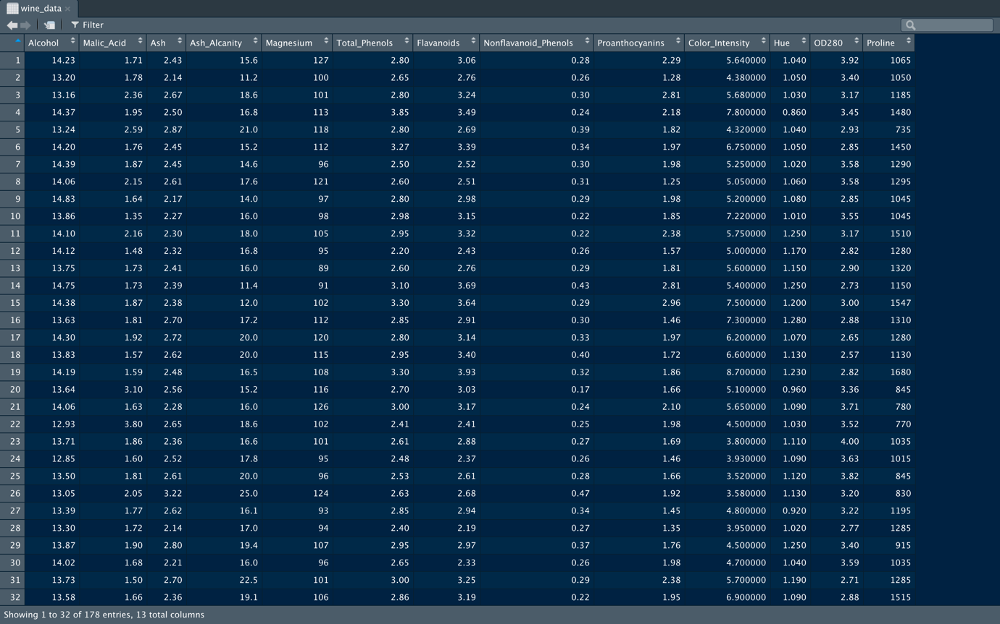

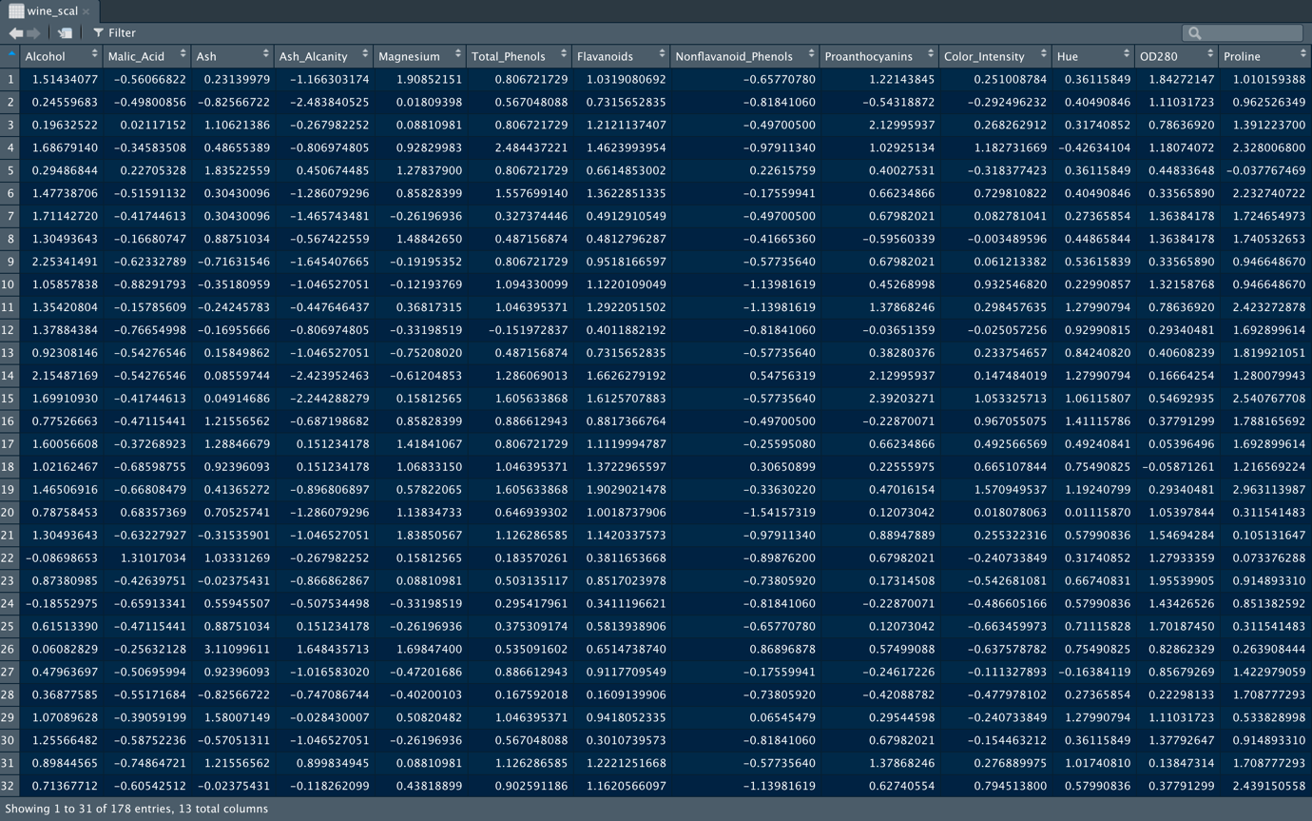

**Implementation in R and Results:**

**Packages:**

The packages used are

* Dplyr – This package is used for data manipulation. Used to drop rows and columns
* Skimr – Using the R package skimr, you can easily show summary statistics.
* ClusterR – Clustering techniques based on centroid (k-means, mini-batch-k-means, k-medoids) and distribution (GMM) are included in the ClusterR package.
* Factoextra – Provides some simple routines for extracting and visualising the results of data analysis. It also includes utilities for reducing various clustering analysis procedures, as well as data visualization using 'ggplot2'.

**Clustering:**

Firstly, the 4 packages above are imported. This is completed using the library function after they have all been downloaded using the install.packages function. The following code to import the packages are below,

library(dplyr)

library(cluster)

library(skimr)

library(factoextra)

Next the working directory is set and the data is inputted into R studios using the write.csv function mentioned in the data reprocessing section. The code for this step is below,

setwd("/Users/ben/Documents/Data Science/Assignment/ASDM/TASK3")

wine_data <- read.csv("wine-clustering.csv")

After this, the wine data is scaled to ensure all the data has the same scaling/centre. The code for this step is below,

wine_scal <- scale(wine_data)

Before, the k-mean clustering can be done, the correct number of clusters need to be know, this can be done by looking at the total within of sum of square values when the number of clusters are increased. This can be completed using the fviz_nbclust from the factoextra package. This plots the clusters vs error plot. The code and plot can be seen below,

fviz_nbclust(wine_data, kmeans, method = "wss")

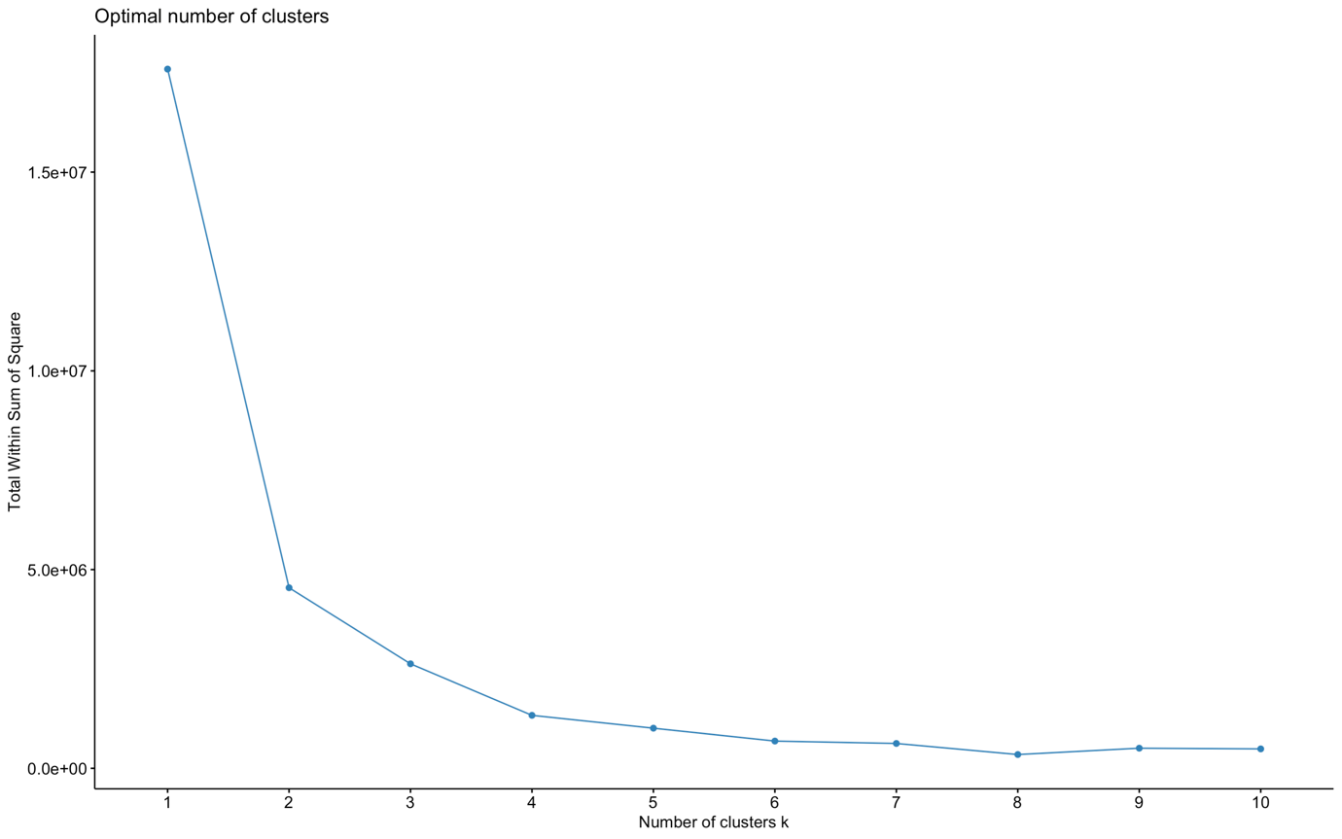

The correct number of clusters can be deciding by looking at the elbow looking turning the graph. Where the line starts to curve from point 2 and point 3 suggest the most optimal cluster is around these points. Cluster number 3 would be most optimal since there is minimal change in the error form cluster 3 to 4 suggesting it won’t have a big effect. The number of clusters chosen is 3.

Now the clusters are selected, the k means can be calculated. This can be done using the cluster package. The kmean function is used to create the clustering data. In the function, the scaled data is selected, the number of clusters and the row the clustering will start. By default, the row start is 1. The set.seed command keeps consistent results. The code and printed results are below,

Set.seed(2599)

wine_km <- kmeans(wine_scal, 3, nstart=1)

print(wine_km)

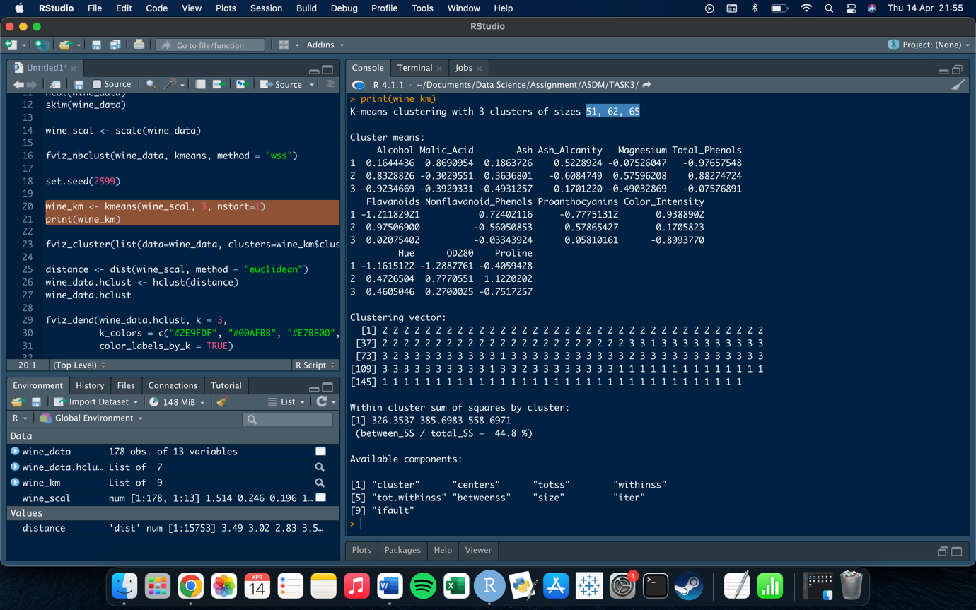

The number of wines separated between the 3 clusters are 51, 62 and 65 respectively. Clustering vector returns which cluster each individual row is allocated to. Furthermore, to the printed results, the k means can be plotted. This can be done using the fviz_cluster function. The code to plot and plot are below,

fviz_cluster(list(data=wine_data, clusters=wine_km$cluster))

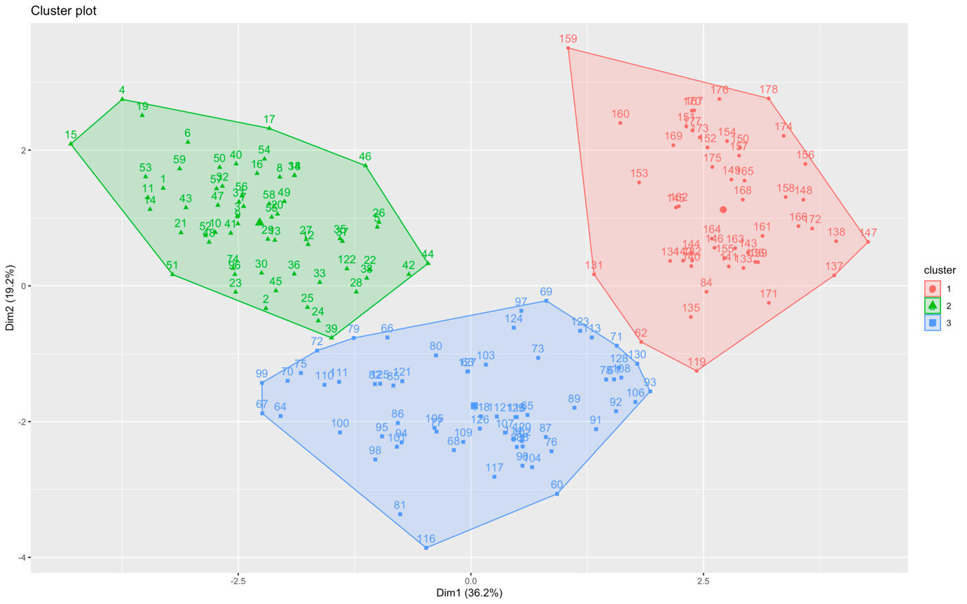

The plot shows 3 clusters. Each cluster are the wines created from the 3 different variants. The plot clearly shows the divide in the wines and shows the grouping to the different variants used. The plot also shows the which wines used different cultivars. Additionally, another cluster plot can be created which introduce the hierarchy of the clusters. This is completed by first calculating the Euclidean distance between the data using the dist function and selecting the Euclidean method. Next, the hclust function on the distance vector is performed. The hclust is a function performs a hierarchical cluster analysis using a set of dissimilarities for the objects being clustered. Finally, the fviz_dend function is used to add colour to the plot and separate the clusters. The resulting plot and used code is below,

distance <- dist(wine_scal, method = "euclidean")

wine_data.hclust <- hclust(distance)

fviz_dend(wine_data.hclust, k = 3,

k_colors = c("#2E9FDF", "#00AFBB", "#E7B800", "#FC4E07"),

color_labels_by_k = TRUE)

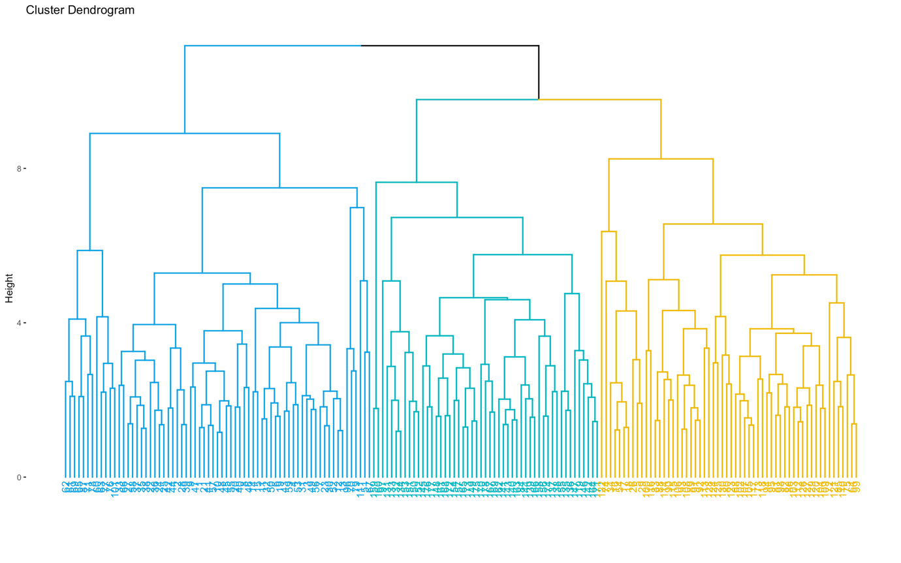

This tree produces 3 separate clusters. The tree has 178 separations.

**Implementation in SAS and Results:**

To perform the clustering mining in SAS, the SAS enterprise miner software is used. As the software is opened, new project is selected where the initial blank workstation will pop up. Firstly, a diagram is created by right clicking on the diagram tab and selecting create diagram. This diagram is then named, and a blank diagram will appear. Next the data is imported. This is done by going to sample in the tool bar and dragging and dropping the file import tab into the blank diagram. The data is then selected by going to import file under the train section in the properties window. The data file was created previous in R Studios by saving the clean prepared data using the write.csv function that saves a data frame as a csv. Next, the edit variables option after right clicking the file import node is selected but for this instance, nothing is altered. The variable should look like below.

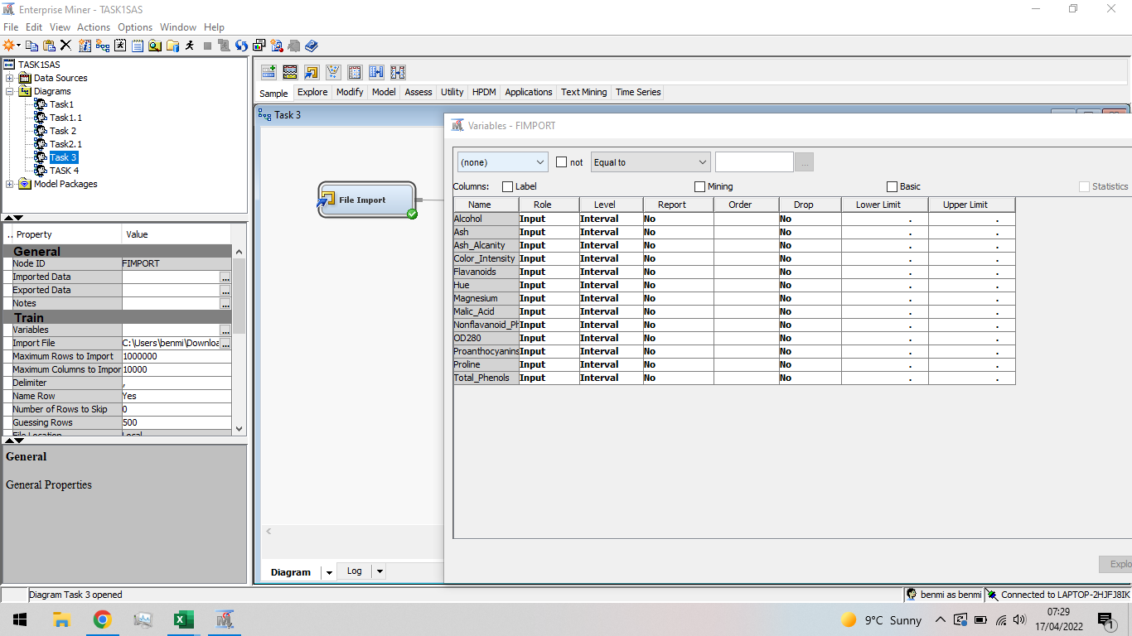

After this, the clustering is performed using the cluster node found under explore tab found in the tool bar. This clustering node is then connected to the file import. Next in the properties window, the number of clusters tab is edited. Firstly, the specification method is changed to user specify and the maximum number of clusters to 3. This is to find the grouping of the 3 cultivars. The process flow and property window can be seen below.

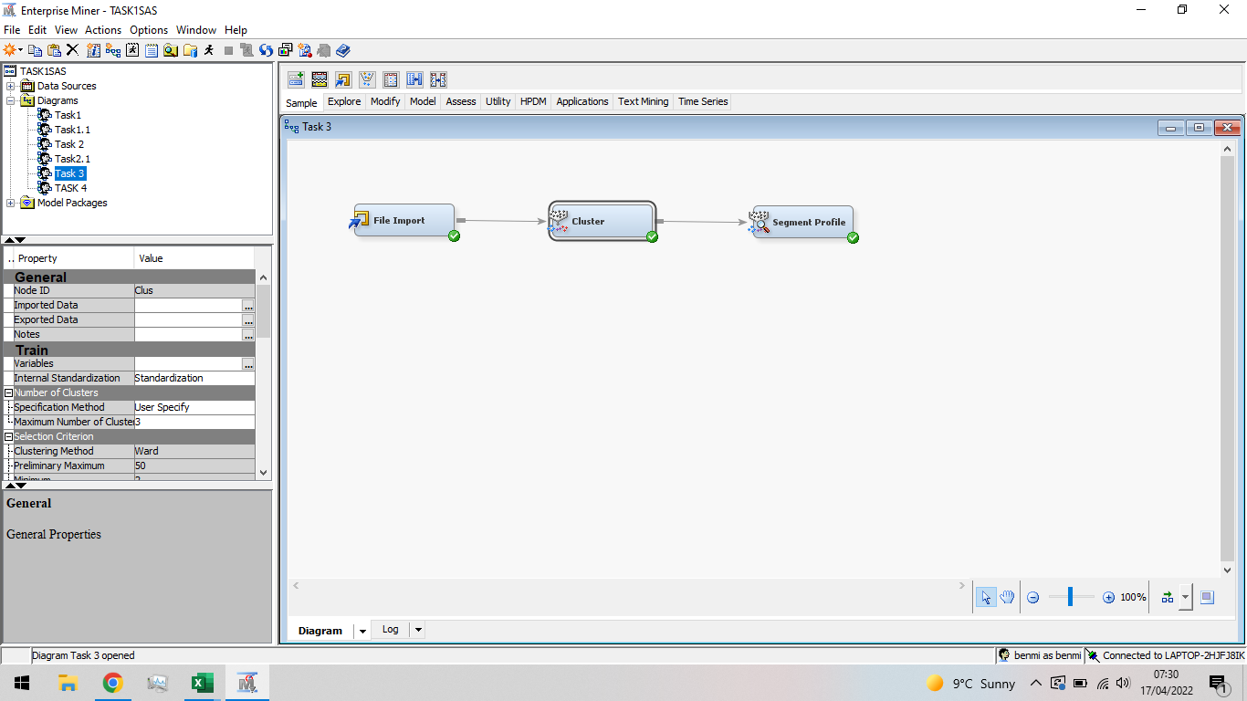

Inspecting the results of this cluster node, the segmentation of the clusters can be analysed. The 3-cluster created are separated by size as 62 65 and 51 wines respectively. The decision tree is used to create the separate clusters.  The Cluster Profile Tree may be used to determine influential input factors, such as which variables are most beneficial for grouping data. The tree produced has 7 nodes and the most influential variables is the colour intensity and flavonoids.

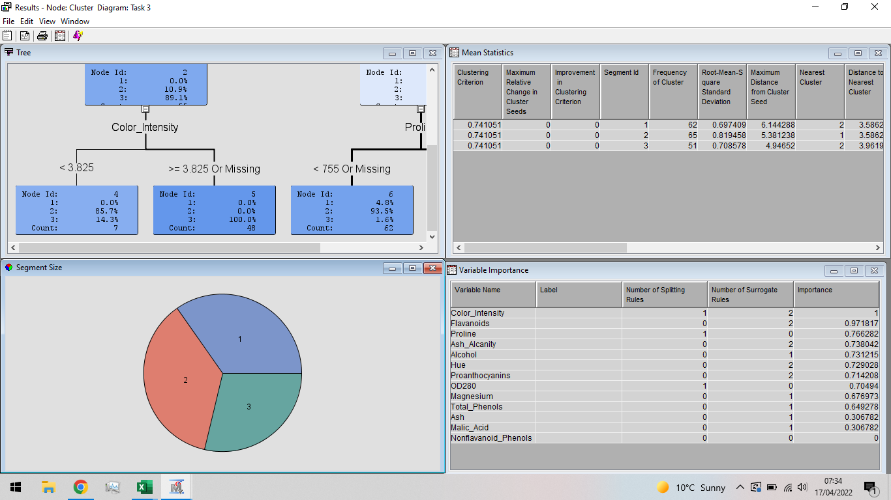



Lastly for the clustering, a segment profile is attached to the cluster node. This segment profile is found under the assess tab in the tool bar. This node is used to explore the clustered data further. Nothing is changed in the property window.

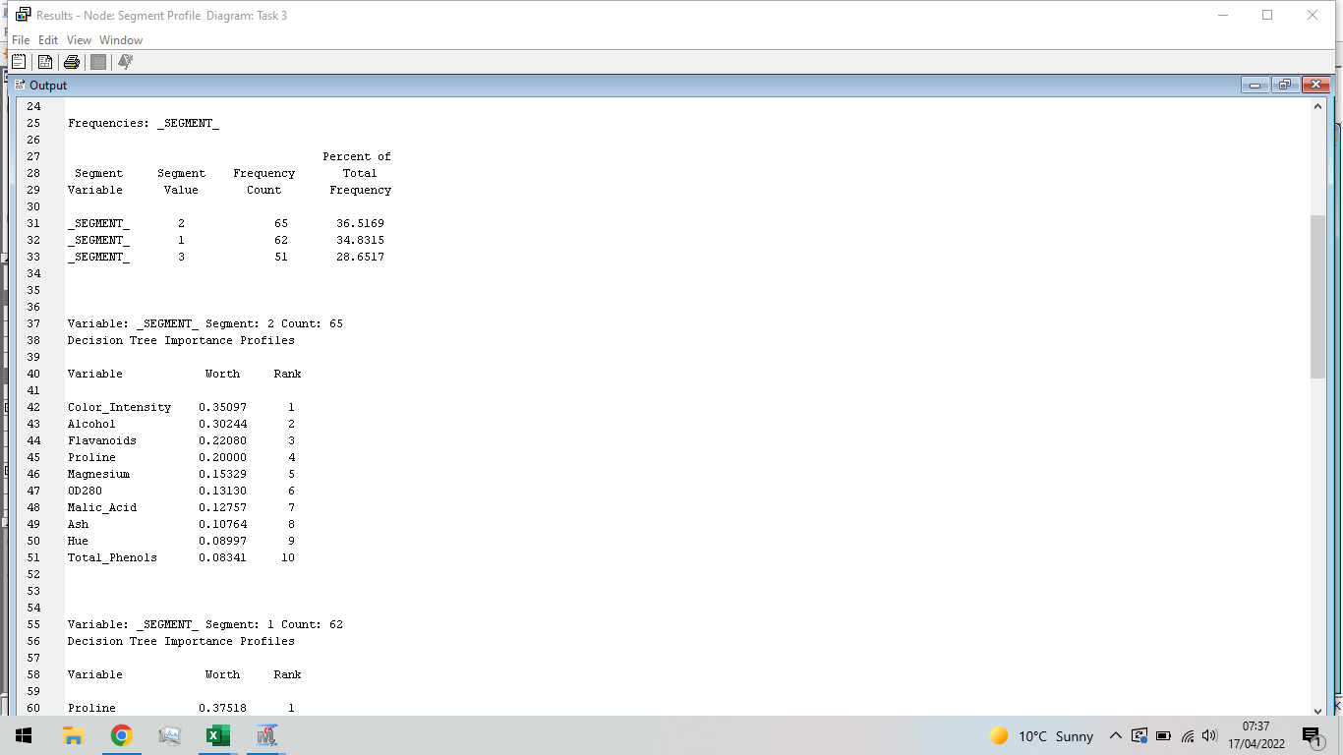

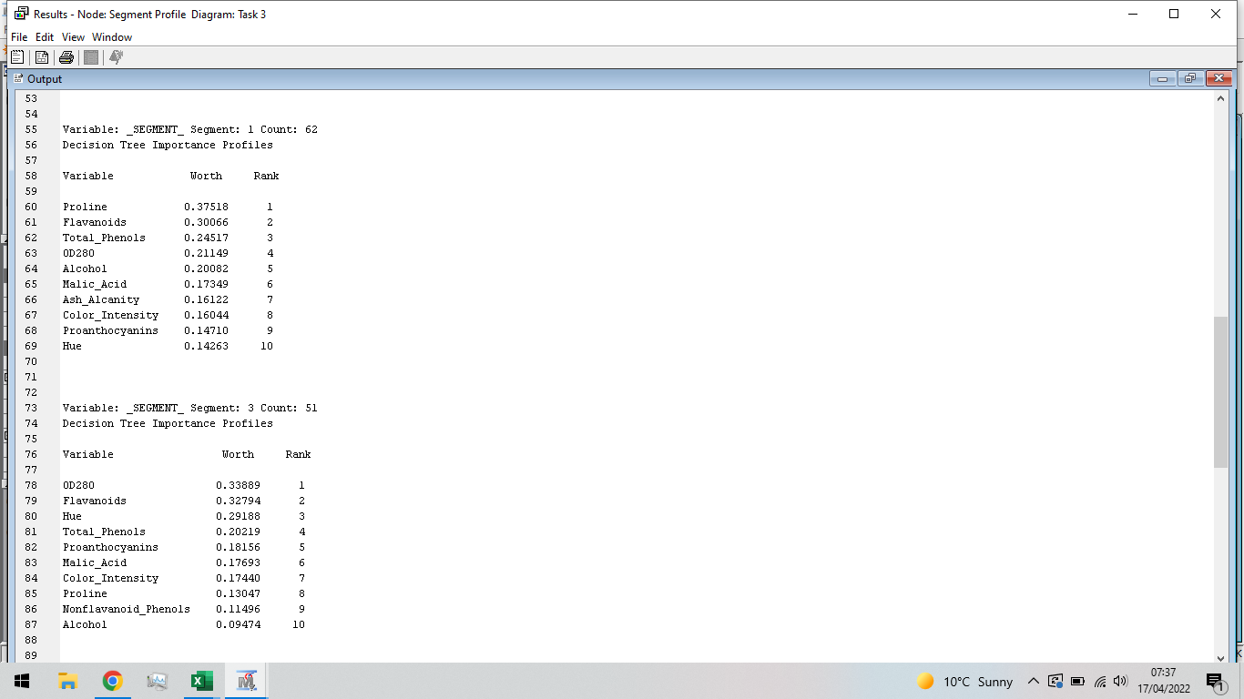

Running the result produces firstly a variable importance profile for each cluster. This is great for observing which variable decides which cluster. Thus, the above two images show the ranking of the variable foo each segment. For segment 1 or the wine created at cultivar 1, the wines are profiled largely by the colour intensity. For segment 2, the wines are profiled largely by the proline and segment 3 by the 0D280 chemical.

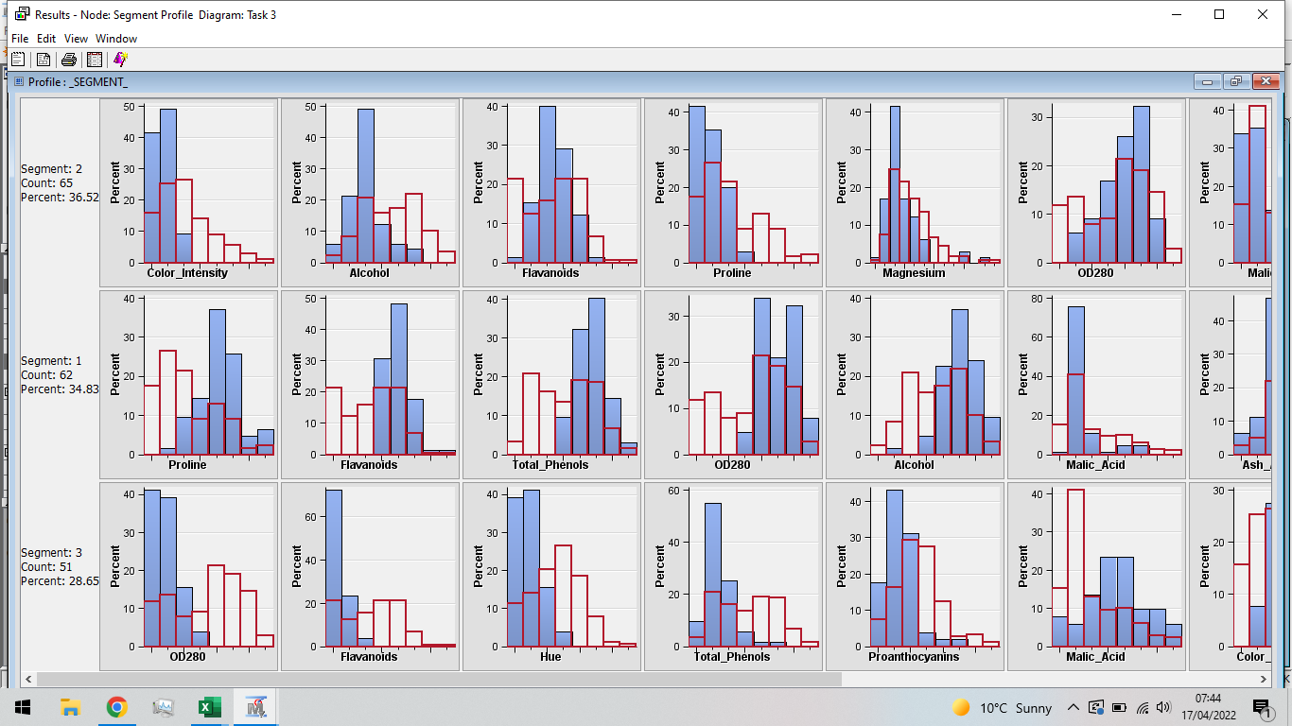

Additionally, for each segment the population density plots for each variable can be compared to the original data set (plot in red). It can be seen for example, in segment 2, the colour intensity is relatively low compared to the original data set. Furthermore, for segment 1, the proline chemical is relatively high compared to the original data set.

**Conclusion:**

To conclude, in this task, clustering analysis has been performed. Clustering is an unsupervised technique, which means the classifier does not need any training data to understand how to group. It is the process of dividing a collection of data into a set of useful subclasses. The K-Mean clustering algorithm will be employed in this work. The data set used in on different wines created from 3 cultivars. This k-means clustering is completed is R-studios and in SAS enterprise miner. In R, 3 clusters are created with a respective size of 51, 62 and 65 respectively. It is found that 3 are the best amount of clustered to be used. Furthermore, in SAS, 3 cluster are created with a respective size of 51, 62 and 65. This is the exact same as the R studios. Furthermore, it is found that for segment 1 or the wine created at cultivar 1, the wines are profiled largely by the colour intensity. For segment 2, the wines are profiled largely by the proline and segment 3 by the 0D280 chemical.

**Section 4: Data Mining by Sentimental Analysis**

**Introduction:**

Sentimental analysis takes an important role in natural language processing or NLP. Natural Language Processing (NLP) is the computerized approach to analysing text that is based on both a set of theories and a set of technologies (Liddy, 2001). The goal of NLP is to replicate human like language processes. Sentimental analysis is a quick growing filed in computer science and is hard to find the root where it all started. It is believed to have started in the 1990’s however the processes only really boomed after 2004 when the web popularized (Mäntylä, Graziotin, & Kuutil). The sort of sentimental analysis used in this task is word clouds. Word clouds are graphical representations of word frequency that give words that appear more frequently in a source text more emphasis (Henderson, Evergreen, & Jarosewich, 2020). The word clouds are going to be used to analyse reviews for hotels accommodations and restaurants to provide an insight what the customers think about them. The objectives for this task are,

* Perform a short and concise literature review to find other application and studies there are around sentimental analysis. What are individuals using this data mining technique for and discover?
* Perform data preparation and exploration steps. This includes exploring the variables included in the data and to find what they are and their significance. Furthermore, in the data preparation, conduct a deep clean of the data including such processes like stemming.
* Perform R studios implementation of the cleaned data from the data preparation step and used word clouds to get and insight on what people are saying about the 30 hotel accommodations studied. For this task, the hotels are all located in Rawai therefore the data needs to be filtered for this location.
* On the 30 Hotels in Rawai, perform text mining in SAS.

**Literature Review:**

Paper explores the different techniques and methodologies used in sentimental analysis. The paper explores these different techniques on various review data and comprises the advantages and disadvantages of each one. Machine learning methods like SVM, NB, Maximum Entropy methods were discussed, and it was discovered they improve the analysis is some ways. Other methods like lexicon and rule-based methods were used (Ganesh & Devika, 2016).

Paper on lexicon based sentimental analysis. proposes a lexicon-based sentiment classification framework that categorises tweets as positive, negative, or neutral. Slangs used in tweets are also detected and scored using the suggested system. The proposed system outperforms the existing systems, according on the comparison results. It has a binary classification accuracy of 92 percent and a multi-class classification accuracy of 87 percent (Asghar, Kundi, Khan, & Ahmad, 2014).

In a paper on sentimental analysis of Arabic. Comments since comments are provided in unorganized forms with typically informal phrases, idioms, and possibly mixed languages, Sentimental analysis for online reviews presents hurdles to researchers. Due to the language's complexity and the small amount of current research available and analysed datasets collected for this purpose. Furthermore, there are additional obstacles in Arabic, in this paper, a very large sentiment lexicon is built for this purpose. The results show that the proposed tool performs very well ( Al-Ayyoub, Essa , & Alsmad, 2015).

**Data preparation:**

The dataset used is on hotel reviews. The data contains 53644 rows and 5 columns. Each row for one individual review and its respective hotel name, hotel id, the review, review date and location.

* Hotel Name: Name of the hotels. Character data.
* Hotel id: The id to the respective hotel in the row. Character data.
* Review: Review given by an individual for the Hotel visited. Character data.
* Review Date: Date the review was given from an individual. Character Data
* Location: The location the Hotel is located. Character Data

The data was imported using a read.csv function that reads csv files and imports them into R studios where the fields/columns are separated using comma characters and records/rows terminated by new names/lines. Next a separate subset was created to start the sentimental analysis. A location “Rawai” was chosen for this section. This choice was done at random and then validated if there were enough hotels in the subset to complete the task. In the Rawai location, there was 39 unique hotels totalling to a data set of 3811 rows and 5 columns. Next a subset was created for each of 30 chosen hotels out of the total 39. These 30 hotels were chosen from random. The hotels could have been sorted from most reviewed to least however, the problem with this is, it introduced alphabetical ordering for hotels with the same frequency of reviews and this could potentially reduce variety. Similar type of hotels in the Rawai would have been selected in bigger datasets. After the location and hotels are selected, the review column alone is extracted. Due to encoding error later, the extracted review column form needed changing to a byte. This was done using the following code,

SpoonfulSugar_Text <- SpoonfulSugar$Review

SpoonfulSugar_Text <- iconv(enc2utf8(SpoonfulSugar_Text),sub="byte")

Now we have got a character data set for each of the hotel review columns that contain every review for that hotel. The next step is to clean these reviews. Starting at looking at the head of the SpoonfulSugar hotel for example,

head(SpoonfulSugar_Text)

[1] "Stopped in after seeing so many great reviews had the tuna salad it was huge\nAnd a peanut protein smoothie\nThen had carrot cake and coffee\nEverything was delicious and it<92>s a cool hipster vibe place so made it more unique"

[2] "We had been to the cafe' many times in the past and it was great. This visit was very disappointing, as the standard and atmosphere had changed. I think even the owners. Our breakfast was average and did not enjoy it at all. A shame...More"

[3] "A kitch place with good and healthy food. No luxury,but nice and cosy. Staff is polite and gives top service! My first choice as a breakfast place!"

[4] "Popped in here for a coffee , cake break and will certainly come back\nEasy parking . Great atmosphere . Friendly staff ."

[5] "The servers so friendly and speak very well English. The food is quite delicious. Coffee is one of the best I<92>ve had in the area."

[6] "We love pancake here was really lovely. We had with tropical fruit like pine apple, banana so good. Staff are speaking English well and friendly."

Looking over these 6 reviews, they still include punctuation, digits, blank spaces and other things like \n. These can be easily removed, using the gsub function. Other words can be removed like the location since this already know from the before selection. The resulting first 6 review now look like this,

[1] "Stopped in after seeing so many great reviews had the tuna salad it was huge And a peanut protein smoothie Then had carrot cake and coffee Everything was delicious and its a cool hipster vibe place so made it more unique"

[2] "We had been to the cafe many times in the past and it was great This visit was very disappointing as the standard and atmosphere had changed I think even the owners Our breakfast was average and did not enjoy it at all A shameMore"

[3] "A kitch place with good and healthy food No luxurybut nice and cosy Staff is polite and gives top service My first choice as a breakfast place"

[4] "Popped in here for a coffee cake break and will certainly come back Easy parking Great atmosphere Friendly staff "

[5] "The servers so friendly and speak very well English The food is quite delicious Coffee is one of the best Ive had in the area"

[6] "We love pancake here was really lovely We had with tropical fruit like pine apple banana so good Staff are speaking English well and friendly"

The 6 reviews look a lot different. However, there are still some things to clean like removing uppercases, removing stop words and stemming the reviews. Stemming is a process changing a word to its original stem like playing will be changed to plays. Stemming introduces problem since it doesn’t take into account context therefore sometimes a word meaning is lost (Miku, 2009). Lemmatization fixes this issue however it won’t be used in this task.

During the sentimental analysis, a package called Corpus will be used to remove any stop words, stem the reviews, strip any white spaces and make all the text to lowercase. The reviews are then ready.

**Data Exploration:**

From the original dataset before pre-processing, there were 5 variables. The 5 variables were, Hotel id, Hotel name, Date of review, Review and location. Using the plyr package which include the Unique function, the amount of unique location can easily be found. There are a total of 25 locations. Furthermore, using the table function, the frequency of the number of reviews for each Location can be discovered and it is found that Patong has the highest number of reviews and Sakhu has the smallest.

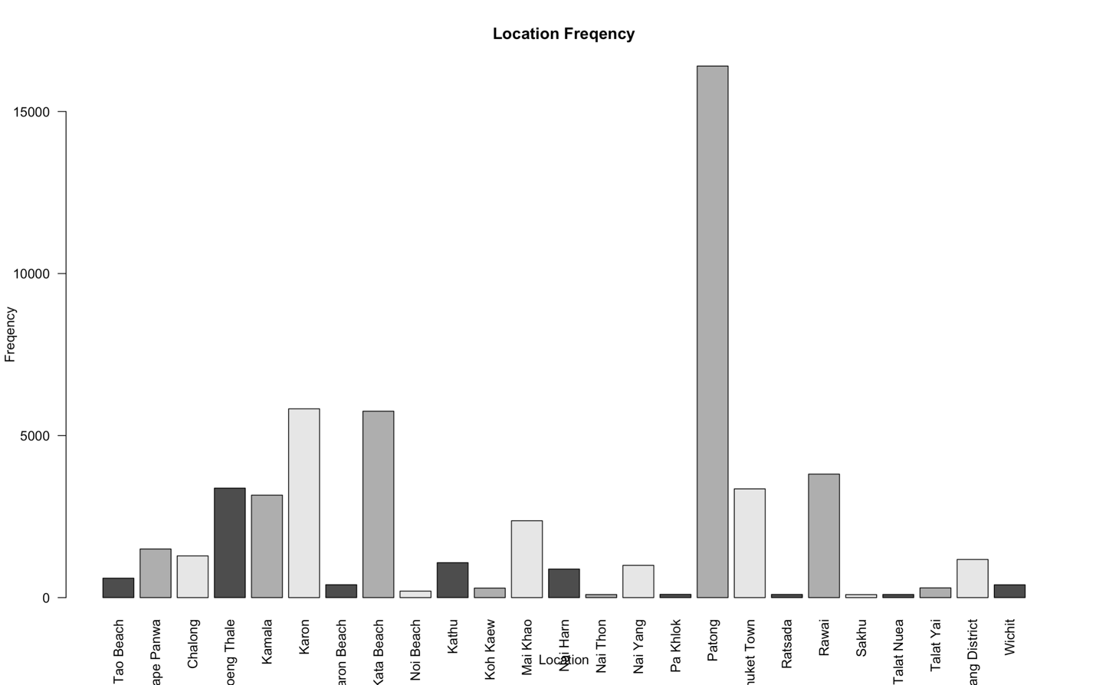

In addition, in these 25 locations, there is 537 different hotels.

**Implementation in R and Results:**

**Packages:**

The packages used are

* tm – Text mining package. This package provides the framework for text mining applications.
* plyr – Package used for data manipulation and used to explore datasets with its extra added functions.
* word cloud –
* Corpus – Corpus is collections of documents containing (natural language) text. Corpus is the main structure that tm uses for storing and manipulating text documents.

**Sentimental Analysis:**

After the dataset was cleaned and each of the 30 hotels had individual subset for each of their respective review column, Text mining on the positivity of each hotel can be measured. Furthermore, a word cloud for the most consistently used words can be plotted. This word cloud gives a quick overlook on the general thought of the hotel and what people have been saying about it.

Firstly, positive and negative lexicon data is loaded and imported into R studios. These datasets are used to compare with the review data to decide if the words used are positive or negative. Then two functions are created, one called corpus and one called sentiment. The corpus continues to clean the text data even further, like mentioned in the data pre-processing section, the function removes stop words, stems the words, strips the white spaces and changes every letter to lowercase.

**Hotel 1: A Spoonful of Sugar -**



Hotel 1, A spoonful of sugar, has a percentage of 88.44% of positive reviews. From words used with a higher frequency of 3, there were a total of 329 positive words and 43 negative words. Some of the most frequent words were great, coffee, place, cake. From the word cloud, this Hotel restaurant is most likely a coffee shop.

**Hotel 2: Green Tamarind Kitchen -**



Hotel 2, Green Tararind Kitchen, has a percentage of 81.11% of positive reviews. From words used with a higher frequency of 3, there were a total of 219 positive words and 51 negative words. Some of the most frequent words were burger, burgers, amazing, fries and place. From the word cloud, this Hotel restaurant is most likely a burger joint. In addition, this word cloud shows not all words were stemmed as burger and burgers appear. This is likely because these words were not included in the stemming dataset.

**Hotel 3: The Family Restaurant -**



Hotel 3, The Family Restaurant, has a percentage of 87.76% of positive reviews. From words used with a higher frequency of 3, there were a total of 258 positive words and 36 negative words. Some of the most frequent words were food, restaurant, staff, great, friendly, prices. From the word cloud, this Hotel restaurant is most likely a restaurant with great service and family atmosphere however expensive. However, most of the most frequent words are word from the Hotel accommodation’s name and don’t give much indication how the place performs. These should be removed.

**Hotel 4: Rossovivo Ristorante Italiano E Pizzeria -**



Hotel 4, Rossovivo Ristorante Italiano E Pizzeria, has a percentage of 89.86% of positive reviews. From words used with a higher frequency of 3, there were a total of 248 positive words and 28 negative words. Some of the most frequent words were food, pasta, service, pizza, Italian and staff. From the word cloud, this Hotel restaurant is most likely a traditional Italian restaurant with great staff service.

**Hotel 5: The Islander -**



Hotel 5, The Islander, has a percentage of 90.71% of positive reviews. From words used with a higher frequency of 3, there were a total of 283 positive words and 29 negative words. Some of the most frequent words were food, great, friendly, English and roast. From the word cloud, this Hotel restaurant is most likely a friendly English fish and chip bar with fantastic staff.

**Hotel 6: Cashew Nuts Food -**



Hotel 6, Cashew Nuts Food, has a percentage of 87.46% of positive reviews. From words used with a higher frequency of 3, there were a total of 293 positive words and 42 negative words. Some of the most frequent words were food, good, great and price. From the word cloud, this Hotel restaurant is most likely a place that serves great food at good prices.

**Hotel 7: Kook Restaurant -**



Hotel 7, Kook Restaurant, has a percentage of 84.27% of positive reviews. From words used with a higher frequency of 3, there were a total of 300 positive words and 56 negative words. Some of the most frequent words were food, good, Italian and tasty. From the word cloud, this Hotel restaurant is most likely a place that serves great Italian food.

**Hotel 8: The Breakfast Hut -**



Hotel 8, The Breakfast Hut, has a percentage of 84.74% of positive reviews. From words used with a higher frequency of 3, there were a total of 272 positive words and 49 negative words. Some of the most frequent words were food, good, breakfast, English and service. From the word cloud, this Hotel restaurant is most likely an English restaurant that serves English breakfasts and has good service.

**Hotel 9: Le Celtique -**



Hotel 9, Le Celtique, has a percentage of 85.86% of positive reviews. From words used with a higher frequency of 3, there were a total of 255 positive words and 42 negative words. Some of the most frequent words were food, good, French, atmosphere and service. From the word cloud, this Hotel restaurant is most likely a French restaurant that serves good food with a decent atmosphere.

**Hotel 10: Rawai View Cafe' & Bar -**



Hotel 10, Rawai View Café’ & Bar, has a percentage of 87.32% of positive reviews. From words used with a higher frequency of 3, there were a total of 303 positive words and 44 negative words. Some of the most frequent words were food, great, view, music and staff. From the word cloud, this Hotel restaurant is most likely a restaurant with an amazing view and great staff.

**Hotel 11: Moo Restaurant -**



Hotel 11, Moo Restaurant, has a percentage of 80.39% of positive reviews. From words used with a higher frequency of 3, there were a total of 246 positive words and 60 negative words. Some of the most frequent words were food, great, cheap and full. From the word cloud, this Hotel restaurant is most likely a restaurant with good cheap food however the place is busy.

**Hotel 12: Sala Mexicali -**



Hotel 12, Sala Mexicali, has a percentage of 80.78% of positive reviews. From words used with a higher frequency of 3, there were a total of 269 positive words and 64 negative words. Some of the most frequent words were food, good, Mexican, staff, and choice. From the word cloud, this Hotel restaurant is most likely a Mexican restaurant with good food with plenty of choices.

**Hotel 13: The Oceanfront Restaurant and Bar at Kata Rocks -**



Hotel 13, The Oceanfront Restaurant and Bar at Kata Rocks, has a percentage of 88.65% of positive reviews. From words used with a higher frequency of 3, there were a total of 289 positive words and 37 negative words. Some of the most frequent words were food, view, kata, sunset, and cocktails. From the word cloud, this Hotel restaurant is most likely a restaurant with gorgeous view of the sunset where you can drink cocktails and eat good food.

**Hotel 14: Il Tagliere da Massimo -**



Hotel 14, Il Tagliere da Massimo, has a percentage of 85.05% of positive reviews. From words used with a higher frequency of 3, there were a total of 256 positive words and 45 negative words. Some of the most frequent words were food, Pizza, Italian, service, and beach. From the word cloud, this Hotel restaurant is most likely an Italian restaurant at the beach that provides good service.

**Hotel 15: Restaurant Treffpunkt -**



Hotel 15, Il Tagliere da Massimo, has a percentage of 80.92% of positive reviews. From words used with a higher frequency of 3, there were a total of 229 positive words and 54 negative words. Some of the most frequent words were food, good, staff, moderately friendly, and German. From the word cloud, this Hotel restaurant is most likely a German restaurant with good food that provide moderately friendly service.

**Hotel 16: Surin Bay Inn Restaurant-**

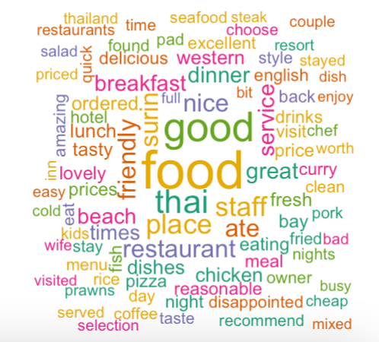

Hotel 16, Surin Bay Inn Restaurant, has a percentage of 80.25% of positive reviews. From words used with a higher frequency of 3, there were a total of 256 positive words and 63 negative words. Some of the most frequent words were food, good, friendly, beach and western. From the word cloud, this Hotel restaurant is most likely a restaurant with good service with western food.

**Hotel 17: Delish Café -**



Hotel 17, Delish Cafe, has a percentage of 87.46% of positive reviews. From words used with a higher frequency of 3, there were a total of 300 positive words and 43 negative words. Some of the most frequent words were food, coffee, cafe, friendly and breakfast. From the word cloud, this Hotel restaurant is most likely a café restaurant that friendly and focuses on breakfasts and warm drinks like coffee and tea.

**Hotel 18: Mando Restaurant & Steakhouse -**

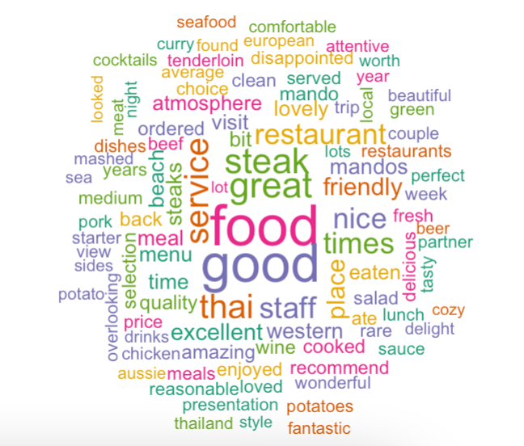

Hotel 18, Mando Restaurant & Steakhouse, has a percentage of 84.37% of positive reviews. From words used with a higher frequency of 3, there were a total of 286 positive words and 53 negative words. Some of the most frequent words were food, good, steak, friendly, staff and service. From the word cloud, this Hotel restaurant is most likely a steak restaurant that friendly and has great service. Also provides good food.

**Hotel 19: Atsumi Raw Café -**



Hotel 19, Atsumi Raw Cafe, has a percentage of 85.21% of positive reviews. From words used with a higher frequency of 3, there were a total of 288 positive words and 50 negative words. Some of the most frequent words were food, raw, cafe, great and healthy. From the word cloud, this Hotel restaurant is most likely a raw sushi restaurant that provides a healthy alternative.

**Hotel 20: Mookdee Seafood -**



Hotel 20, Mookdee Seafood, has a percentage of 75.32% of positive reviews. From words used with a higher frequency of 3, there were a total of 174 positive words and 57 negative words. Some of the most frequent words were food, fresh, seafood, cost and price. From the word cloud, this Hotel restaurant is most likely that provides fresh excellent seafood but at a high price.

**Hotel 21: COCONUT Bar & Restaurant - Rawai Beach -**



Hotel 21, COCONUT Bar & Restaurant - Rawai Beach, has a percentage of 82.7% of positive reviews. From words used with a higher frequency of 3, there were a total of 263 positive words and 55 negative words. Some of the most frequent words were food, great, nice, staff and beach. From the word cloud, this Hotel restaurant is most likely providing good staff service with a beach view.

**Hotel 22: Mamasita Mexican -**



Hotel 22, Mamasita Mexican, has a percentage of 87.58% of positive reviews. From words used with a higher frequency of 3, there were a total of 289 positive words and 41 negative words. Some of the most frequent words were food, great, Mexican, tacos and home. From the word cloud, this Hotel restaurant is most likely a Mexican restaurant that serves delicious food and has a friendly homely feel to the place.

**Hotel 23: Nikitas Beach Restaurant-**



Hotel 23, Nikitas Beach Restaurant has a percentage of 84.47% of positive reviews. From words used with a higher frequency of 3, there were a total of 272 positive words and 50 negative words. Some of the most frequent words were food, great, view, beach and service. From the word cloud, this Hotel restaurant is most likely a beach restaurant that serves decent food with good service.

**Hotel 24: Hooters Phuket -**



Hotel 24, Hooters Phuket, has a percentage of 79.41% of positive reviews. From words used with a higher frequency of 3, there were a total of 243 positive words and 63 negative words. Some of the most frequent words were service, good, food, staff and friendly. From the word cloud, this Hotel restaurant is most likely focusses on service and the experience that the staff provide over the food.

**Hotel 25: Red Chopsticks At Patong -**



Hotel 25, Red Chopsticks At Patong, has a percentage of 82.58% of positive reviews. From words used with a higher frequency of 3, there were a total of 237 positive words and 50 negative words. Some of the most frequent words were service, good, food, menu and affordable. From the word cloud, this Hotel restaurant is most likely a restaurant with plenty of selection that serve a Varity of meals throughout the day.

**Hotel 26: Lucky 13 Sandwich Rawai -**



Hotel 26, Lucky 13 Sandwich Rawai, has a percentage of 79.55% of positive reviews. From words used with a higher frequency of 3, there were a total of 245 positive words and 63 negative words. Some of the most frequent words were sandwich, great, food, staff and time. From the word cloud, this Hotel restaurant is most likely a sandwich or sub restaurant that provides good subs/sandwiches in good ordering times.

**Hotel 27: Norbu's Steakhouse -**



Hotel 27, Norbu’s Steakhouse, has a percentage of 81.37% of positive reviews. From words used with a higher frequency of 3, there were a total of 214 positive words and 49 negative words. Some of the most frequent words were service, owner, decor, steak and top. From the word cloud, this Hotel restaurant is most likely a fancy restaurant with great décor. The restaurant probably provides great top of the range food with great service from the owner and staff.

**Hotel 28: Cafe Java -**



Hotel 28, Café Java, has a percentage of 81.07% of positive reviews. From words used with a higher frequency of 3, there were a total of 257 positive words and 60 negative words. Some of the most frequent words were French, good, food, prices and dishes. From the word cloud, this Hotel restaurant is most likely a café restaurant with plenty of selection that serves multiple dishes however at a costly price.

**Hotel 29: Bon Island Restaurant -**



Hotel 29, Bon Island Restaurant, has a percentage of 85.86% of positive reviews. From words used with a higher frequency of 3, there were a total of 249 positive words and 41 negative words. Some of the most frequent words were island, boat, beach and wonderful. From the word cloud, this Hotel restaurant is most likely a restaurant that provides a great boat experience with multiple activities.

**Hotel 30: Khun Pha -**



Hotel 30, Khun Pha, has a percentage of 70.59% of positive reviews. From words used with a higher frequency of 3, there were a total of 144 positive words and 60 negative words. Some of the most frequent words were fresh, seafood and market. From the word cloud, this Hotel restaurant is most likely a seafood restaurant that provides fresh food however it also includes a chaotic market.

Most of the accommodation in the chosen Rawai location were positive. Most of the created word clouds had more than 80% of positive reviews. On average out of the 30 hotels, the average percentage of positive reviews were, 83.73% and the mean positive and negative words were, 259 and 49 respectively. There were on average around 5 times more positives words included in the reviews than negative. The most positive review out of the 30 hotels was hotel 5 with 90.71% of positive reviews and the most negative was hotel 30 with 70.59% of positive reviews. A consistent word that reappeared in all the reviews was food, which would be removed if the task was done again since it’s obvious and not needed. It takes up a large part of the word cloud. The word clouds are a great quick representation of the given reviews. Word clouds are quick, engaging and provides the essential information however, longer words can look more important than smaller word which can miss lead your interpretation (ALIDA, 2012).

**Conclusion:**

To conclude, in this task, sentimental analysis was performed on the reviews of 30 hotel accommodations found in the Rawai region. In the R studios implantation where word clouds were used to see the mostly used word in the reviews and how positive they were. Word clouds are graphical representations of word frequency that give words that appear more frequently in a source text more emphasis (Henderson, Evergreen, & Jarosewich, 2020). It is seen that pretty much all the hotels had positive reviews having an average 83.73% of positive words in the review. The best Hotel out of the 30 chosen was hotel 5 and the least positive was hotel 30. Sentimental analysis.

**Shiny Dashboard:**

The task chosen to perform the shiny dashboard is task 3, cluster mining. For this shiny dashboard, the goal is to make an interactable dashboard where the number of clusters or k can be changed resulting in cluster plot and cluster tree diagram to be updated. This was first completed by loading the library, shinydashboard and first creating a blank dashboard. This can be done using the following code,

library(shiny)

library(shinydashboard)

ui <- dashboardPage(

dashboardHeader(),

dashboardSidebar(),

dashboardBody()

)

server <- function(input, output) { }

shinyApp(ui, server)

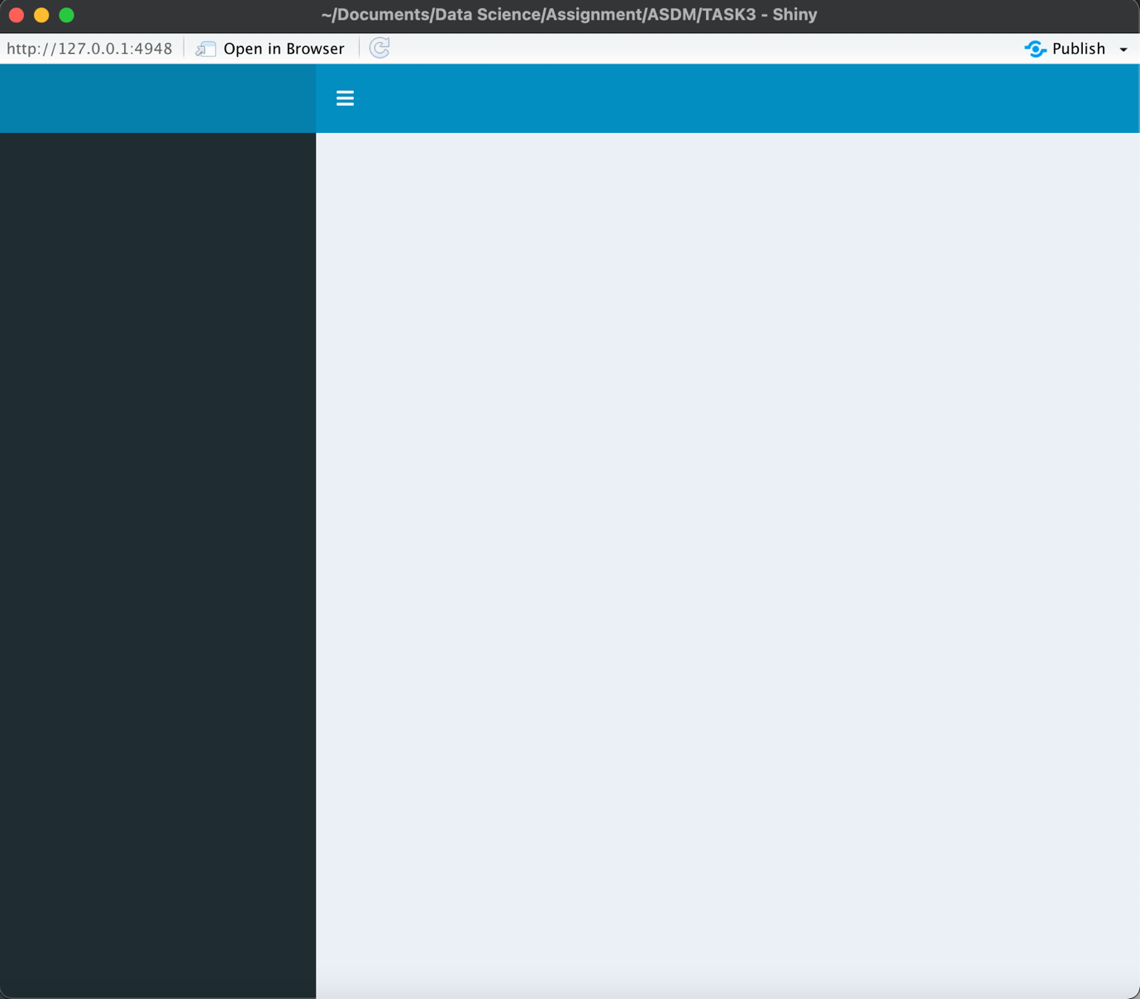

This creates a blank dashboard with no header, sidebar and nothing to occupy the body. This dashboard is obviously ineffective. We'll need to include components that do something. We can include content-containing boxes in the body. Boxes need to put into rows, this is done using the fluidRow function where the boxes can be specified for example if they are going to be a plot or slider. For this instance, we will use two plots and a slider. The slider will control the number of clusters from when k=1 to k=5. The following code creates a dashboard with two plots and a slider.

library(shiny)

library(shinydashboard)

ui <- dashboardPage(

dashboardHeader(title = "Cluster Plots"),

dashboardSidebar(),

dashboardBody(

fluidRow(

box(plotOutput("plot1", height = 300)),

box(plotOutput("plot2", height = 300)),

box(

title = "Controls",

sliderInput("slider", "Number of Clusters:", 1, 5, 3), width = 12

)

)

)

)

server <-function(input, output) {}

shinyApp(ui, server)

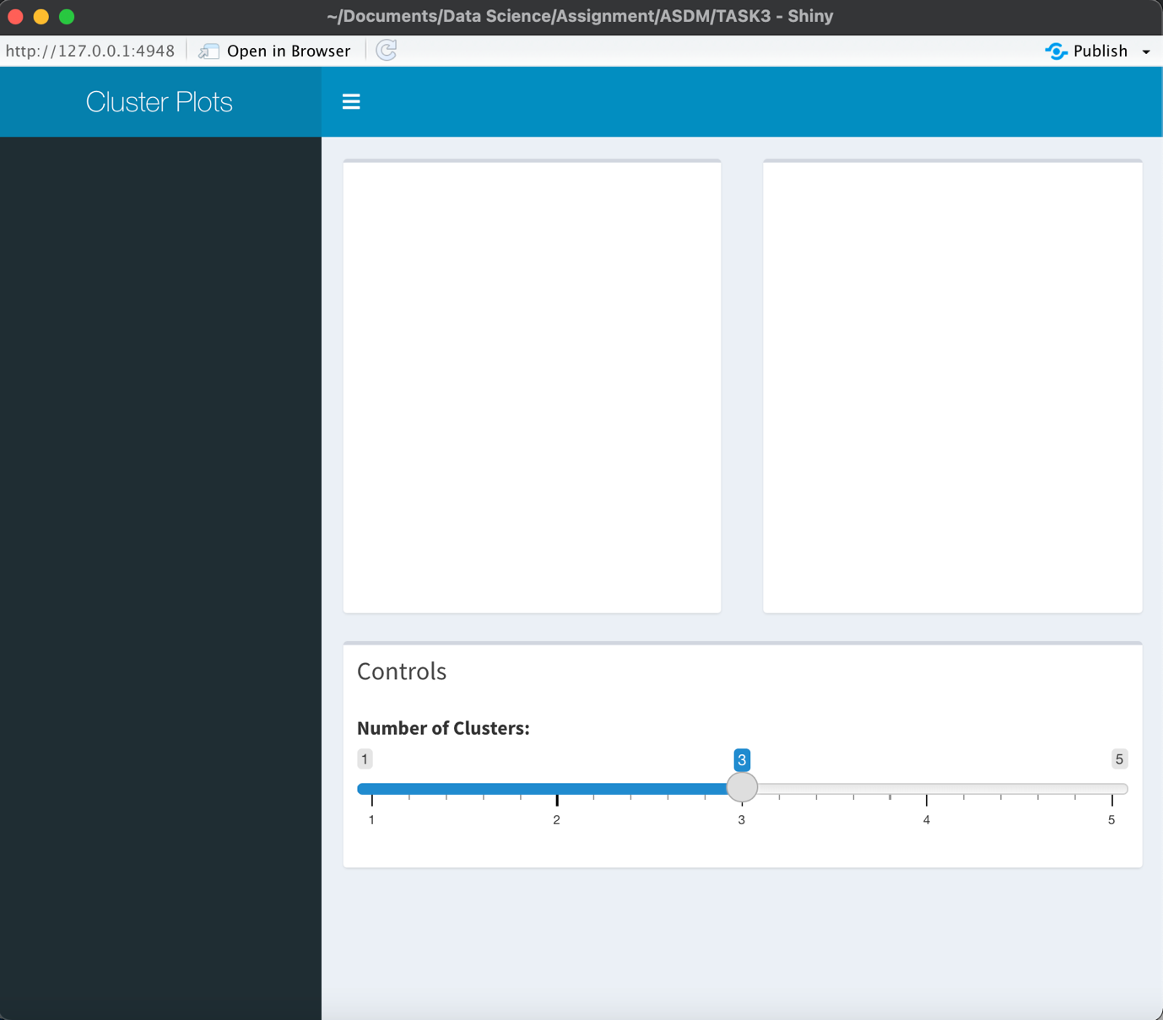

Lastly, the plots connecting to the slider are inputted into the boxes. This is done by rendering the plot as the output in the function command. Furthermore, adding the input as the slider for the value of k. The code and final dashboard is a follows,

library(shiny)

library(shinydashboard)

ui <- dashboardPage(

dashboardHeader(title = "Cluster Plots"),

dashboardSidebar(),

dashboardBody(

fluidRow(

box(plotOutput("plot1", height = 300)),

box(plotOutput("plot2", height = 300)),

box(

title = "Controls",

sliderInput("slider", "Number of Clusters:", 1, 5, 3), width = 12

)

)

)

)

server <- function(input, output) {

set.seed(2599)

output$plot1 <- renderPlot({

wine_km <- kmeans(wine_scal, input$slider, nstart=1)

fviz_cluster(list(data=wine_scal, clusters=wine_km$cluster))

})

output$plot2 <- renderPlot({

fviz_dend(wine_data.hclust, input$slider, color_labels_by_k = TRUE)

})

}

shinyApp(ui, server)

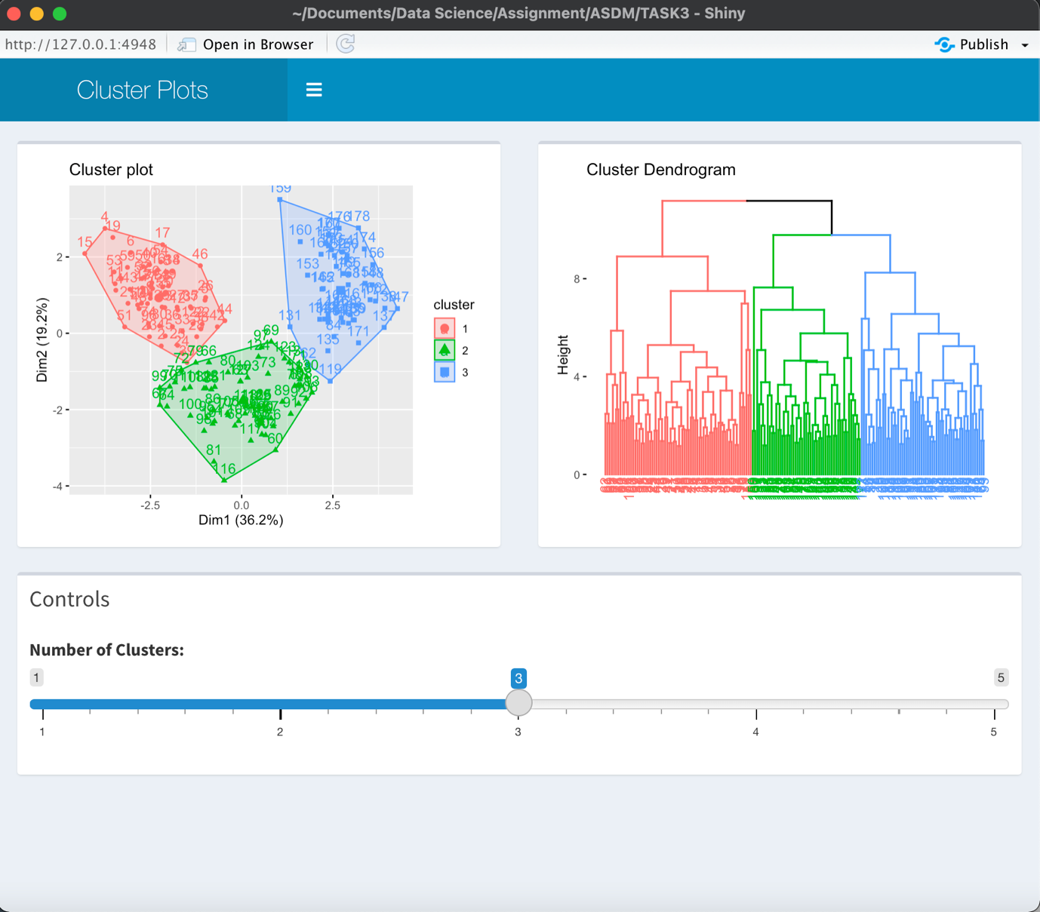

This is with 3 clusters; However the number of clusters can be changed therefore,

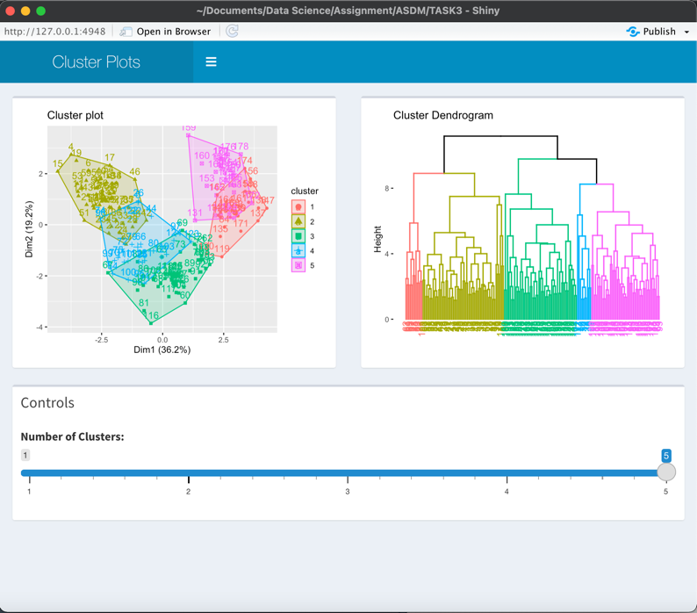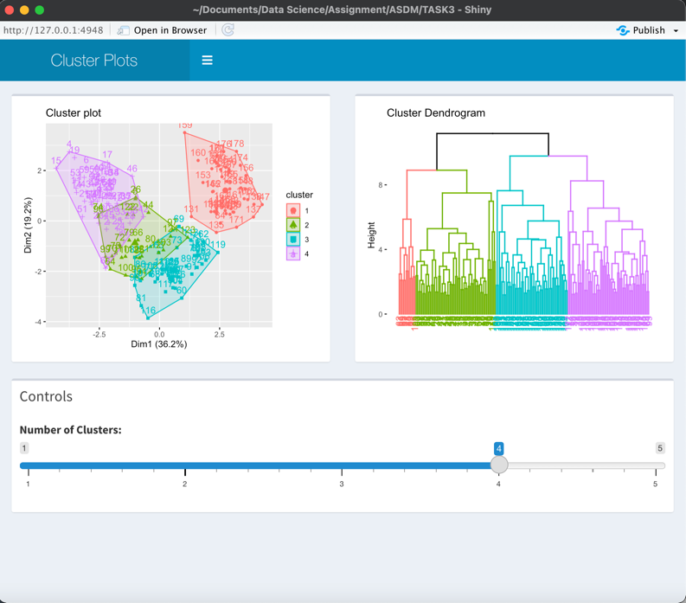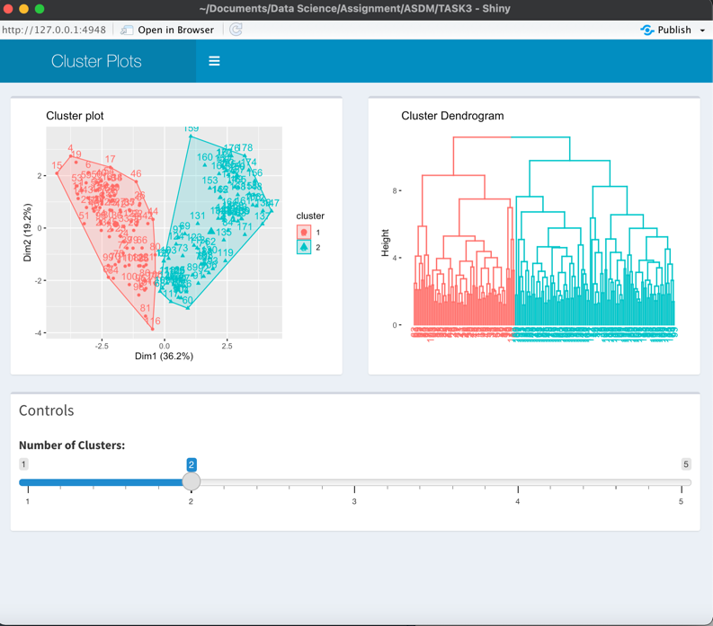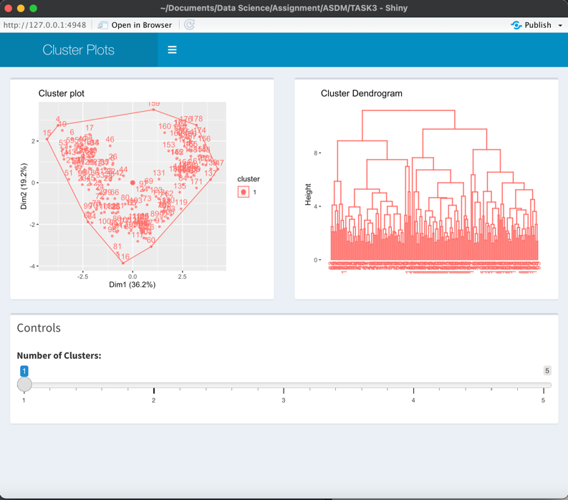

# References:

Al-Ayyoub, M., Essa , S. B., & Alsmad, I. (2015). Lexicon-based sentiment analysis of Arabic tweets. *International Journal of Social Network Mining*, 101-114.

Aggarwal , N. (2012). *A Mid – Point based k-mean Clustering Algorithm for Data mining.* Faridabad: Department Of Computer Science MRCE .

ALIDA. (2012, August 9). *The Pros and Cons of Word Clouds as Visualizations*. Retrieved from ALIDA: https://www.alida.com/the-alida-journal/pros-and-cons-word-clouds-visualizations

Angeline, D. D. (2013). Association Rule Generation for Student Performance Analysis using Apriori Algorithm. *The SIJ Transactions on Computer Science Engineering & its Applications*, 2321-2381.

Application of improved time series Apriori algorithm by frequent itemsets in association rule data mining based on temporal constraint. (n.d.).

Asghar, D. M., Kundi, F., Khan, A., & Ahmad, S. (2014). Lexicon-Based Sentiment Analysis in the Social Web. *journal of basic and applied scietific research*, 238-248.

Bansal , A., & Sharma , M. (2017). ArticlePDF Available Improved K-mean Clustering Algorithm for Prediction Analysis using Classification Technique in Data Mining. *International Journal of Computer Applications*, 35-40.

Friedl, M. A., & Brodley, C. E. (1997). Decision tree classification of land cover from remotely sensed data. *Remote Sensing of Environment*, 399-409.

Ganesh, S. A., & Devika, M. D. (2016). Sentiment Analysis: A Comparative Study on Different Approaches. *Procedia Computer Science*, 44-49.

Henderson, S., Evergreen, S., & Jarosewich, T. (2020, July 21). *Word Cloud*. Retrieved from better evaluation: https://www.betterevaluation.org/en/evaluation-options/wordcloud

Huang, Z. (n.d.). *A Fast Clustering Algorithm to Cluster Very Large Categorical Data Sets in Data Mining.* Canberra : Cooperative Research Centre for Advanced Computational Systems.

Liddy, E. D. (2001). *Natural Language Processing.* Syracuse: CENTER FOR NATURAL LANGUAGE PROCESSING .

Mäntylä, M., Graziotin, D., & Kuutil, M. (n.d.). *The Evolution of Sentiment Analysis - A Review of Research Topics, Venues, and Top Cited Papers.* Institute of Software Technology, University of Stuttgart.

Mandave , P. (2013). Data mining using Association rule based on APRIORI algorithm and improved approach with illustration. *International Journal of Latest Trends in Engineering and Technology*.

Miku. (2009, November 24). *What is the difference between lemmatization vs stemming?* Retrieved from Stack Overflow: https://stackoverflow.com/questions/1787110/what-is-the-difference-between-lemmatization-vs-stemming

Song, Y.-Y., & Lu, Y. (2015). Decision tree methods: applications for classification and prediction. *Shanghai Arch Psychiatry*, 130-135.

Standardization and Its Effects on K-Means Clustering Algorithm. (2013). *Research Journal of Applied Sciences, Engineering and Technology* , 3299-3303.

Sumithra, R., & Paul, S. (2010). Using distributed apriori association rule and classical apriori mining algorithms for grid based knowledge discovery. *2010 Second International conference on Computing*, 1-5.

Turney, P. D. (1995). Cost-Sensitive Classification: Empirical Evaluationof a Hybrid Genetic Decision Tree Induction Algorithm. *Journal of Artificial Intelligence Research 2*, 369-409.

Wang , C., & Zheng , X. (2020). Application of improved time series Apriori algorithm by frequent itemsets in association rule data mining based on temporal constraint. *Evolutionary Intelligence volume 13*, 39-49.

**Appendix:**

**Task 1 R studio script:**

library(party)

library(dplyr)

library(ggplot2)

setwd("/Users/ben/Documents/Data Science/Assignment/ASDM/TASK1")

data <- read.delim("adult.data", sep=",", header=FALSE)

names(data) <- c("age", "workclass","fnlwgt", "education", "educationNo", "martialstatus",

"occupation", "relationship", "race", "sex", "capitalgain", "capitalloss",

"hrsperweek", "nativecountry","salary")

data2 <- data[,c(1:3,5:7,9:15)]

data2[data2 == " ?"] <- "Na"

Missing <- subset(data2, data2 == "Na")

data3 <- data2[!grepl("Na",data2$workclass),]

Missing <- subset(data3, data3 == "Na")

data4 <- data3[!grepl("Na",data3$occupation),]

Missing <- subset(data4, data4 == "Na")

data5 <- data4[!grepl("Na",data4$nativecountry),]

Missing <- subset(data5, data5 == "Na")

write.csv(data5,"Task1_Data.csv", quote = FALSE, row.names = FALSE)

## Tree

data5$salaryF <- as.factor(data5$salary)

str(data5)

set.seed(2599)

pd <- sample(2, nrow(data5),replace=TRUE, prob=c(0.20,0.80))

train <- data5[pd==1,]

validate <- data5[pd==2,]

tree <- ctree (salaryF ~ age + educationNo + capitalgain + capitalloss + hrsperweek, data = train)

tree

plot(tree, type="simple")

tab <- table(predict(tree), train$salaryF)

sum(diag(tab))/sum(tab)

**Task 2 R studio script:**

## Packages and Import of Data

library(arules)

library(tidyverse)

library(plyr)

library(arulesViz)

library(ggplot2)

library(skimr)

setwd("/Users/ben/Documents/Data Science/Assignment/ASDM/TASK2")

RetailData <- read.csv("RetailData.csv", colClasses="factor")

RetailData$InvoiceDate <- format.Date(RetailData$InvoiceDate)

## Remove rows with missing data

nrow(RetailData)

ncol(RetailData)

RetailData <- na.omit(RetailData)

nrow(RetailData)

RetailData <- RetailData[!grepl("C", RetailData$InvoiceNo),]

skim(RetailData)

RetailData$Quantity <- as.numeric(RetailData$Quantity)

Quan <- subset(RetailData, RetailData$Quantity < 0)

##Exploration

RetailData %>% group_by(CustomerID)

RetailData %>% group_by(InvoiceNo)

clear <- c("a","b","c","d","e","f","g","h","i","j","k","l","m","n","o","p",

"q","r","s","t","u","v","w","x","y","z","?","check","CHECK","Dagamed",

"Crushed","crushed ctn","CRUK Commission", "crushed", "crushed boxes",

"cracked", "counted", "code mix up? 84930", "check?","came coded as 20713",

"can't find", "broken", "Breakages", "barcode problem", "Bank Charges",

"AMAZON","amazon","Amazon","amazon adjust", "AMAZON FEE", "Amazon sold sets",

"amazon sales", "Amazon Adjustment", "adjust", "adjustment","Adjustment",

"Adjust bad debt", "add stock to allocate online orders")

RetailData <- !grepl(clear, "", RetailData)

A <- RetailData[3]

B <- table(A)

B

## Select Cols wanted

itemlist <- ddply(RetailData,c("CustomerID","InvoiceDate"), function(df1)paste(df1$Description, collapse = ","))

write.csv(itemlist,"Retail", quote = FALSE, row.names = TRUE)

tr <- read.transactions('Retail', format = 'basket', sep=',')

## Rules

rules <- apriori(tr, parameter = list(supp=0.005, conf=0.9))

rules <- sort(rules, by='confidence', decreasing = TRUE)

inspect(rules[1:20])

summary(rules)

rules2 <- rules[1:20]

plot(rules2)

plot(rules2, method="graph")

**Task 3 R studio script:**

## Clustering

library(dplyr)

library(cluster)

library(skimr)

library(factoextra)

setwd("/Users/ben/Documents/Data Science/Assignment/ASDM/TASK3")

wine_data <- read.csv("wine-clustering.csv")

nrow(wine_data)

ncol(wine_data)

skim(wine_data)

wine_scal <- scale(wine_data)

fviz_nbclust(wine_data, kmeans, method = "wss")

set.seed(2599)

wine_km <- kmeans(wine_scal, 3, nstart=1)

print(wine_km)

fviz_cluster(list(data=wine_scal, clusters=wine_km$cluster))

distance <- dist(wine_scal, method = "euclidean")

wine_data.hclust <- hclust(distance)

fviz_dend(wine_data.hclust, k = 3,

k_colors = c("#2E9FDF", "#00AFBB", "#E7B800", "#FC4E07"),

color_labels_by_k = TRUE)

print(wine_data.hclust)

## Shiny Dashboard

library(shiny)

library(shinydashboard)

ui <- dashboardPage(

dashboardHeader(title = "Cluster Plots"),

dashboardSidebar(),

dashboardBody(

fluidRow(

box(plotOutput("plot1", height = 300)),

box(plotOutput("plot2", height = 300)),

box(

title = "Controls",

sliderInput("slider", "Number of Clusters:", 1, 5, 3), width = 12

)

)

)

)

server <- function(input, output) {

set.seed(2599)

output$plot1 <- renderPlot({

wine_km <- kmeans(wine_scal, input$slider, nstart=1)

fviz_cluster(list(data=wine_scal, clusters=wine_km$cluster))

})

output$plot2 <- renderPlot({

fviz_dend(wine_data.hclust, input$slider,

color_labels_by_k = TRUE)

})

}

shinyApp(ui, server)

**Task 4 R studio script:**

library(tm)

library(wordcloud)

library(plyr)

library(corpus)

setwd("/Users/ben/Documents/Data Science/Assignment/ASDM/Task4")

Review <- read.csv("tourist_accommodation_reviews.csv", header= TRUE)

Acc <- subset(Review, Location == " Rawai")

positive_lexicon <- read.csv("positive-lexicon.txt")

negative_lexicon <- read.csv("negative-lexicon.txt")

stopword <- gsub("[[:punct:]]", "", stopwords(kind="smart"))

words <- c("ismore","andmore","rawai", "phuket", "themore", "thb",

"fufuucfufufubbfufuuffufuau")

par(mar=c(0,0,0,0))

write.csv(Acc,"attempt1.csv", quote = TRUE, row.names = FALSE)

Hotels = c("A Spoonful of Sugar", "Green Tamarind Kitchen", "The Family Restaurant",

"Rossovivo Ristorante Italiano E Pizzeria", "The Islander", "Cashew Nuts Food",

"Kook Restaurant","The Breakfast Hut", "Le Celtique", "Rawai View Cafe' & Bar",

"Moo Restaurant", "Sala Mexicali", "The Oceanfront Restaurant and Bar at Kata Rocks",

"Il Tagliere da Massimo", "Restaurant Treffpunkt", "Mando Restaurant & Steakhouse",

"Surin Bay Inn Restaurant", "Delish Cafe", "Atsumi Raw Cafe", "Mookdee Seafood",

"COCONUT Bar & Restaurant - Rawai Beach", "Mamasita Mexican", "Nikitas Beach Restaurant",

"Hooters Phuket", "Red Chopsticks At Patong", "Lucky 13 Sandwich Rawai", "Norbu's Steakhouse",

"Cafe Java", "Bon Island Restaurant", "Khun Pha")

#Hotel 1

SpoonfulSugar <- subset(Acc, Hotel.Restaurant.name == "A Spoonful of Sugar")

SpoonfulSugar_Text <- SpoonfulSugar$Review

SpoonfulSugar_Text <- iconv(enc2utf8(SpoonfulSugar_Text),sub="byte")

SpoonfulSugar_Text <- gsub("[[:punct:]]|http\\S+\\s*|[[:digit:]]|^ | $", "", SpoonfulSugar_Text)

SpoonfulSugar_Text <- gsub("\n", " ",SpoonfulSugar_Text)

SpoonfulSugar_Text <- gsub('", "', " ",SpoonfulSugar_Text)

SpoonfulSugar_Text <- Corpus(VectorSource(SpoonfulSugar_Text))

SpoonfulSugar_Text <- tm_map(SpoonfulSugar_Text, stripWhitespace)

SpoonfulSugar_Text <- tm_map(SpoonfulSugar_Text, stem_snowball)

SpoonfulSugar_Text <- tm_map(SpoonfulSugar_Text, tolower)

SpoonfulSugar_Text <- tm_map(SpoonfulSugar_Text, removeWords, stopword)

SpoonfulSugar_Text <- tm_map(SpoonfulSugar_Text, removeWords, words)

source("Setiment.R")

sentiment(SpoonfulSugar_Text)

#Hotel 2

GreenKitchen <- subset(Acc, Hotel.Restaurant.name == "Green Tamarind Kitchen")

GreenKitchen_Text <- GreenKitchen$Review

GreenKitchen_Text <- iconv(enc2utf8(GreenKitchen_Text),sub="byte")

GreenKitchen_Text <- gsub("[[:punct:]]|http\\S+\\s*|[[:digit:]]|^ | $", "", GreenKitchen_Text)

GreenKitchen_Text <- gsub("\n", " ",GreenKitchen_Text)

GreenKitchen_Text <- gsub('", "', " ",GreenKitchen_Text)

GreenKitchen_Text <- Corpus(VectorSource(GreenKitchen_Text))

GreenKitchen_Text <- tm_map(GreenKitchen_Text, stripWhitespace)

GreenKitchen_Text <- tm_map(GreenKitchen_Text, stem_snowball)

GreenKitchen_Text <- tm_map(GreenKitchen_Text, tolower)

GreenKitchen_Text <- tm_map(GreenKitchen_Text, removeWords, stopword)

GreenKitchen_Text <- tm_map(GreenKitchen_Text, removeWords, words)

source("Setiment.R")

sentiment(GreenKitchen_Text)

#Hotel 3

FamRest <- subset(Acc, Hotel.Restaurant.name == "The Family Restaurant")

FamRest_Text <- FamRest$Review

FamRest_Text <- iconv(enc2utf8(FamRest_Text),sub="byte")

FamRest_Text <- gsub("[[:punct:]]|http\\S+\\s*|[[:digit:]]|^ | $", "", FamRest_Text)

FamRest_Text <- gsub("\n", " ",FamRest_Text)

FamRest_Text <- gsub('", "', " ",FamRest_Text)

FamRest_Text <- Corpus(VectorSource(FamRest_Text))

FamRest_Text <- tm_map(FamRest_Text, stripWhitespace)

FamRest_Text <- tm_map(FamRest_Text, stem_snowball)

FamRest_Text <- tm_map(FamRest_Text, tolower)

FamRest_Text <- tm_map(FamRest_Text, removeWords, stopword)

FamRest_Text <- tm_map(FamRest_Text, removeWords, words)

source("Setiment.R")

sentiment(FamRest_Text)

#Hotel 4

Rossovivo <- subset(Acc, Hotel.Restaurant.name == "Rossovivo Ristorante Italiano E Pizzeria")

Rossovivo_Text <- Rossovivo$Review

Rossovivo_Text <- iconv(enc2utf8(Rossovivo_Text),sub="byte")

Rossovivo_Text <- gsub("[[:punct:]]|http\\S+\\s*|[[:digit:]]|^ | $", "", Rossovivo_Text)

Rossovivo_Text <- gsub("\n", " ",Rossovivo_Text)

Rossovivo_Text <- gsub('", "', " ",Rossovivo_Text)

Rossovivo_Text <- Corpus(VectorSource(Rossovivo_Text))

Rossovivo_Text <- tm_map(Rossovivo_Text, stripWhitespace)

Rossovivo_Text <- tm_map(Rossovivo_Text, stem_snowball)

Rossovivo_Text <- tm_map(Rossovivo_Text, tolower)

Rossovivo_Text <- tm_map(Rossovivo_Text, removeWords, stopword)

Rossovivo_Text <- tm_map(Rossovivo_Text, removeWords, words)

source("Setiment.R")

sentiment(Rossovivo_Text)

#Hotel 5

Islander <- subset(Acc, Hotel.Restaurant.name == "The Islander")

Islander_Text <- Islander$Review

Islander_Text <- iconv(enc2utf8(Islander_Text),sub="byte")

Islander_Text <- gsub("[[:punct:]]|http\\S+\\s*|[[:digit:]]|^ | $", "", Islander_Text)

Islander_Text <- gsub("\n", " ",Islander_Text)

Islander_Text <- gsub('", "', " ",Islander_Text)

Islander_Text <- Corpus(VectorSource(Islander_Text))

Islander_Text <- tm_map(Islander_Text, stripWhitespace)

Islander_Text <- tm_map(Islander_Text, stem_snowball)

Islander_Text <- tm_map(Islander_Text, tolower)

Islander_Text <- tm_map(Islander_Text, removeWords, stopword)

Islander_Text <- tm_map(Islander_Text, removeWords, words)

source("Setiment.R")

sentiment(Islander_Text)

#Hotel 6

Cashew <- subset(Acc, Hotel.Restaurant.name == "Cashew Nuts Food")

Cashew_Text <- Cashew$Review

Cashew_Text <- iconv(enc2utf8(Cashew_Text),sub="byte")

Cashew_Text <- gsub("[[:punct:]]|http\\S+\\s*|[[:digit:]]|^ | $", "", Cashew_Text)

Cashew_Text <- gsub("\n", " ",Cashew_Text)

Cashew_Text <- gsub('", "', " ",Cashew_Text)

Cashew_Text <- Corpus(VectorSource(Cashew_Text))

Cashew_Text <- tm_map(Cashew_Text, stripWhitespace)

Cashew_Text <- tm_map(Cashew_Text, stem_snowball)

Cashew_Text <- tm_map(Cashew_Text, tolower)

Cashew_Text <- tm_map(Cashew_Text, removeWords, stopword)

Cashew_Text <- tm_map(Cashew_Text, removeWords, words)

source("Setiment.R")

sentiment(Cashew_Text)

#Hotel7

Kook <- subset(Acc, Hotel.Restaurant.name == "Kook Restaurant")

Kook_Text <- Kook$Review

Kook_Text <- iconv(enc2utf8(Kook_Text),sub="byte")

Kook_Text <- gsub("[[:punct:]]|http\\S+\\s*|[[:digit:]]|^ | $", "", Kook_Text)

Kook_Text <- gsub("\n", " ",Kook_Text)

Kook_Text <- gsub('", "', " ",Kook_Text)

Kook_Text <- Corpus(VectorSource(Kook_Text))

Kook_Text <- tm_map(Kook_Text, stripWhitespace)

Kook_Text <- tm_map(Kook_Text, stem_snowball)

Kook_Text <- tm_map(Kook_Text, tolower)

Kook_Text <- tm_map(Kook_Text, removeWords, stopword)

Kook_Text <- tm_map(Kook_Text, removeWords, words)

source("Setiment.R")

sentiment(Kook_Text)

#Hotel 8

BreakfastHut <- subset(Acc, Hotel.Restaurant.name == "The Breakfast Hut")

BreakfastHut_Text <- BreakfastHut$Review

BreakfastHut_Text <- iconv(enc2utf8(BreakfastHut_Text),sub="byte")

BreakfastHut_Text <- gsub("[[:punct:]]|http\\S+\\s*|[[:digit:]]|^ | $", "", BreakfastHut_Text)

BreakfastHut_Text <- gsub("\n", " ",BreakfastHut_Text)

BreakfastHut_Text <- gsub('", "', " ",BreakfastHut_Text)

BreakfastHut_Text <- Corpus(VectorSource(BreakfastHut_Text))

BreakfastHut_Text <- tm_map(BreakfastHut_Text, stripWhitespace)

BreakfastHut_Text <- tm_map(BreakfastHut_Text, stem_snowball)

BreakfastHut_Text <- tm_map(BreakfastHut_Text, tolower)

BreakfastHut_Text <- tm_map(BreakfastHut_Text, removeWords, stopword)

BreakfastHut_Text <- tm_map(BreakfastHut_Text, removeWords, words)

source("Setiment.R")

sentiment(BreakfastHut_Text)

#Hotel9

LeCeltique <- subset(Acc, Hotel.Restaurant.name == "Le Celtique")

LeCeltique_Text <- LeCeltique$Review

LeCeltique_Text <- iconv(enc2utf8(LeCeltique_Text),sub="byte")

LeCeltique_Text <- gsub("[[:punct:]]|http\\S+\\s*|[[:digit:]]|^ | $", "", LeCeltique_Text)

LeCeltique_Text <- gsub("\n", " ",LeCeltique_Text)

LeCeltique_Text <- gsub('", "', " ",LeCeltique_Text)

LeCeltique_Text <- Corpus(VectorSource(LeCeltique_Text))

LeCeltique_Text <- tm_map(LeCeltique_Text, stripWhitespace)

LeCeltique_Text <- tm_map(LeCeltique_Text, stem_snowball)

LeCeltique_Text <- tm_map(LeCeltique_Text, tolower)

LeCeltique_Text <- tm_map(LeCeltique_Text, removeWords, stopword)

LeCeltique_Text <- tm_map(LeCeltique_Text, removeWords, words)

source("Setiment.R")

sentiment(LeCeltique_Text)

#Hotel10

RawaiCafe <- subset(Acc, Hotel.Restaurant.name == "Rawai View Cafe' & Bar")

RawaiCafe_Text <- RawaiCafe$Review

RawaiCafe_Text <- iconv(enc2utf8(RawaiCafe_Text),sub="byte")

RawaiCafe_Text <- gsub("[[:punct:]]|http\\S+\\s*|[[:digit:]]|^ | $", "", RawaiCafe_Text)

RawaiCafe_Text <- gsub("\n", " ",RawaiCafe_Text)

RawaiCafe_Text <- gsub('", "', " ",RawaiCafe_Text)

RawaiCafe_Text <- Corpus(VectorSource(RawaiCafe_Text))

RawaiCafe_Text <- tm_map(RawaiCafe_Text, stripWhitespace)

RawaiCafe_Text <- tm_map(RawaiCafe_Text, stem_snowball)

RawaiCafe_Text <- tm_map(RawaiCafe_Text, tolower)

RawaiCafe_Text <- tm_map(RawaiCafe_Text, removeWords, stopword)

RawaiCafe_Text <- tm_map(RawaiCafe_Text, removeWords, words)

source("Setiment.R")

sentiment(RawaiCafe_Text)

#Hotel11

Moo <- subset(Acc, Hotel.Restaurant.name == "Moo Restaurant")

Moo_Text <- Moo$Review

Moo_Text <- iconv(enc2utf8(Moo_Text),sub="byte")

Moo_Text <- gsub("[[:punct:]]|http\\S+\\s*|[[:digit:]]|^ | $", "", Moo_Text)

Moo_Text <- gsub("\n", " ",Moo_Text)

Moo_Text <- gsub('", "', " ",Moo_Text)

Moo_Text <- Corpus(VectorSource(Moo_Text))

Moo_Text <- tm_map(Moo_Text, stripWhitespace)

Moo_Text <- tm_map(Moo_Text, stem_snowball)

Moo_Text <- tm_map(Moo_Text, tolower)

Moo_Text <- tm_map(Moo_Text, removeWords, stopword)

Moo_Text <- tm_map(Moo_Text, removeWords, words)

source("Setiment.R")

sentiment(Moo_Text)

#Hotel12

Sala <- subset(Acc, Hotel.Restaurant.name == "Sala Mexicali")

Sala_Text <- Sala$Review

Sala_Text <- iconv(enc2utf8(Sala_Text),sub="byte")

Sala_Text <- gsub("[[:punct:]]|http\\S+\\s*|[[:digit:]]|^ | $", "", Sala_Text)

Sala_Text <- gsub("\n", " ",Sala_Text)

Sala_Text <- gsub('", "', " ",Sala_Text)

Sala_Text <- Corpus(VectorSource(Sala_Text))

Sala_Text <- tm_map(Sala_Text, stripWhitespace)

Sala_Text <- tm_map(Sala_Text, stem_snowball)

Sala_Text <- tm_map(Sala_Text, tolower)

Sala_Text <- tm_map(Sala_Text, removeWords, stopword)

Sala_Text <- tm_map(Sala_Text, removeWords, words)

source("Setiment.R")

sentiment(Sala_Text)

#Hotel13

Oceanfront <- subset(Acc, Hotel.Restaurant.name == "The Oceanfront Restaurant and Bar at Kata Rocks")

Oceanfront_Text <- Oceanfront$Review

Oceanfront_Text <- iconv(enc2utf8(Oceanfront_Text),sub="byte")

Oceanfront_Text <- gsub("[[:punct:]]|http\\S+\\s*|[[:digit:]]|^ | $", "", Oceanfront_Text)

Oceanfront_Text <- gsub("\n", " ",Oceanfront_Text)

Oceanfront_Text <- gsub('", "', " ",Oceanfront_Text)

Oceanfront_Text <- Corpus(VectorSource(Oceanfront_Text))

Oceanfront_Text <- tm_map(Oceanfront_Text, stripWhitespace)

Oceanfront_Text <- tm_map(Oceanfront_Text, stem_snowball)

Oceanfront_Text <- tm_map(Oceanfront_Text, tolower)

Oceanfront_Text <- tm_map(Oceanfront_Text, removeWords, stopword)

Oceanfront_Text <- tm_map(Oceanfront_Text, removeWords, words)

source("Setiment.R")

sentiment(Oceanfront_Text)

#Hotel14

Tagliere <- subset(Acc, Hotel.Restaurant.name == "Il Tagliere da Massimo")

Tagliere_Text <- Tagliere$Review

Tagliere_Text <- iconv(enc2utf8(Tagliere_Text),sub="byte")

Tagliere_Text <- gsub("[[:punct:]]|http\\S+\\s*|[[:digit:]]|^ | $", "", Tagliere_Text)

Tagliere_Text <- gsub("\n", " ",Tagliere_Text)

Tagliere_Text <- gsub('", "', " ",Tagliere_Text)

Tagliere_Text <- Corpus(VectorSource(Tagliere_Text))

Tagliere_Text <- tm_map(Tagliere_Text, stripWhitespace)

Tagliere_Text <- tm_map(Tagliere_Text, stem_snowball)

Tagliere_Text <- tm_map(Tagliere_Text, tolower)

Tagliere_Text <- tm_map(Tagliere_Text, removeWords, stopword)

Tagliere_Text <- tm_map(Tagliere_Text, removeWords, words)

source("Setiment.R")

sentiment(Tagliere_Text)

#Hotel15

treffpunkt <- subset(Acc, Hotel.Restaurant.name == "Restaurant Treffpunkt")

treffpunkt_Text <- treffpunkt$Review

treffpunkt_Text <- iconv(enc2utf8(treffpunkt_Text),sub="byte")

treffpunkt_Text <- gsub("[[:punct:]]|http\\S+\\s*|[[:digit:]]|^ | $", "", treffpunkt_Text)

treffpunkt_Text <- gsub("\n", " ",treffpunkt_Text)

treffpunkt_Text <- gsub('", "', " ",treffpunkt_Text)

treffpunkt_Text <- Corpus(VectorSource(treffpunkt_Text))

treffpunkt_Text <- tm_map(treffpunkt_Text, stripWhitespace)

treffpunkt_Text <- tm_map(treffpunkt_Text, stem_snowball)

treffpunkt_Text <- tm_map(treffpunkt_Text, tolower)

treffpunkt_Text <- tm_map(treffpunkt_Text, removeWords, stopword)

treffpunkt_Text <- tm_map(treffpunkt_Text, removeWords, words)

source("Setiment.R")

sentiment(treffpunkt_Text)

#Hotel16

surin <- subset(Acc, Hotel.Restaurant.name == "Surin Bay Inn Restaurant")

surin_Text <- surin$Review

surin_Text <- iconv(enc2utf8(surin_Text),sub="byte")

surin_Text <- gsub("[[:punct:]]|http\\S+\\s*|[[:digit:]]|^ | $", "", surin_Text)

surin_Text <- gsub("\n", " ",surin_Text)

surin_Text <- gsub('", "', " ",surin_Text)

surin_Text <- Corpus(VectorSource(surin_Text))

surin_Text <- tm_map(surin_Text, stripWhitespace)

surin_Text <- tm_map(surin_Text, stem_snowball)

surin_Text <- tm_map(surin_Text, tolower)

surin_Text <- tm_map(surin_Text, removeWords, stopword)

surin_Text <- tm_map(surin_Text, removeWords, words)

source("Setiment.R")

sentiment(surin_Text)

#Hotel17

DelishCafe <- subset(Acc, Hotel.Restaurant.name == "Delish Cafe")

DelishCafe_Text <- DelishCafe$Review

DelishCafe_Text <- iconv(enc2utf8(DelishCafe_Text),sub="byte")

DelishCafe_Text <- gsub("[[:punct:]]|http\\S+\\s*|[[:digit:]]|^ | $", "", DelishCafe_Text)

DelishCafe_Text <- gsub("\n", " ",DelishCafe_Text)

DelishCafe_Text <- gsub('", "', " ",DelishCafe_Text)

DelishCafe_Text <- Corpus(VectorSource(DelishCafe_Text))

DelishCafe_Text <- tm_map(DelishCafe_Text, stripWhitespace)

DelishCafe_Text <- tm_map(DelishCafe_Text, stem_snowball)

DelishCafe_Text <- tm_map(DelishCafe_Text, tolower)

DelishCafe_Text <- tm_map(DelishCafe_Text, removeWords, stopword)

DelishCafe_Text <- tm_map(DelishCafe_Text, removeWords, words)

source("Setiment.R")

sentiment(DelishCafe_Text)

#Hotel18

Mando <- subset(Acc, Hotel.Restaurant.name == "Mando Restaurant & Steakhouse")

Mando_Text <- Mando$Review

Mando_Text <- iconv(enc2utf8(Mando_Text),sub="byte")

Mando_Text <- gsub("[[:punct:]]|http\\S+\\s*|[[:digit:]]|^ | $", "", Mando_Text)

Mando_Text <- gsub("\n", " ",Mando_Text)

Mando_Text <- gsub('", "', " ",Mando_Text)

Mando_Text <- Corpus(VectorSource(Mando_Text))

Mando_Text <- tm_map(Mando_Text, stripWhitespace)

Mando_Text <- tm_map(Mando_Text, stem_snowball)

Mando_Text <- tm_map(Mando_Text, tolower)

Mando_Text <- tm_map(Mando_Text, removeWords, stopword)

Mando_Text <- tm_map(Mando_Text, removeWords, words)

source("Setiment.R")

sentiment(Mando_Text)

#Hotel19

Atsumi <- subset(Acc, Hotel.Restaurant.name == "Atsumi Raw Cafe")

Atsumi_Text <- Atsumi$Review

Atsumi_Text <- iconv(enc2utf8(Atsumi_Text),sub="byte")

Atsumi_Text <- gsub("[[:punct:]]|http\\S+\\s*|[[:digit:]]|^ | $", "", Atsumi_Text)

Atsumi_Text <- gsub("\n", " ",Atsumi_Text)

Atsumi_Text <- gsub('", "', " ",Atsumi_Text)

Atsumi_Text <- Corpus(VectorSource(Atsumi_Text))

Atsumi_Text <- tm_map(Atsumi_Text, stripWhitespace)

Atsumi_Text <- tm_map(Atsumi_Text, stem_snowball)

Atsumi_Text <- tm_map(Atsumi_Text, tolower)

Atsumi_Text <- tm_map(Atsumi_Text, removeWords, stopword)

Atsumi_Text <- tm_map(Atsumi_Text, removeWords, words)

source("Setiment.R")

sentiment(Atsumi_Text)

#Hotel20

Mookdee <- subset(Acc, Hotel.Restaurant.name == "Mookdee Seafood")

Mookdee_Text <- Mookdee$Review

Mookdee_Text <- iconv(enc2utf8(Mookdee_Text),sub="byte")

Mookdee_Text <- gsub("[[:punct:]]|http\\S+\\s*|[[:digit:]]|^ | $", "", Mookdee_Text)

Mookdee_Text <- gsub("\n", " ",Mookdee_Text)

Mookdee_Text <- gsub('", "', " ",Mookdee_Text)

Mookdee_Text <- Corpus(VectorSource(Mookdee_Text))

Mookdee_Text <- tm_map(Mookdee_Text, stripWhitespace)

Mookdee_Text <- tm_map(Mookdee_Text, stem_snowball)

Mookdee_Text <- tm_map(Mookdee_Text, tolower)

Mookdee_Text <- tm_map(Mookdee_Text, removeWords, stopword)

Mookdee_Text <- tm_map(Mookdee_Text, removeWords, words)

source("Setiment.R")

sentiment(Mookdee_Text)

#Hotel21

CoconutBar <- subset(Acc, Hotel.Restaurant.name == "COCONUT Bar & Restaurant - Rawai Beach")

CoconutBar_Text <- CoconutBar$Review

CoconutBar_Text <- iconv(enc2utf8(CoconutBar_Text),sub="byte")

CoconutBar_Text <- gsub("[[:punct:]]|http\\S+\\s*|[[:digit:]]|^ | $", "", CoconutBar_Text)

CoconutBar_Text <- gsub("\n", " ",CoconutBar_Text)

CoconutBar_Text <- gsub('", "', " ",CoconutBar_Text)

CoconutBar_Text <- Corpus(VectorSource(CoconutBar_Text))

CoconutBar_Text <- tm_map(CoconutBar_Text, stripWhitespace)

CoconutBar_Text <- tm_map(CoconutBar_Text, stem_snowball)

CoconutBar_Text <- tm_map(CoconutBar_Text, tolower)

CoconutBar_Text <- tm_map(CoconutBar_Text, removeWords, stopword)

CoconutBar_Text <- tm_map(CoconutBar_Text, removeWords, words)

source("Setiment.R")

sentiment(CoconutBar_Text)

#Hotel22

Mamasita <- subset(Acc, Hotel.Restaurant.name == "Mamasita Mexican")

Mamasita_Text <- Mamasita$Review

Mamasita_Text <- iconv(enc2utf8(Mamasita_Text),sub="byte")

Mamasita_Text <- gsub("[[:punct:]]|http\\S+\\s*|[[:digit:]]|^ | $", "", Mamasita_Text)

Mamasita_Text <- gsub("\n", " ",Mamasita_Text)

Mamasita_Text <- gsub('", "', " ",Mamasita_Text)

Mamasita_Text <- Corpus(VectorSource(Mamasita_Text))

Mamasita_Text <- tm_map(Mamasita_Text, stripWhitespace)

Mamasita_Text <- tm_map(Mamasita_Text, stem_snowball)

Mamasita_Text <- tm_map(Mamasita_Text, tolower)

Mamasita_Text <- tm_map(Mamasita_Text, removeWords, stopword)

Mamasita_Text <- tm_map(Mamasita_Text, removeWords, words)

source("Setiment.R")

sentiment(Mamasita_Text)

#Hotel23

Nikitas <- subset(Acc, Hotel.Restaurant.name == "Nikitas Beach Restaurant")

Nikitas_Text <- Nikitas$Review

Nikitas_Text <- iconv(enc2utf8(Nikitas_Text),sub="byte")

Nikitas_Text <- gsub("[[:punct:]]|http\\S+\\s*|[[:digit:]]|^ | $", "", Nikitas_Text)

Nikitas_Text <- gsub("\n", " ",Nikitas_Text)

Nikitas_Text <- gsub('", "', " ",Nikitas_Text)

Nikitas_Text <- Corpus(VectorSource(Nikitas_Text))

Nikitas_Text <- tm_map(Nikitas_Text, stripWhitespace)

Nikitas_Text <- tm_map(Nikitas_Text, stem_snowball)

Nikitas_Text <- tm_map(Nikitas_Text, tolower)

Nikitas_Text <- tm_map(Nikitas_Text, removeWords, stopword)

Nikitas_Text <- tm_map(Nikitas_Text, removeWords, words)

source("Setiment.R")

sentiment(Nikitas_Text)

#Hotel24

Hooters <- subset(Acc, Hotel.Restaurant.name == "Hooters Phuket")

Hooters_Text <- Hooters$Review

Hooters_Text <- iconv(enc2utf8(Hooters_Text),sub="byte")

Hooters_Text <- gsub("[[:punct:]]|http\\S+\\s*|[[:digit:]]|^ | $", "", Hooters_Text)

Hooters_Text <- gsub("\n", " ",Hooters_Text)

Hooters_Text <- gsub('", "', " ",Hooters_Text)

Hooters_Text <- Corpus(VectorSource(Hooters_Text))

Hooters_Text <- tm_map(Hooters_Text, stripWhitespace)

Hooters_Text <- tm_map(Hooters_Text, stem_snowball)

Hooters_Text <- tm_map(Hooters_Text, tolower)

Hooters_Text <- tm_map(Hooters_Text, removeWords, stopword)

Hooters_Text <- tm_map(Hooters_Text, removeWords, words)

source("Setiment.R")

sentiment(Hooters_Text)

#Hotel25

RedChopsticks <- subset(Acc, Hotel.Restaurant.name == "Red Chopsticks At Patong")

RedChopsticks_Text <- RedChopsticks$Review

RedChopsticks_Text <- iconv(enc2utf8(RedChopsticks_Text),sub="byte")

RedChopsticks_Text <- gsub("[[:punct:]]|http\\S+\\s*|[[:digit:]]|^ | $", "", RedChopsticks_Text)

RedChopsticks_Text <- gsub("\n", " ",RedChopsticks_Text)

RedChopsticks_Text <- gsub('", "', " ",RedChopsticks_Text)

RedChopsticks_Text <- Corpus(VectorSource(RedChopsticks_Text))

RedChopsticks_Text <- tm_map(RedChopsticks_Text, stripWhitespace)

RedChopsticks_Text <- tm_map(RedChopsticks_Text, stem_snowball)

RedChopsticks_Text <- tm_map(RedChopsticks_Text, tolower)

RedChopsticks_Text <- tm_map(RedChopsticks_Text, removeWords, stopword)

RedChopsticks_Text <- tm_map(RedChopsticks_Text, removeWords, words)

source("Setiment.R")

sentiment(RedChopsticks_Text)

#Hotel26

Lucky13 <- subset(Acc, Hotel.Restaurant.name == "Lucky 13 Sandwich Rawai")

Lucky13_Text <- Lucky13$Review

Lucky13_Text <- iconv(enc2utf8(Lucky13_Text),sub="byte")

Lucky13_Text <- gsub("[[:punct:]]|http\\S+\\s*|[[:digit:]]|^ | $", "", Lucky13_Text)

Lucky13_Text <- gsub("\n", " ",Lucky13_Text)

Lucky13_Text <- gsub('", "', " ",Lucky13_Text)

Lucky13_Text <- Corpus(VectorSource(Lucky13_Text))

Lucky13_Text <- tm_map(Lucky13_Text, stripWhitespace)

Lucky13_Text <- tm_map(Lucky13_Text, stem_snowball)

Lucky13_Text <- tm_map(Lucky13_Text, tolower)

Lucky13_Text <- tm_map(Lucky13_Text, removeWords, stopword)

Lucky13_Text <- tm_map(Lucky13_Text, removeWords, words)

source("Setiment.R")

sentiment(Lucky13_Text)

#Hotel27

Norbu <- subset(Acc, Hotel.Restaurant.name == "Norbu's Steakhouse")

Norbu_Text <- Norbu$Review

Norbu_Text <- iconv(enc2utf8(Norbu_Text),sub="byte")

Norbu_Text <- gsub("[[:punct:]]|http\\S+\\s*|[[:digit:]]|^ | $", "", Norbu_Text)

Norbu_Text <- gsub("\n", " ",Norbu_Text)

Norbu_Text <- gsub('", "', " ",Norbu_Text)

Norbu_Text <- Corpus(VectorSource(Norbu_Text))

Norbu_Text <- tm_map(Norbu_Text, stripWhitespace)

Norbu_Text <- tm_map(Norbu_Text, stem_snowball)

Norbu_Text <- tm_map(Norbu_Text, tolower)

Norbu_Text <- tm_map(Norbu_Text, removeWords, stopword)

Norbu_Text <- tm_map(Norbu_Text, removeWords, words)

source("Setiment.R")

sentiment(Norbu_Text)

#Hotel28

CafeJava <- subset(Acc, Hotel.Restaurant.name == "Cafe Java")

CafeJava_Text <- CafeJava$Review

CafeJava_Text <- iconv(enc2utf8(CafeJava_Text),sub="byte")

CafeJava_Text <- gsub("[[:punct:]]|http\\S+\\s*|[[:digit:]]|^ | $", "", CafeJava_Text)

CafeJava_Text <- gsub("\n", " ",CafeJava_Text)

CafeJava_Text <- gsub('", "', " ",CafeJava_Text)

CafeJava_Text <- Corpus(VectorSource(CafeJava_Text))

CafeJava_Text <- tm_map(CafeJava_Text, stripWhitespace)

CafeJava_Text <- tm_map(CafeJava_Text, stem_snowball)

CafeJava_Text <- tm_map(CafeJava_Text, tolower)

CafeJava_Text <- tm_map(CafeJava_Text, removeWords, stopword)

CafeJava_Text <- tm_map(CafeJava_Text, removeWords, words)

source("Setiment.R")

sentiment(CafeJava_Text)

#Hotel29

BonIsland <- subset(Acc, Hotel.Restaurant.name == "Bon Island Restaurant")

BonIsland_Text <- BonIsland$Review

BonIsland_Text <- iconv(enc2utf8(BonIsland_Text),sub="byte")

BonIsland_Text <- gsub("[[:punct:]]|http\\S+\\s*|[[:digit:]]|^ | $", "", BonIsland_Text)

BonIsland_Text <- gsub("\n", " ",BonIsland_Text)

BonIsland_Text <- gsub('", "', " ",BonIsland_Text)

BonIsland_Text <- Corpus(VectorSource(BonIsland_Text))

BonIsland_Text <- tm_map(BonIsland_Text, stripWhitespace)

BonIsland_Text <- tm_map(BonIsland_Text, stem_snowball)

BonIsland_Text <- tm_map(BonIsland_Text, tolower)

BonIsland_Text <- tm_map(BonIsland_Text, removeWords, stopword)

BonIsland_Text <- tm_map(BonIsland_Text, removeWords, words)

source("Setiment.R")

sentiment(BonIsland_Text)

#Hotel30

KhunPha <- subset(Acc, Hotel.Restaurant.name == "Khun Pha")

KhunPha_Text <- KhunPha$Review

KhunPha_Text <- iconv(enc2utf8(KhunPha_Text),sub="byte")

KhunPha_Text <- gsub("[[:punct:]]|http\\S+\\s*|[[:digit:]]|^ | $", "", KhunPha_Text)

KhunPha_Text <- gsub("\n", " ",KhunPha_Text)

KhunPha_Text <- gsub('", "', " ",KhunPha_Text)

KhunPha_Text <- Corpus(VectorSource(KhunPha_Text))

KhunPha_Text <- tm_map(KhunPha_Text, stripWhitespace)

KhunPha_Text <- tm_map(KhunPha_Text, stem_snowball)

KhunPha_Text <- tm_map(KhunPha_Text, tolower)

KhunPha_Text <- tm_map(KhunPha_Text, removeWords, stopword)

KhunPha_Text <- tm_map(KhunPha_Text, removeWords, words)

source("Setiment.R")

sentiment(KhunPha_Text)